## 

## ePVP (PVP EXTRANET) USER TRAINING MANUAL

**TB FUNCTIONS**

**Last updated April 2016**

## The DARDNI web address for this manual is:

## https://www.dardni.gov.uk/sites/default/files/publications/dard/epvp-manual.pdf

**Index**

1. **Introduction** **3**
2. **System Requirements** **3**
3. **Accessing ePVP** **3**
4. **The Login screen** **7**
5. **Choose Application Screen** **8**
6. **The TB Home Page** **9**
7. **Create Test**  **11**
8. **Test Information**  **13**
9. **Downloading tests to PDAs** **30**
10. **Uploading tests from PDAs** **31**
11. **View Tests by Herd** **32**
12. **Allocated Tests** **34**
13. **View Itinerary** **37**
14. **Tests for Sign-Off** **38**
15. **View Test Status** **39**
16. **View Claims** **40**
17. **Downloads** **41**
18. **E-mail DVO** **42**
19. **Animal Details** **42**
20. **Rearranged Tests** **44**
21. **AM/PM Information** **45**
22. **PM Conditions** **45**
23. **ePVP Statistics** **46**
24. **PVP Contract** **46**
25. **PVP Manual** **46**
26. **Change Password** **46**
27. **Logout** **47**

## Introduction

The Department of Agriculture and Rural Development provides an Internet based interface (termed the ePVP or PVP Extranet) through which Private Veterinary Practices are able to exchange information with the Animal and Public Health Information System (APHIS). Private Veterinary Practitioners (PVPs) can access elements of the following disease control programmes: Bovine TB, Brucellosis; and Bluetongue and can access elements of the Pig Health Scheme.

This manual deals with accessing ePVP to control and manage TB tests carried out on cattle herds by PVPs on behalf of the Department and with accessing post-mortem, histopathology, and bacteriology examination reports.

1. **System requirements**

ePVP is a browser-based system which provides access by PVPs and their administrative employees to elements of APHIS via a DARD managed web portal. The Practice must use compatible IT software in order to be able to access and interact with ePVP.

ePVP is currently compatible with:

Windows 7 Operating System and later versions of this software and either Internet Explorer 8 web browser and later versions of this software or Google Chrome.

1. **Accessing ePVP**

Access ePVP at <https://www2.dardni.gov.uk/aphisportals/login.aspx>. Create a shortcut to this site on your PC Desktop.

Access to the PVP Extranet system is strictly controlled. DARD administrators control access to the system.

The Practice must submit a list of staff who are to be granted access to the PVP Extranet and their grading.

DARD will set up each user as necessary.

To access ePVP you must have a Practice code, a User code, a Password and a Group.

### User code

Each PVP Extranet user is assigned a unique ‘user code’ by DARD. The user code is up to eight characters long. If you are a vet approved for TB testing, the user code is the same as your TB testing code.

### Password

Every user of the PVP Extranet must have a password. A general password will be assigned to the practice initially for first sign on. At the first sign on each individual user will be required to change his/her password to one chosen by him/herself. The Password must be between 8 and 10 characters

When a user first connects to the system, he/she will be asked to choose a new password.

It is important to each individual’s own security that their personal password be changed from time to time. If the interval is too long the system may force a password change upon the user.

In the following circumstances the ‘Change Password’ page will be displayed prior to the Home page:

* If your password has expired *i.e.* it has been 30 days or more since you last changed your password.
* If the password has been reset by APHIS Support Unit at your request.

**Forgotten Password**

If a password has been forgotten it can be ‘reset’ by DARD support personnel. When this happens the user will be required to set a new password the next time that they login. Please contact DARDNI HELPDESK at 028 9052 5048. You must contact the System Administrator (Tel **028 9052 5048**) between 08.30 and 17.30 Monday-Friday to be re-enabled. There is an out of hours service also: 07788108719 or 07788108720.

### Practice code

Details of all Private Veterinary Practices are already recorded on the APHIS system. Each practice has a unique ‘practice code’ – the user must supply this practice code when attempting to gain access to the system.

The system will check to ensure that there is an existing association between the practice and the user before access to the system is allowed.

**Group**

Each PVP Extranet user will be assigned to a ‘group’ when first set up on the system. The available groups are:

* **ONLINE PRACTICE USER**
* **SENIOR ONLINE PRACTICE USER**

The group to which a user is assigned determines what functions of the system are available to them when they are signed onto the Extranet.

*Users assigned to the ‘ONLINE PRACTICE USER’ group will* ***NOT*** *be able to carry out final signoff of test results.*

*ONLY Users assigned to the ‘SENIOR ONLINE PRACTICE USER’ group will be able to carry out final signoff of TB test results.*

**Disabling permission to login**

You are only allowed **a maximum of 3 unsuccessful login attempts** after which your access to the Extranet will be temporarily revoked (disabled). An unsuccessful login is an incorrect password supplied with the correct User Code. Each unsuccessful attempt is stored with the user details in the database (the count of unsuccessful login attempts is reset to 0 after a successful login). The System Administrator will need to re-enable login access for any revoked user. Please contact DARDNI’ HELPDESK at 0289052 5048 between 08.30 and 17.30 Monday-Friday. There is an out of hours service also: 07788108719 or 07788108720.

## Confidentiality of practice information

Confidentiality of practice information is an important aspect of the new PVP Extranet system. For this reason it is not possible for one practice to examine or manipulate information associated with another practice.

# The Login screen

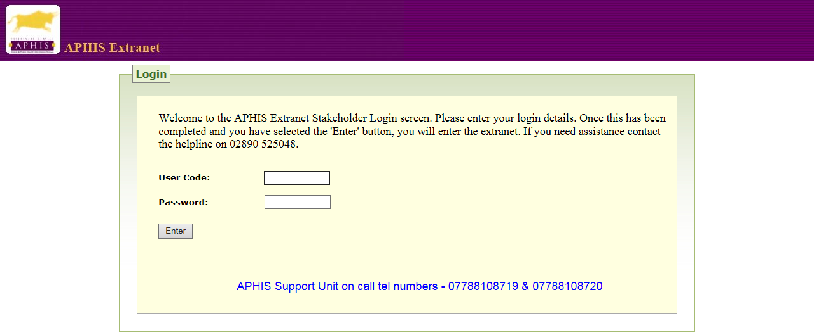

Users of the Extranet are to change their passwords every 30 days.

For users logging in for the first time, a default password will be set by DARD. You will be informed of the default password.

1. **Choose Application Screen**

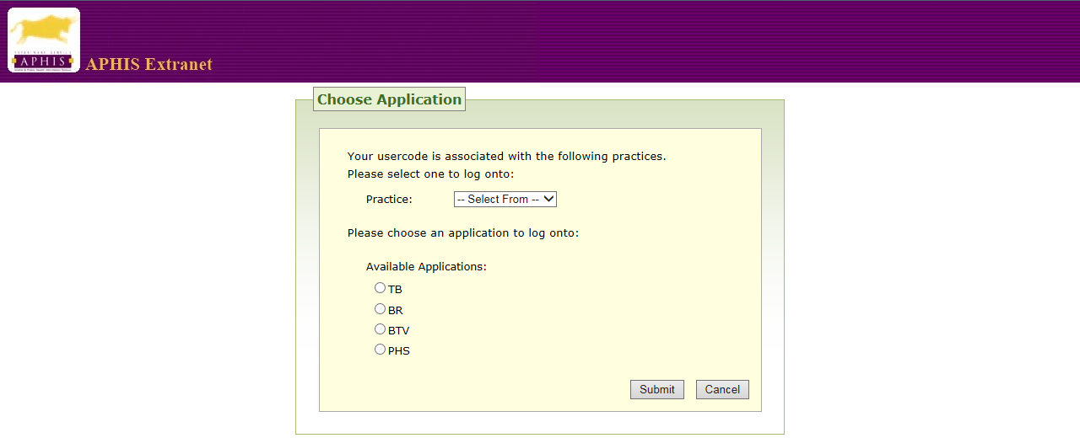

The Practice code is a unique code assigned to each Private Veterinary Practice. This field will accept uppercase characters only.

### Having entered your practice code, select TB and Submit.

You will now reach the TB Home Page.

### TB Home Page

If, after reading Section 3, you are still experiencing difficulty accessing the TB Home Pagecontact the APHIS Support Unit Helpdesk at **028 9052 5048.** Out of hours assistance is available on 07788108719 or 07788108720

You can also email **aphis.supportunit@dardni.gov.uk**

Note that the name of the current user and their associated practice name are extracted from the database and displayed on the right hand side of the header.

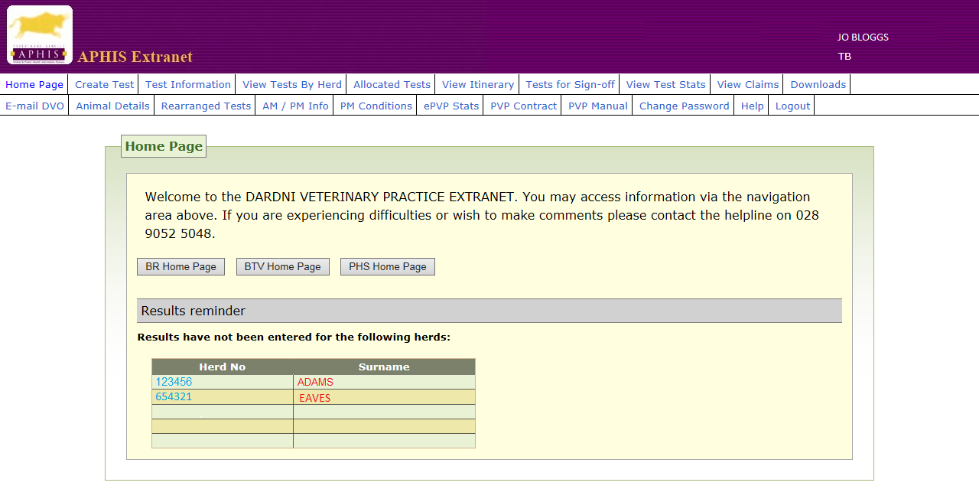

As you can see, once you have reached the TB Home Page you can access all the functions of ePVP. The functions are described in the table on the next page.

You can also leave the TB Home Page to visit the Brucellosis Home Page, the Bluetongue Virus Home Page and the Pig Health Scheme Home Page.

On the TB Home Page there may also be a reminder to enter results for any tests allocated to the practice that are more than 10 days past the arrange date but for which no results have yet been entered or a reminder to have signed off any TB tests allocated to the practice that are more than 10 days past the completion date but are not yet signed-off. If you select one of the herds the **Test Information** page will be opened up.

|  |  |
| --- | --- |
| **Create Test** | Allows you to create a Private Check Test or a Private Not Tested for 15 Months Test (PNT) |
| **Test Information** | Details of individual TB tests stored on the system. Most functions, which need to be carried out on TB tests, can be accessed from this page. |
| **View Tests by Herd** | Enter a herd number and see all the tests associated with that herd, allocated to the practice, displayed. |
| **Allocated Tests** | View a list of all tests allocated to the practice that have yet to be arranged. A drop box is available to select tests as required. |
| **View Itinerary** | View the planned TB testing itinerary for a practice, or an individual vet, on a particular date. These are arranged in time order and/or user order if no user is selected. |
| **Tests for Sign-Off** | See a list of all TB tests awaiting final sign-off by a senior member of practice staff prior to final submission to DARDNI. **Changes cannot be made after Sign Off as the report is now a VETERINARY CERTIFICATE**. |
| **View Test Status** | Allows you to see the status of any test in any month or year |
| **View Claims** | Available only to Sign Off user codes for the practice. Look at a list of claims that have been submitted by the practice for a specified period of time. Options to view “Claims Paid” and “Claims NOT Paid.” |
| **Downloads** | Allows you to download Allocated Tests, Overdue Tests, Paid Claims, Unpaid Claims, Ante-Mortem and Post-Mortem Details and Handheld Test Results (*i.e.* uploaded tests). |
| **E-mail DVO** | You can email information to any of the ten DVO’s. The practice e-mail address must be registered with the “Help” desk to avail of this facility. |
| **Animal Details** | This option allows you to enter an animal tag number and conduct search for that animal. |
| **Rearranged Tests** | Displays a list of tests which have been rearranged within the last ten days. Numbers of rearrangements are incremented. |
| **AM/PM info** | Shows the results of ante-mortem and post-mortem examinations of animals from herds associated on APHIS with your practice |
| **PM Conditions** | Shows examples of conditions found at Post-Mortem |
| **ePVP stats** | Shows TB disclosure statistics for your practice and for Northern Ireland DVOs and also shows late test submission rate for your practice |
| **PVP Contract** | Shows VP1 |
| **PVP Manual** | Shows VP2 |
| **Change Password** | Allows you to change your password |
| **Logout** | To finish a session |

Alert messages may appear when you log in. These messages will be of two kinds. There will be global messages that will appear to all users who successfully log onto the system. There will also be messages, which will be DVO specific messages, which will only be for users who have the same DVO code as the DVO code of the division from which the message has been issued. An example of a message that may appear when the homepage is loaded is shown below.

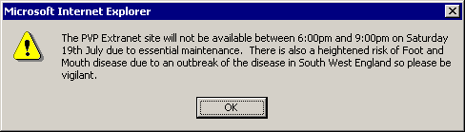

Clicking OK will cause the message to disappear.

1. **Create Test**

On the Create Test Screen you can create a Private Check Test (PCT) or a Private Not Tested for 15 months Test (PNT). As well as the herd number, you must know the IACS Number or Business ID for the herd keeper.

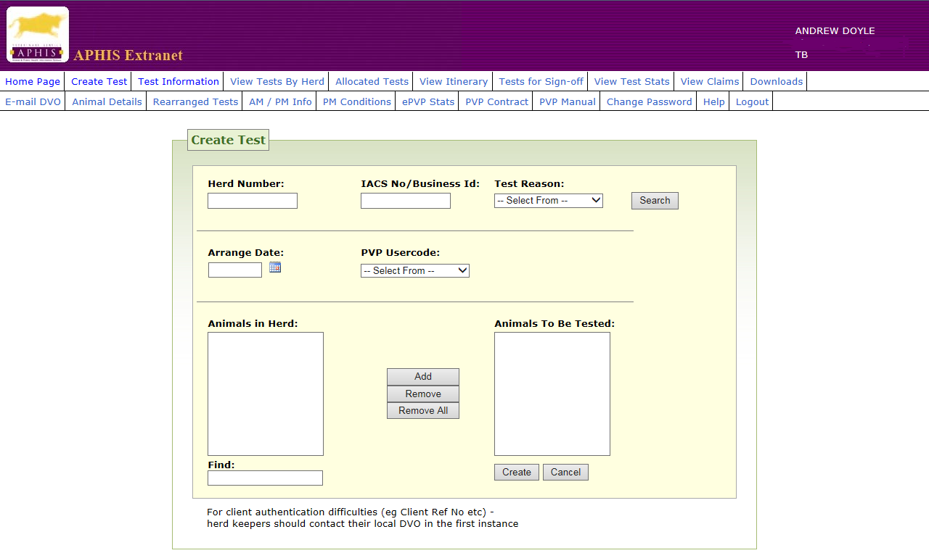

**42 day warning for PCTs**

A warning message will appear on ePVP when setting a PCT test as follows: “Please check there is a minimum of 42 days from the completion of the animal’s previous test to the arrange date for the PCT.”  The user can click on “OK” in the same window to clear the message.

### TBN status and MTO test

If an animal has an individual TBN status (any animal not TB tested for 15 months), a message will appear on screen before a brucellosis MTO test can be set for the animal: “Animal currently has a TBN restriction. Inform herd keeper animal must have a clear TB test before moving. Do you wish to proceed?”

If the user selects ‘Yes’ then the test will be created as normal. If the user selects ‘No’ the test will not be created.

1. **Test Information**

The Test Information Screen is the path to most of the information you will need about any TB test. You can access the Test Information Screen from the menu bar or from Allocated Tests, View Itinerary, and Tests for Sign-Off screens. As well as being the main page through which test data is displayed, the Test Information page is also the central point from which the various test tasks (*e.g.* result entry) are accessed. Thus, before a user can do any work on a test he/she must first open the test in the Test Information page.

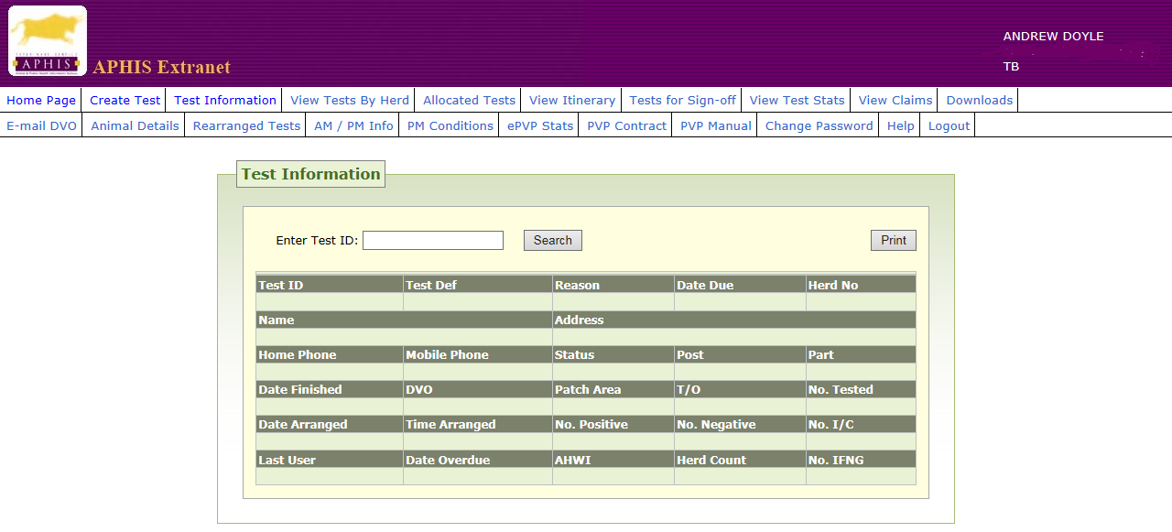

## When you key in a Test ID you have access to available information on the test and a range of functions.

The functions are as follows:

|  |  |
| --- | --- |
| Rearrange Test | Allows you to rearrange a test which has not yet been carried out |
| Print Sheets | Allows you to print BT15 test sheets |
| TB Batch | Enter the Tuberculin Batch |
| Enter Results | Enter results when the test has been carried out |
| Reprint BT15 | Reprint the BT15 or just the header sheet |
| Download Sheets | Allows you to download the test sheets on to your PC |
| Upload Results | Upload the results once they have been entered |
| Redownload BT15 | Allows you to download test sheets a second time |
| Comments | Allows you to see comments which have been entered for this test |
|  |  |

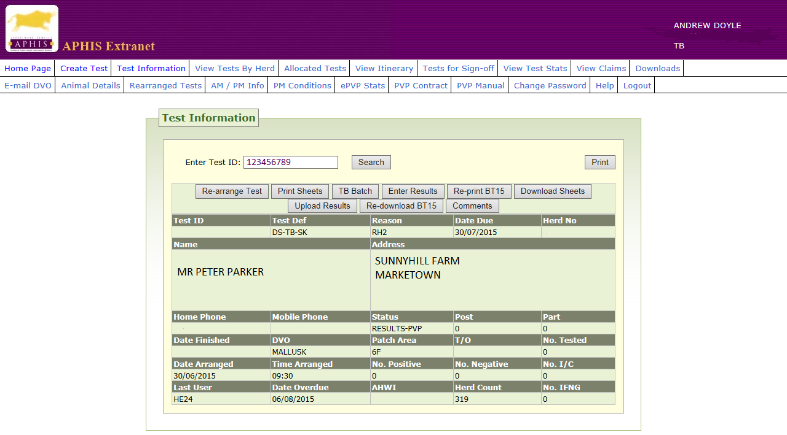

**Accessing TB test information using the test identifier (ID)**

Enter the unique identification number of the test into the field provided and press the ‘Search’ button. If a valid test ID is entered then the entire test details will be displayed. If the test ID entered is not allocated to the current practice then the message ‘Test not allocated to practice’ is displayed.

If the test is a TB test allocated to the practice but is not an AHT (Annual Herd Test) then a warning message **‘This test is not an AHT’** is displayed. When the message is acknowledged, by pressing the “OK” button the Test Information page is populated with the Test Details.

**Test Statuses**

It is important to understand the Test Cycle in order to understand test statuses. The Test Cycle is represented on the following page:



## The meanings of the Test Statuses are shown in the table below.

|  |  |
| --- | --- |
| **Status** | **Description** |
| CREATE | The TB test is created on APHIS in the Divisional Veterinary Office (unless it is a Private Check Test in which case it is created by the Private Veterinary Practice) |
| ALLOCATE | The TB test is allocated at this stage to a Private Veterinary Practice |
| ARRANGE | The date and time of the TB test is arranged at this stage |
| RESULTS-PVP | TB test has been arranged and is now awaiting entry of field data collected by the PVP. The information is entered at the practice office. |
| RESULTS-PVP/PE | TB test data has been **P**art **E**ntered but entry of test data is not completed. This status allows users to save partially entered data and then complete the data entry at a later stage. |
| RESULTS-PVP/SO | TB test data have been entered in full but are awaiting final ‘***Sign Off’*** by one of the authorised Practice Principals. |
| INTERPRET | The TB test can be interpreted in the Divisional Veterinary Office at this stage |
| FOLLOW-UP | Follow up actions are carried out during this stage *e.g.* changing the herd’s TB status and creating the next herd test. |
| COMPLETE | All actions relating to the TB test have been completed and the test status is now complete. |

**Arranging Tests**

This Arrange Test option will only be available to the PVP when an arranged date has not been set and the test status is ‘ARRANGE’.

The Test Information screen will be displayed with an ‘Enter Arrange Date’ button.

This screen allows the user to enter arrangement details for the test. This includes the date and time at which the test will be carried out and the practice vet scheduled to carry out the test. You can print off an Appointment Letter.

An Arrange date must be entered. Entry of an Arrange time is optional. If the TB test being arranged in an Annual Herd Test (AHT), the system will check that the arrange date is no sooner than 10 months after the herd’s previous completed AHT test. If an Arrange time is entered it must be in the 24hr clock format HH:MM.

The status of the test will be updated to ‘RESULTS-PVP’ and the Test Information page will be re-displayed showing the new test details.

**Printing BT 15 sheets**

On the Test Information page the Print Sheets button is only available to the user when the test has a status of RESULTS-PVP *i.e.* the test is awaiting result entry.

Select the option ‘Print Sheets’. You can print the test sheets as many times as you wish while the test status is at RESULTS-PVP.

The process of printing test sheets is comprised of a series of steps:

1. Create result rows to store the test results
2. Open a new window, display farmer and test information
3. Print the test sheets

Once the form has been generated in the new window you will be automatically shown the print dialogue box that gives you the opportunity to modify printing properties.

Please use the page margins as shown in the pop-up below:

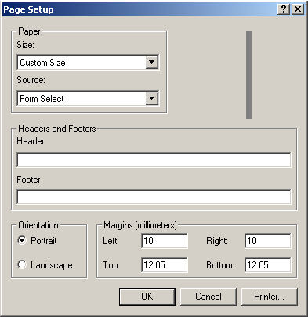

The ‘**Print Sheets’** option can also be accessed from the **View Itinerary** screen.

Note: There was an issue that, in some instances, test sheets would not print out if the test was arranged for the earliest date possible on ePVP. This has been fixed.

**Rearranging Tests**

This page is opened through the ‘Rearrange test’ button displayed on the Test Information page when a test has a status of RESULTS-PVP. It allows the Practice to change some of the test arrangement details previously entered.

The ‘Requested By’ field allows the practice to indicate who has requested the test to be rearranged, Herd owner indicates or Practice.

**Cancelling tests without rearranging**

You can cancel a test by removing the existing Arrange date and leaving the field blank. Also a new ‘Arrange date’ for the test can be entered.

If the Arrange date is changed either by canceling the test (*i.e.* removing the existing Arrange date) or by entering a new one, then the count of the number of postponements will be recorded. This will be shown in the Test Information page when it is redisplayed.

Other information can be changed freely (e.g. PVP user code, Test time) without affecting the postponement count – this only gets updated when the Arrange date changes.

When a TB test is cancelled the postponement field will be incremented and the test status will move back to ‘ARRANGE’.

### Recording Tuberculin Batch Numbers

When the TB Batch option on the Test Information page is selected, the system will display the Tuberculin Batch page. This form will present the user with the opportunity to insert the Avian and Bovine Tuberculin batch numbers that were used to perform the test. Note that one batch number for each type of tuberculin must be entered.

The Tuberculin Batch page can be used to enter tuberculin batch information for a test either before or after the test is actually carried out. If entered before the test is carried out it can be used to verify that the tuberculin batch, which will be used in carrying out the test, has not expired.

The User inserts the batch number into the field immediately above the TB batch table and presses the *Add* button to add these batch numbers to the table. When the *Add* is selected the following checks are made:

1. The batch numbers entered must exist in the system. Incorrect batch numbers will be flagged to the user with an appropriate error message.
2. For each valid batch number entered the system will check the batch expiry date as follows:

If the test has been completed and the completion date has been entered (the test completion date is entered via the ‘Date finished’ field on the ‘TB result entry’ page) then the expiry date of the tuberculin batch should be checked against this completion date. If the expiry date of the batch occurred before the test completion date then a warning message will be displayed.

If the test has not been completed (*i.e.* no completion date entered) then the expiry date of the tuberculin batch should be checked against the current day’s date. If the expiry date of the batch occurred before today then a warning message will be displayed.

When the *Save* button is pressed the system will perform the following validations:

* At least one type of each batch number is entered. That is one batch number beginning with the character ‘A’ for Avian, and one batch number beginning with the character ‘B’ for Bovine. There is no upper limit to the number of batches that can be added to the test.

The system will store the test ID and the batch number. One record will be generated for each batch used in the test. The user will then be returned to the Test Information page.

If any of the validation checks are failed a message will be presented to the user outlining the error that has occurred and how they may correct it.

### TB Results

The ***TB Results*** button is available on the Test Information page at all times except when the test has a status of ARRANGE (*i.e.* has yet to be carried out). Clicking on TB results will allow you to either Enter Results or Review Results, depending on the status of the test, as shown in the table below:

|  |  |
| --- | --- |
| **TEST STATUS** | **OPTION** |
| ARRANGE | N/A |
| RESULTS-PVP | Enter Results |
| RESULTS-PVP/PE | Enter Results |
| RESULTS-PVP/SO | Enter Results |
| SYSTEM INTERPRET | Review Results |
| INTERPRET | Review Results |
| FOLLOW-UP | Review Results |
| FOLLOW-UP(ADMIN) | Review Results |
| COMPLETE | Review Results |

### TB Result entry

This screen allows individual animal test results to be entered and modified. The animals displayed in the list will be those, which the system considered to be in the herd at the time the test sheets were printed plus animals added by the tester.

Measurements need only be entered for animals that have shown rises between day 1 and day 4.

Apart from the *Status* and *Res* fields (see below) all other fields will be blank when the form is initially displayed.

The following fields are presented at the top of the page:

### Date Finished

### PVP User code (Testing Officer)

The following fields are displayed for each animal listed:

#### Animal tag

This is a display only field showing the tag number of each animal included in the test.

You will also be able to enter a DNA tag corresponding to an Animal tag. Click on Change in the DNA tag field.

#### Status

This field is used to record a residency status code. The default status value of this field is ‘OK’ indicating that the animal was properly tested, days 1 and 4. However it is possible, for a variety of reasons, that an animal may not be tested in which case other residency status codes are necessary to indicate a reason for non-testing. The other residency status codes are listed on the following page.

|  |  |
| --- | --- |
| **Residency Status** | **Meaning** |
| OK | Animal tested correctly. |
| MO | Moved out prior to day 1 of the test. |
| MO4 | Moved out after day 1 and before day 4 |
| NP | Not presented. Animal believed to be in herd but has not been presented by the farmer for testing on both day 1 and day 4. |
| NP4 | Not presented on day 4. Animal was presented for test on day 1 but not on day 4. Animal is still believed to be in the herd. |
| DE | Dead |
| DE4 | Dead. Animal was tested on day 1 but died and could not therefore be tested on day 4. |
| OT | Other test. The animal is scheduled for an individual test of the same type. The PVP has decided not to test the animal as it will be tested as part of another test. |
| PT | Part test. The animal has not been tested, as this is a part test. The animal will have already been tested or will be tested subsequently in another part test. |
| IRO | This code indicates that the animal has not been tested due to incorrect Identification and Registration information *e.g.* animal is too young. |

**Measurement input fields:**

**1A:** Avian site measurement Day 1. A value should only be entered if there is a difference between this and the day 4 measurement. If a value is entered it must be a whole number that is greater than zero and less than 99.

**1B:** Bovine measurement Day 1. A value should only be entered if there is a difference between this and the day 4 measurement.

**4A:** Avian measurement Day 4. A value should only be entered if there is a difference between this and the day 1 measurement.

**4B:** Bovine measurement Day 4. A value should only be entered if there is a difference between this and the day 1 measurement.

**Swelling description fields:**

**Swl A:** If you choose to describe a swelling there are 18 possible values.

|  |  |
| --- | --- |
| **Swelling Type** | **Description** |
| C | Circumscribed |
| S | Slight Oedema |
| D | Diffused Oedema |
| E | Extended Oedema |
| CP | Circumscribed & Pain |
| SP | Slight Oedema & Pain |
| DP | Diffused Oedema & Pain |
| EP | Extended Oedema & Pain |
| CH | Circumscribed & Heat |
| SH | Slight Oedema & Heat |
| DH | Diffused Oedema & Heat |
| EH | Extended Oedema & Heat |
| EX | Exudation |
| NC | Necrosis |
| CHP | Circumscribed & Heat & Pain |
| SHP | Slight Oedema & Heat & Pain |
| DHP | Diffused Oedema & Heat & Pain |
| EHP | Extended Oedema & Heat & Pain |

**Swl B:** As for Swl A

**Recording of PVP on-farm interpretation**

**Res:** This field is used record the PVP on-farm interpretation of the TB test. There are three possible values, which will be listed in a drop-down list box. These are ‘P’ for positive, ‘N’ for negative, ‘I’ for inconclusive. The default value is ‘N’.

# Recording remarks

# Remarks: This field is used to record any remarks, as entered on the test sheet. Up to 50 characters can be entered into this field.

**Changing an animal’s breed, sex, colour or date of birth:**

**Change Animal Button:** This provides access to a screen containing further information about an animal including **colour, sex breed and date of birth**. If during the clinical examination the PVP records a discrepancy between the animal’s Identification & Recorded details as printed by APHIS and those which exist in reality (*e.g.* different colour), then these discrepancies need be recorded on this screen. Identification and Registration (I&R) information which can be changed includes colour, sex and breed. The page also allows free text remarks to be recorded about the animal.

A general comment can be added to the remarks field (up to 60 characters). The *remarks* field should be used to record remarks relevant to the animal’s I&R details as opposed to the actual testing of the animal. This field has no relationship with the remarks field on the TB test result entry form.

The **Save** button saves any changes, closes the page and returns to the result entry page. Changes are only saved on ePVP if the colour, sex or breed information selected is different from that currently recorded in APHIS, or if a remark has been entered. Note, these changes are not applied directly to the animal’s database record on APHIS. Any such changes are recorded for future examination by personnel at the local DVO. The decision as to whether to update the animal’s identification and registration data will be taken at this stage.

The **Close** button closes the page and returns to the result entry page without attempting to save any changes.

Note that if changes are made to an animal’s detail on a test, the background colour row for that animal on the Test Result Entry page will be coloured green once results have been saved.

## Adding animals to a test

There are a variety of reasons why an animal may need to be added to a test. For examples, it may have moved into the herd in the period after the test sheets were printed or the herd owner may not have registered its birth. In the ‘Test Results Entry’ page there are two buttons, ‘**Record Births**’ and ‘**Purchased Animals**’. These buttons allow the user to add animals to the test that were not on the original test sheets.

**Record Births**

This button opens up a form. It contains a table with sufficient entries for 5 animals. Each row of the table will consist of drop down combo boxes for the following entries: Colour, Breed, Sex and Animal Tag.

The list of breeds is in an abbreviated format *e.g.* AA etc.

The process of recording will occur when the user presses the Record button. Some of the checks that are carried out at front-end APHIS registration will be omitted because they are not relevant at this stage *e.g.* checking for a non-operational herd or a no stock herd. An error message will appear if the user has not selected an entry from each of the combo boxes.

The calculation and application of statuses to animals registered on the PVP Extranet site will replicate the functionality of the registration process in front–end APHIS as closely as possible. However, recording animals this way will not involve any checks to determine if there any conflicts with the date of birth of the animal being registered and any of its siblings.

**Purchased Animals**

This button opens a form which is used for adding animals that are already registered in APHIS but were not included in the list of animals to be tested.

The page will initially display blank. The animal tag fields will be enabled for data entry. The user can enter up to five tag numbers of animals to be added to the test. Having entered one or more tags, the ‘**Search**’ button should be pressed. This will carry out a search of the database to verify the animal numbers entered. If the animals are known to the system, their colour, sex, breed, DOB and current herd will be presented in the fields provided. The information will be displayed in blue text if the animal was not in the test herd on day one of the test. Also in this circumstance the text ‘Not known in herd at time of test’ will be displayed to the right side of the row. If the animal tag entered is not that of a registered animal, then the text ‘Unknown animal’ will be displayed to the right hand side.

To prevent duplicates, if any animal is already in the test, or is already in the above list, then message ‘Duplicate’ will be displayed on the right hand side of the corresponding row. The fields colour, sex, breed etc. will remain blank in this case.

The ‘**Save**’ button is used to add the animals listed to the test. The ‘Purchased Animal’ page will close and the user will be returned to the result entry page with the new animals added to the end of the list (in bar number order). Note, only those animals that have been successfully searched will be added to the list (this excludes any ‘Unknown animal’). For any animal added to the test in this way, the ‘Residency status’ field will be set as follows:

* ‘OK’ if it is determined from the animal’s movement history that it was in the herd at the time of test.
* ‘IN’ if it is appears from the animal’s movement history that it wasn’t in the herd at the time of test (in this case ‘Res status’ will be an ordinary ‘display-only’ field.). The ‘IN’ residency status therefore indicates that the animal is IN the herd but there is no movement history/documentation to support this.

The ‘**Close**’ button will close the page and return to the TB result entry page without adding any animals.

**Saving test results**

**Save Button:** saves the work completed at any stage in the result entry process to the database; the status of the test will change to RESULTS-PVP/PE (indicating *P*art *E*ntry), and return the User to the Test Information page.

## You are recommended to save results frequently so that data entered may not be lost *e.g.* by power failure or line disruption. Data entered should be saved at least after every 12 animals.

# Completing Results Entry

# Complete Button: allows the user to signify the completion of the result entry process for this test.

A number of checks will be carried when the button is pressed.

Where a value has been entered in any of the following the fields *1A, 1B, 4A, 4B, SWL A, SWL B* then all fields *1A, 1B, 4A, 4B* must also have values i.e. all results should be entered for the individual animal. An ‘Incomplete Results’ message will be presented if the results for any individual animal have not been completed.

However, if any animal has a status of ‘MO4’, ‘DE4’, ‘NP4’ indicating that it was tested on day 1 and not day 4, then it is acceptable for the animal to have results entered for day 1 (*1A, 1B*) and have no results entered for day 4 (*4A, 4B*).

The system will check that Tuberculin batch details have been entered for the test. If they have not, an error message will be displayed.

If the checks complete successfully a message box will be displayed showing a summary of the test statistics including;

total animals listed

total animals tested

total animals with field result ‘P’

total animals with field result ‘I’

total animals with field result ‘N’

You will be asked to confirm that the test statistics are correct as shown in the example below:

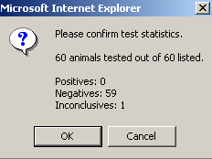

If the response is ‘No’ you will be returned to the TB result entry form and corrections can be made. If the response is ‘Yes’ the test will be assigned a status of **RESULTS-PVP/SO** (indicating that the test is now awaiting sign-off by a senior member of the practice staff).

**Signing off the test from the Test Information Page**

### Signoff Button: the Sign-Off button is available only to Senior Practice Persons who have “Sign Off” Code.

This button is used to indicate that the test has been completed to the satisfaction of the Practice Principal and is to be submitted to the local DVO for any additional processing. This button is only be available to senior members of the practice staff authorised by the Aphis Support Unit.

The same checks are carried out at *Signoff* as when the *Complete* button is activated

If the checks complete successfully, the operator will be shown the test statistics and asked to confirm that they are correct. If the statistics are correct, results will be saved and the additional test processing activities described below will be carried out. In addition the test will be assigned a status of **SYSTEM INTEPRET** (indicating that the test is ready for automatic interpretation by the system at the DVO in whose area the herd resides.).

Note when a test is signed-off a number of additional processing activities are carried out. For the most part these do not require any user interaction. The additional processing activities are:

* Highlight Identification and Registration changes to any animals on the test to the local DVO
* The test will be examined 7 days after the test date, to determine if any movement issues are still outstanding.
* If any animals have a result status of ‘DE’ or ‘DE4’ they will be immediately moved out of the system to the DEAD database
* Carry out ‘part test’ processing. If any animal on the test has a ‘PT’ *result status* then the user will be asked to confirm that this is a Part Test.
* Carry out any ‘subsumed’ test processing. This is when an individual animal test is ‘subsumed’ within the larger herd test.
* Check for no stock. If no stock were tested, the user will be asked to confirm that this was a ‘no stock test’.

When the above processing has been completed, the ‘Sign off’ user will ‘ok’ the test claim form to continue.

When results are being entered on the Test Result Entry page and saved and the page has been reopened, the colour used by ePVP may change for an entry. Thus, when a positive result is entered in the result column, the entire background colour of the row relating to that animal will be displayed in red. If an animal has an inconclusive result entered in the results column, the entire background colour of the row for that animal will be coloured blue.

**Late Sign-Off Of Tests**

If PVP is signing off a TB test and

* >7 calendar days have passed, where all animals are negative
* >2 working days have passed, if there are inconclusive reactors
* >1 working day has passed, if there are positive reactor(s)

a new pop up box will be displayed as follows: “Late sign-off: It is >7 (or2 or 1 as appropriate) days since the test was finished.”

The PVP can click on one of two dropdown comments:

1. There were ROI animals to be entered

2. Other

The comment will be automatically added to the scratchpad and can be viewed in APHIS and in ePVP.

Note: “Working days” for PVPs for the purposes of signing off TB tests on ePVP are Monday to Friday. For example, reactors identified on a Friday must be signed-off by Monday (midnight) - although preferably as soon as possible.

This facility was requested so that PVPs testing in border areas, who may regularly have to wait for ROI animals to be entered onto the herd list, can note the reason for the delay in sign off.

1. **Downloading tests to Personal Digital Assistants**

Your Personal Digital Assistant (PDA) supplier will provide you with synchronisation software to allow your PDA to communicate with ePVP through Windows Mobile Device Centre on your PC. The task of downloading tests to PDAs is carried out using this software.

1. Download Sheets to the designated PC directory using the Download Sheets button within Test Information

2. Connect a USB cable into your PC

2. Start the PDA

3. Connect the PDA to the PC using the USB cable

4. The Mobile Device Centre programme will start.

5. Enter your PIN

6. Initiate the file exchange by opening the synchronisation programme on the PC

7. All BT15 .xml files in the designated PC directory will be downloaded to the PDA and encrypted



1. **Uploading tests from Personal Digital Assistants**

The task of uploading tests to ePVP is carried out using the synchronisation software operating through Windows Mobile Device Centre on your PC.

1. Connect a USB cable into your PC

2. Start the PDA

3. Connect the PDA to the PC using the USB cable

4. The Mobile Device Centre programme will start.

5. Enter your PIN

6. Initiate the file exchange by opening the synchronisation programme on the PC

7. Any files available for upload are copied from the device to the Upload folder and decrypted.

8. Upload results to ePVP using the Upload Results button within Test Information

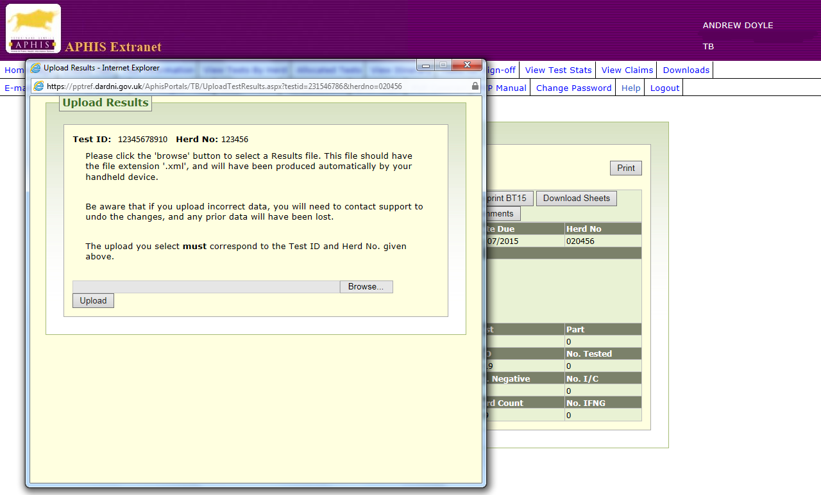

1. **View Tests by Herd**

You can see the results of previous herd tests when you enter a herd number.

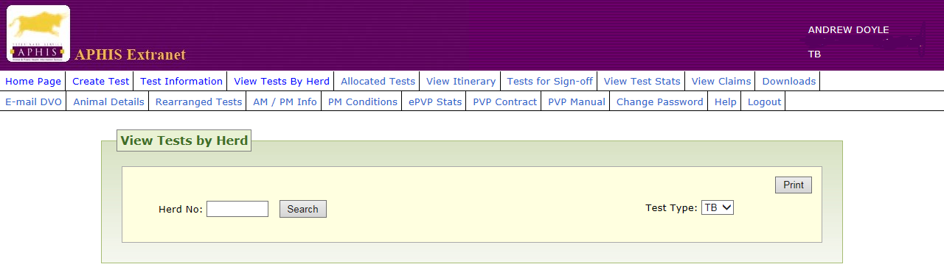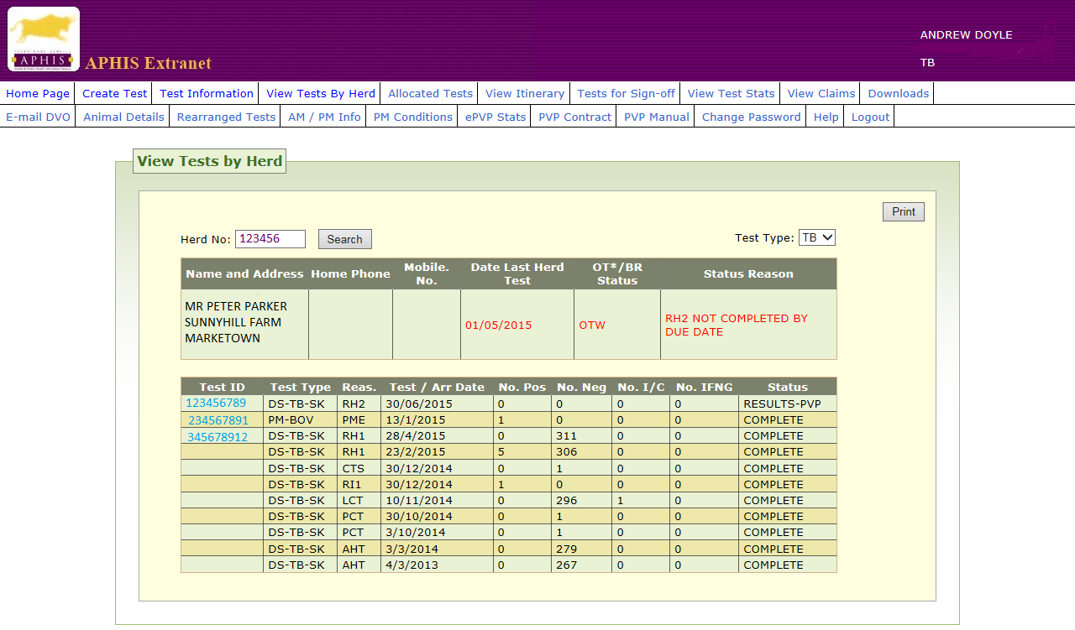

This facility provides the practice with the ability to list all TB tests that have either been carried out within the last 3 years, or are scheduled to be carried out on a particular herd. You enter a herd number and then select the ‘Search’ option.

ePVP checks that your practice has an existing association with the herd. If not (*i.e.* herd is looked after by another veterinary practice), then an error message is displayed.

The following information is displayed for each herd selected:

|  |  |
| --- | --- |
| **Name** | **Description** |
| Test ID | Identification number belonging to the test. |
| Test Type | Specifies the type of test that is to be carried out on the herd. In all cases this will be DS-TB-SK representing a TB skin test. |
| Reas. | This is the three-letter code that identifies the reason for the test on the herd. In most cases this will be AHT (Annual Herd Test). |
| Test/Arr. Date | The test date is displayed if the test has been carried out and the arrange date is displayed if the test has not been carried out. The test date is the date on which the test took place and the arranged date is the date on which the test is due to be carried out. |
| No. Pos. | Number of positive animals in the test (if completed) |
| No. Neg. | Number of negative animals in the test (if completed) |
| No. I/C | Number of inconclusive animals in the test (if completed) |
| Status | The current status of the test. This is used to indicate the current position of the test within the Test Cycle. |

**12.** **Allocated Tests**

The allocated Tests screen gives to access to newly allocated tests, deleted and reallocated tests, currently allocated tests and overdue tests. You can also display all tests for a herd allocated to your practice.

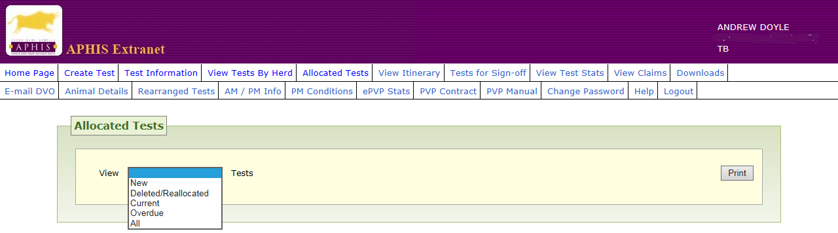

When you are provided with a list of allocated tests you can open each one individually and this opens up the Test Information screen for the herd.

When viewing allocated tests, you are required to select the list that you wish to view. The options are – *New*, *Deleted/Reallocated, Current, Overdue or All* allocated TB tests.

|  |  |
| --- | --- |
| ***New Tests*** | New tests, which have been created and allocated to the user’s practice within the past 10 days will be displayed. These will be tests, which have not yet been arranged *(i.e.* current status is ‘ARRANGE’). The due date of the test will have no bearing on which tests are returned in the search. |
| ***Deleted/***  ***Reallocated Test*** | This will show tests, which had been assigned to the user’s practice, but which have been subsequently deleted within the previous three months. It will also show tests, which have been reallocated to another practice or DARD within the previous three months. The list of tests returned will be a read-only list of tests. |
| ***Current Tests*** | This will display tests for the current month, the following month and also the three months previous to the current one. All these will not have been arranged (i.e. current status is ‘ARRANGE’). The beginning of the date range that will be used to decide what tests to display will be calculated by subtracting three months from the current month. The beginning of the date range will be the first day of whatever month is calculated. The end of the date range used in the calculation will be taken to be the last day of the next month following the current month. For example, if today’s date is 01/01/2016, the tests will be displayed will have a *due date* for the test that falls between 01/10/2015 and 29/02/2016. |
| ***Overdue Tests*** | This option will display the overdue tests page. The user also has the option of pressing the Downloads tab button on the navigation bar. A test is deemed to be overdue when it is on or past the overdue date and for which no results have yet been entered. When looking at the list of overdue tests, the results are displayed in ascending order *i.e.* tests that are displayed at the top of the list are the tests that are the most overdue. |
| ***All Tests*** | This will display all allocated tests, which have not had results entered and have not yet been arranged. The due date of a test will not be taken into account for this search. The search extracts and lists all TB tests that have been allocated to the practice and have a status of ‘ARRANGE’ |

The following information will be displayed for each test listed.

|  |  |
| --- | --- |
| **Name** | **Description** |
| Herd No | Herd number of the herd to be tested. |
| Name / Address | Name and address of the keeper of the farm. |
| Test Type | Specifies the type of test that is to be carried out on the herd. In all cases this will be DS-TB-SK representing a TB skin test. |
| Reas. (Reason) | This is the three-letter code that identifies the reason for the test on the herd. In most cases this will be AHT (Annual Herd Test). |
| Due | Date on which the test was due. This is followed by the number of days the test has passed its due date. |
| Restricted | Displays the value ‘Yes’ or ‘No’ depending on whether or not the herd has a TB status and is therefore restricted. |
| No. | Number of animals in the herd that need to be tested. |
| Post | Number of times the test has been re-arranged. |

## View Itinerary

## You can see your itinerary based on the tests you have arranged. Viewing your itinerary helps you plan to do your work efficiently. Having seen the itinerary, it may be necessary to rearrange tests in order to use your time efficiently.

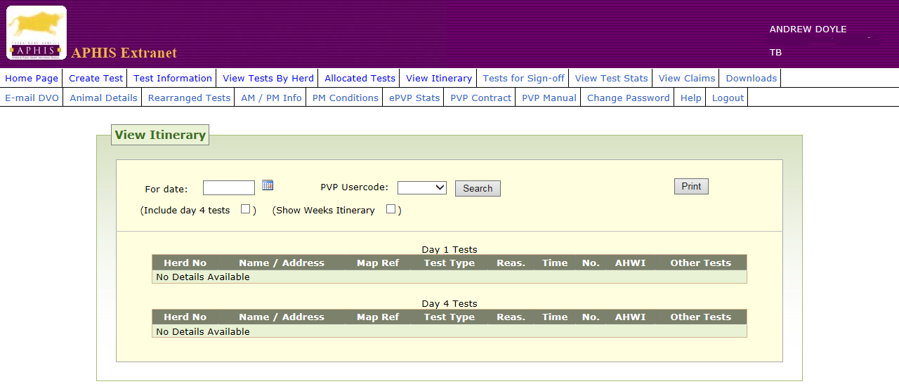

If you are content with the itinerary you can print out all test sheets from this screen if required.

By default, the itinerary shows all tests that have been arranged to start on a particular date. An additional check box is available to ***Include day 4 tests*** on the itinerary list. If checked before the *Search* button is pressed, the system will also list those herd level TB tests due to complete day 4 testing on the entered date.

It is also possible to view the itinerary for a date in the past.

The following information is displayed on the screen:

**Herd No.**

**Name of Herd Keeper**

**Address of Herd Keeper**

**Test Type**

**Reason for Test**

**Start Time**

**Number of animals**

**AHWI – Day 1 or Day 4**

**Other Tests**

By clicking on a test you will be brought to the Test Information Screen.

## Tests for Sign-Off

## All the tests which have results entered are listed and the tests can be signed off by an Authorised Person who will be a Veterinarian and is normally a Practice Principal or a Partner. The Authorised Person for ePVP will have been authorised by the APHIS Support Unit. After tests have been signed off they can be uploaded onto APHIS.

This screen allows the Practice Principal or an authorised senior staff member examine the TB test results prior to final submission to DARD. The authorised person carrying out the Sign-Off procedure is carrying out an act of Certification.

**Instruction to Authorised Person**: Open each test to be Signed Off. By clicking on a test you will be brought to the Test Information Screen. Check that the data is correct and then commit the test for Sign Off under your own user code.

**Late sign-off of tests**

If a TVO, VOT or PVP is signing off a TB test and

* >7 calendar days have passed, where all animals are negative (>7 days), or
* >2 working days have passed, if there are inconclusive reactors (>2 days), or
* >1 working day has passed, if there are positive reactor(s) (>1 day)

a pop up box will be displayed which says, “Late sign-off: It is >x days since the test was finished” where x is 7, 2 or 1 as appropriate.

The TVO, VOT or PVP can click on one of two dropdown comments:

1. There were ROI animals to be entered

2. Other

The comment will be automatically added to the scratchpad and can be viewed in APHIS and in ePVP.

Note: “Working days” for TVOs, VOTs and PVPs for the purposes of signing off TB tests on ePVP are Monday to Friday. For example, reactors identified on a Friday must be signed-off by Monday (midnight) - although preferably as soon as possible.

This facility was requested so that PVPs testing in border areas, who may regularly have to wait for ROI animals to be entered onto the herd list, can note the reason for the delay in sign off.

1. **View Test Status**

This screen allows you to see at what stage in the cycle a test is sitting.



## View Claims

This screen allows you to see what claims the practice has made in any period up to 6 months. The View Claims page can only be be viewed by users assigned to ‘SENIOR ONLINE PRACTICE USER’ group. Anyone who is not in this group and attempts to display the View Claims page will see an error message displayed.

You will select an option from the drop-down menu for paid or unpaid claims.

If you select the ‘paid’ option then all of the claims that have been paid, or passed for payment, in the last three months will be presented. The search to extract all the claims starts with the first of the month three months ago and returns all the claims paid until it reaches today’s date.

If you select the ‘unpaid’ option then all claims that have been entered but not been paid will be displayed. When the claims option has been selected from the drop-down menu, the information will be extracted from the database and displayed as follows.

The TB tests will be sorted according to the claim date therefore the most recent claim will be at the top of the page. All of the TB test information will be displayed on the one page.

The following information is displayed about each test.

|  |  |
| --- | --- |
| **Name** | **Description** |
| No | Row number of Claim |
| Test ID | Identification of the test for which payment is to be made |
| Completed Date | The date on which the test was completed. |
| Herd No | Identification number for the herd that needs to be tested. |
| Name / Address | Name and address of the farmer to whom the herd belongs. |
| Claim Amount | The total amount for which the PVP is claiming. |
| Claim Date | The date on which the claim was made. |

A row number will be displayed beside each test in the View Claims page. In addition the total number of rows and the total amount claimed will be displayed at the bottom of the View Claims Page. The Senior Practice User is able to view unpaid claims even if a claim has not been processed at the Divisional Office.

1. **Downloads**

The Downloads screen allows you to download Allocated Tests, Overdue Tests, Paid Claims, Unpaid Claims, Ante-Mortem and Post-Mortem Details and Handheld Test Results (*i.e.* uploaded tests).

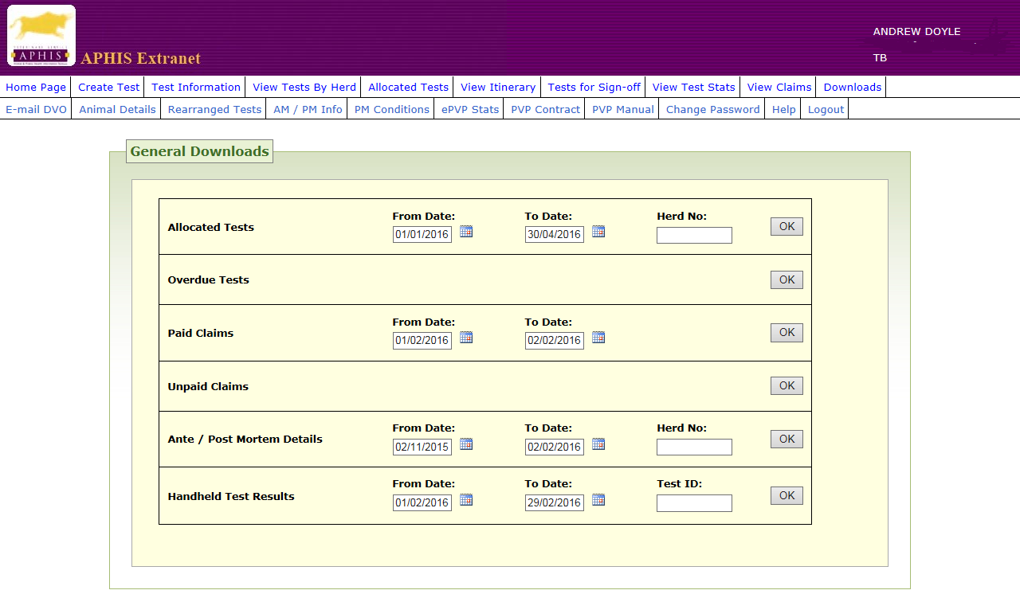

**18.** **E-mail DVO**

This screen allows you to send a message to any DVO by email.

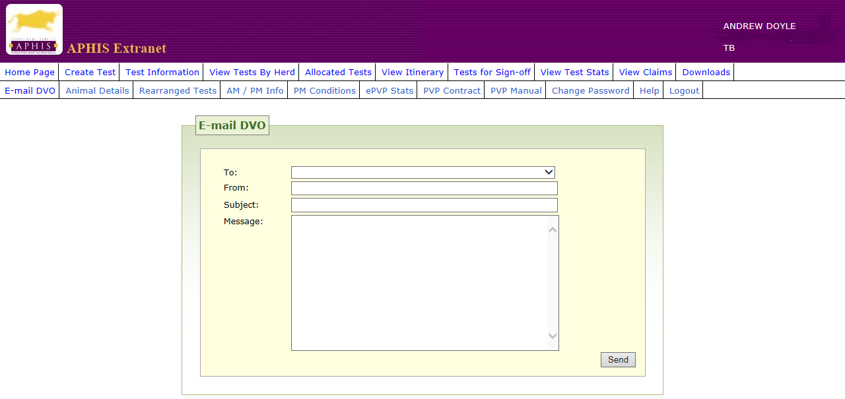

## Animal Details

This screen allows you to see a description of any animal and view post-mortem results for an animal.

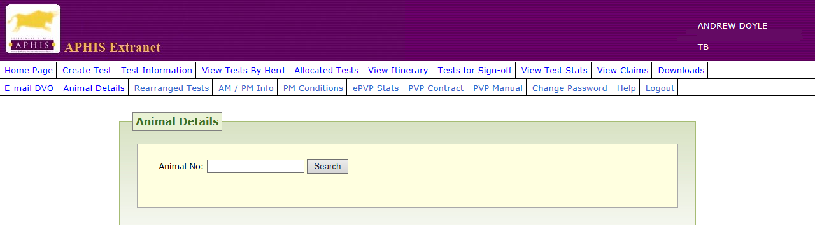

**Search Button**

If an animal number is entered that exists on the system and the herd is associated with your practice, clicking the Search button will produce details of the animal’s colour, breed, sex and date of birth. There is also a Testing History button.

If the animal is in a herd not associated with the PVP code of the user the following message will appear: “This animal is presently in a herd not associated with your practice.” No details will be displayed in this case.

**Testing History Button**

If the animal has had a post-mortem test undertaken, the first row displayed will indicate that a post-mortem exists for the animal. The post-mortem test may not necessarily relate to a TB breakdown. Click on the Open button to display the results of the post-mortem examination.

**Post Mortem Page**

This page displays the test id, the animal number, the herd number and the kill number. In addition there is a text box that may contain entries for the condition, site, description and condemnation code.

**Condemn Field**

The possible values which are allowed in this field, are as follows:

P = Pass - is not condemned.

D = Detained - the organ within which the lesion was found has been detained.

C = Condemned - the organ within which the lesion was found has been condemned.

**Condition Field**

Shows post-mortem examination conditions (or findings), *e.g.* Bruising, Abscess, Oedema *etc*.

**Site**

Shows the carcase site where the condition displayed in the Condition field was found.

**Text Box**

May contain observations made during the post mortem examination.

**TB tests, Histopathology test and Bacteriology test**

A maximum of eight rows showing the details of the last eight TB tests (or Histopathology or Bacteriology tests) in which the animal was tested will be displayed. These eight tests could be animal-level test or herd-level tests; however, they will only be displayed if they are sitting at a status of ‘COMPLETE’.

## Rearranged Tests

When this page is opened a list will be displayed showing tests, which have been rearranged within the previous ten days.

In addition an entry will appear showing the number of times the test has been rearranged.

Clicking on a Test ID will open the Test Information Screen for the relevant test.

**21.** **AM/PM Information**

This screen provides access to ante-mortem and post-mortem information for a herd over a selected period.

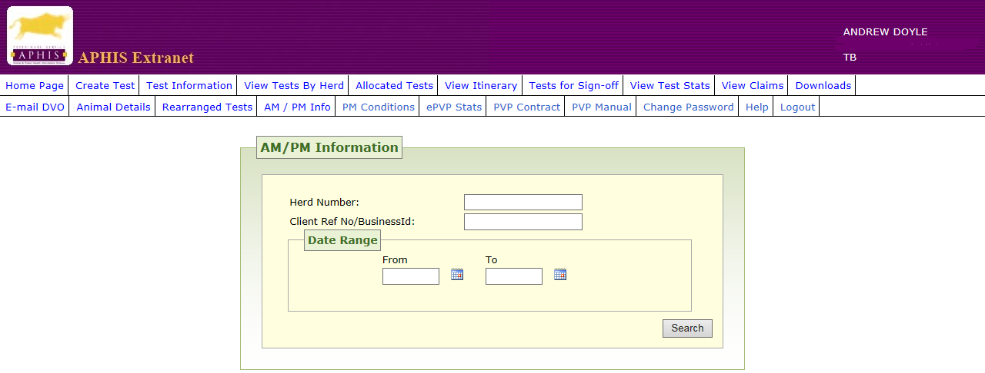

## PM Conditions

This screen provides access to images of a range of conditions seen at Post-Mortem examination.

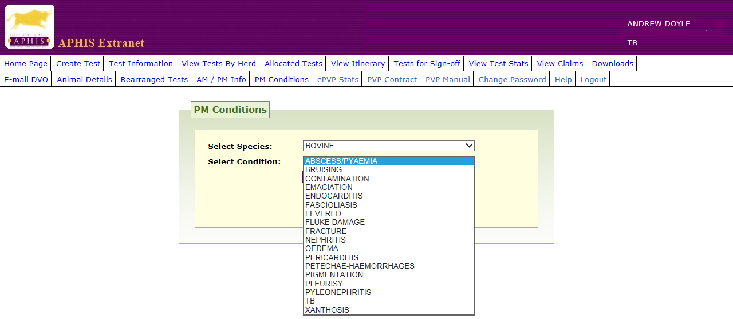

## ePVP Statistics

This screen provides access to your practice’s detection rate and late submission rate and also provides access to stored reports on your practice’s detection rate and of all the Divisional Veterinary Office areas’ detection rates.

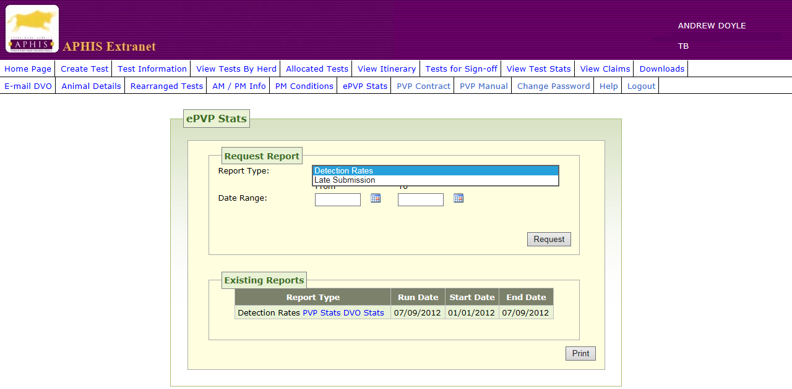

## Contract

This screen provides access to Schedule 1 of the Contract Document

1. **PVP Manual**

This screen provides access to Schedule 11 of the Contract Document

1. **Change Password**

This screen allows you to change your password. Password security is a very important aspect of the PVP Extranet. Users of the Extranet are to change their passwords every 30 days.

1. **Logout**

This screen allows you to log out.