Special Sheep Sales (SSS)

Instructions for aPVPs

PLEASE NOTE THAT AN EAC/SSS MUST CONTAIN EITHER

* ANIMALS FOR BREEDING TO AUSTRIA DENMARK FINLAND SLOVENIA SWEDEN OR
* ANIMALS FOR BREEDING TO EU MEMBER STATES OTHER THAN AUSTRIA DENMARK FINLAND SLOVENIA SWEDEN OR

These instructions cover the roles which aPVPs play in the export of animals through **“Special Sheep**

|  |  |  |
| --- | --- | --- |
|  | INDEX |  |
|  |  |  |
| Section | Name | Page |
| 1 | Introduction | 3 |
| 2 | Special Sheep Sales – Summary of Process | 4 |
| 3 | Application to move animals into a Special Sheep Sale using eSAVI | 5 |
| 4 | Procedure for Initiation of Special Sheep Sale by the  Sale aPVP | 10 |
| 5 | Procedure for entry of animals to a CPR[1] (WEB ENABLED) EAC | 12 |
| 6 | Procedure for entry of animals to a Non CPR (NON WEB ENABLED) EAC | 12 |
| 6.1 | eSAVI Procedure for entry of animals to Non-CPR EAC | 13 |
| 7 | Procedures for Moving animals out of a Special Sheep Sale | 14 |
| 8 | Declaration of Export | 18 |

**Sales”**

# 1. Introduction

“**Special Sheep Sales**” are sales usually of pedigree animals organised at Premises which have been approved as **Export Assembly Centres (EACs)**. All animals entering these sales must be eligible for export to the EU for Breeding. The animals leaving these sales may be exported to ROI/EU, or GB or moved to/returned to Northern Ireland farms.

These instructions cover two areas in which Authorised Private Veterinary Practitioners (aPVPs) may be involved.

**1.1**  Application for a **Veterinary Service Support Certificate (VSSPT)** relating to the animals and the premises of origin and a **Movement Licence** to accompany them to the Special Sheep Sale. (**See** **Section 3**)

**N.B. Any aPVP with access to eSAVI** could be approached by a farmer wishing to move animals to a Special Sheep Sale in order to apply for a “Veterinary Service Support Certificate” and Movement Licence.

**N.B. FARMERS MAY ALSO APPLY TO** DAERA Direct/DVO offices for the Veterinary Service Support Certificate & Movement Licence

**1.2 Being the aPVP responsible for a “Special Sheep Sale”**

In this case the aPVPs responsibilities include:

* Initiating the Special Sheep Sale by applying to the DVO using eSAVI for a Veterinary Service Support Certificate for the EAC premises (**Section 4**)

* Ensuring that only animals eligible for export for breeding to the EU are allowed to enter the EAC where the “Special Sheep Sale” is taking place (**Sections 5& 6**)

* For non-CPR EACs moving the animals into the EAC flock/herd using eSAVI (**Section 6.1**)

* Blood Sampling Rams intended for EU trade for Brucella ovis, if this testing has not already been done prior to entry

* Providing export certification for animals being exported from the sale to ROI/EU and if the need arises GB

* Confirming the exported animals on eSAVI and declaring the export. (**Section 7**)

# 2. Special Sheep Sales - Summary of Process

These sales are normally held by pedigree breed societies in Premises operating as Export Assembly Centres (EACs). All animals entering the sales must be eligible for export to other EU Member States. Farmers must obtain a **Veterinary Service Support Certificate** (**VSSPT**) and a **Movement licence** **(ML)** prior to moving to the Sale. These can only be produced if the animals meet various eligibility criteria. The **(VSSPT)** and (**ML)** can be obtained either from DAERA directly **or** by the farmer’s Authorised Private Veterinary Practitioner (aPVP) applying on their behalf to DAERA through eSAVI. To facilitate the former the farmer must complete an Owner’s Declaration which incorporates an application form and take this to DAERA or their aPVP.

The steps in the process are as follows:

|  |  |  |
| --- | --- | --- |
|  | **Action** | **Additional Information** |
| **Step 1** | Farmer completes Owner’s Declaration **(OD)** which incorporates an application for a Veterinary Service Support  Certificate and Movement Licence. | This has the details of the farm of origin and the EAC, the individual ID numbers and sex of the animals.    Available on the DAERA Internet. |
| **Step 2** | Farmer brings or sends **(OD)** and certificate of Scrapie Monitored Flock Scheme (SMFS) Controlled Risk status or Scrapie Monitored Flock Scheme (SMFS) Negligible Risk status or Scrapie genotyping Certificates to either DAERA or aPVP. | Scrapie Genotype Certificates only required for animals which are not in the  Scrapie Monitoring Scheme |

|  |  |  |
| --- | --- | --- |
| **The following steps refer to the actions when farmer comes to their aPVP** | | |
| **Step 4** | aPVP checks (**OD)** and certificate of Scrapie Monitored Flock Scheme (SMFS) Controlled Risk status or Scrapie Monitored Flock Scheme (SMFS) Negligible Risk status or Scrapie genotyping and if satisfactory proceeds with the process. |  |
| **Step 5** | aPVP creates an “Intention to move to an SSS” on e-SAVI using the information on **(OD)**. | APHIS will perform eligibility checks regarding residence/movements into flock/restrictions etc. and a Veterinary Service Support Certificate will be approved by a DAERA veterinary officer |
| **Step 6** | aPVP prints out the movement licence and the Veterinary Service Support Certificate **(VSSPT).** | This can be printed from the  ‘Licence Approved’ tab |
| **Step 7** | aPVP issues **(VSSPT)** and **(ML)** and reminds farmer what paperwork (s)he needs to take to sale i.e.   * Veterinary Service Support Certificate * Movement Licence * • Owner’s Declaration * certificate of Scrapie Monitored Flock Scheme (SMFS) Controlled Risk status or Scrapie Monitored Flock Scheme (SMFS) Negligible Risk status or Scrapie genotyping * B. ovis results (if applicable)   and points out that eligibility of animals could change before the sale- see right column. | Things which could render animals ineligible after issue of the **(VSSPT)** and **(ML)** include:   1. Movement of animals into flock from a third country   (unless an AIF is in place)   1. Disease or other restriction being placed on flock. 2. Processing of APHIS documents for moves which had happened prior to production of the **(VSSPT)** and **(ML)**. |

# 3. Application to Move Animals into a Special Sheep Sale using eSAVI

On eSAVI, a new tab “Intention to move to SSS” has been added to allow the “Advance Notification of animals into a Special Sheep Sale”, to be created. After clicking on **“Intention to move to SSS”** the following screen appears:

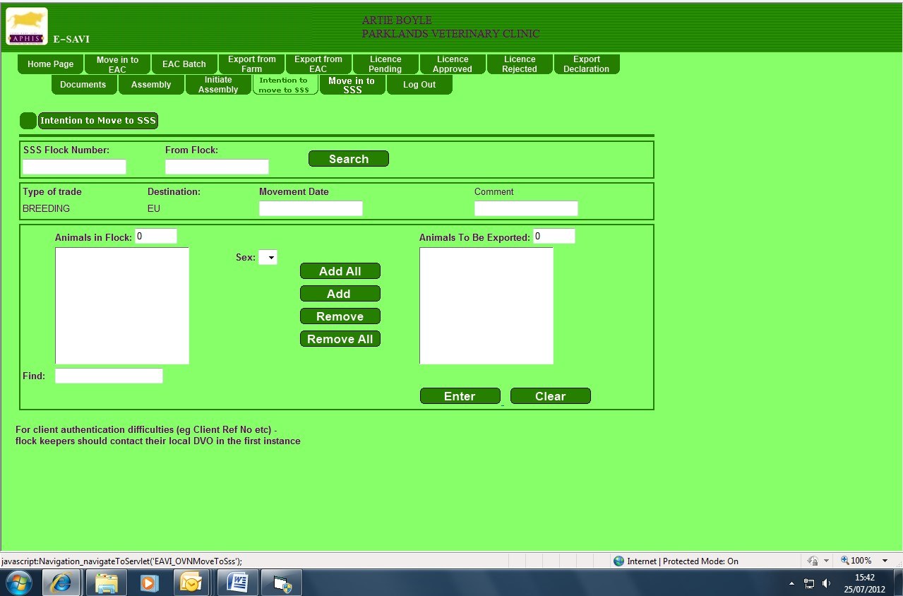

The aPVP inputs the flock/herd number of the EAC where the sheep sale will be held into the “SSS flock number “ box and the flock/herd number from which the animals are intended to move into the “from flock” box.

The system will confirm the name and address of the SSS.

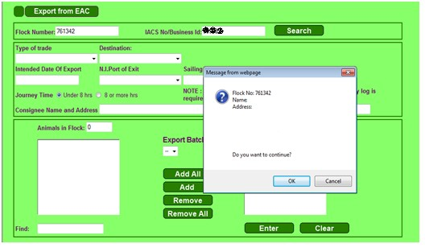

Hit “**OK**”. The list of animals in the flock/herd will appear in the left box. Enter the date the animals will be moving to the SSS into “Movement date” box. This can be up to 10 days before the sale. Select and add the tag number of each animal going to the special sale, specifying its sex M or F, before adding into the right hand box.

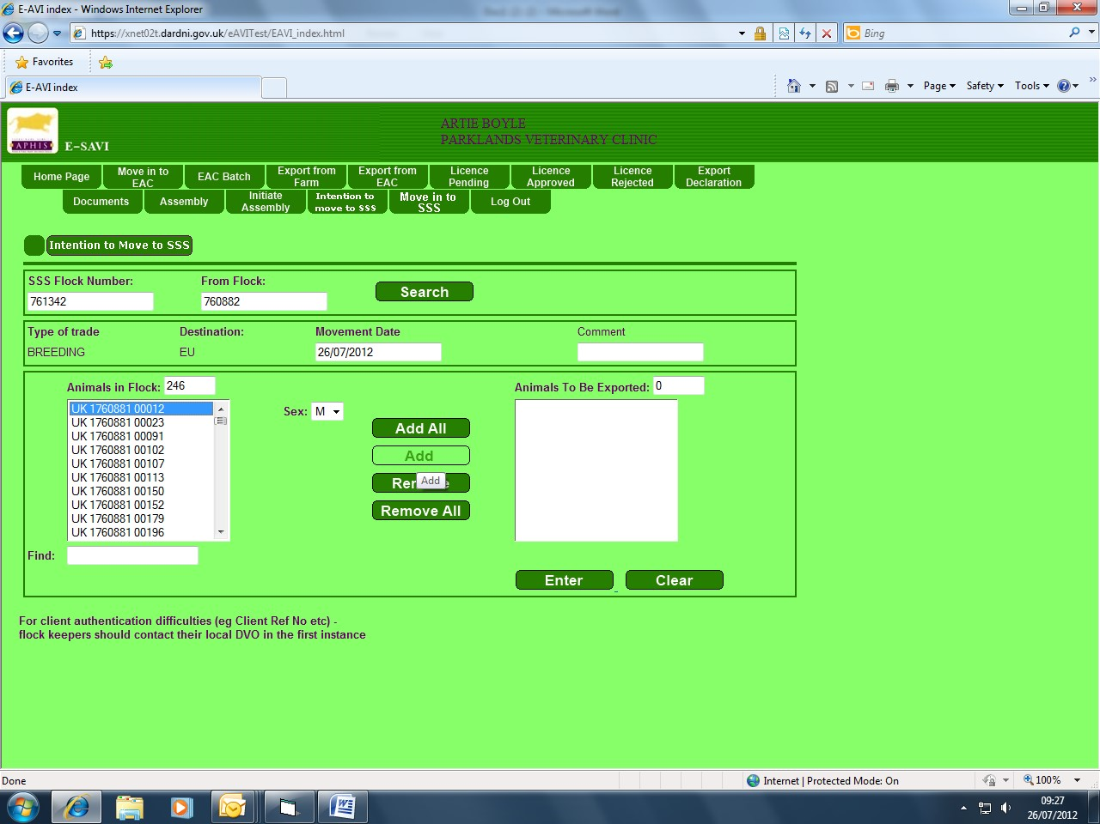

When ‘E**nter**’ is clicked, checks are done to ensure that the animals selected are eligible.

If the animal numbers selected pass the eligibility checks and a Veterinary Service Support Certificate is approved by a DAERA veterinary officer, the following message box will appear, provided the flock is registered with DAERA under the Scrapie Monitored Flock Scheme. Provided you have seen a certificate of Scrapie Monitored Flock Scheme (SMFS) Controlled Risk status or Scrapie Monitored Flock Scheme (SMFS) Negligible Risk status or Scrapie genotyping certificate Click **OK** to create a licence.

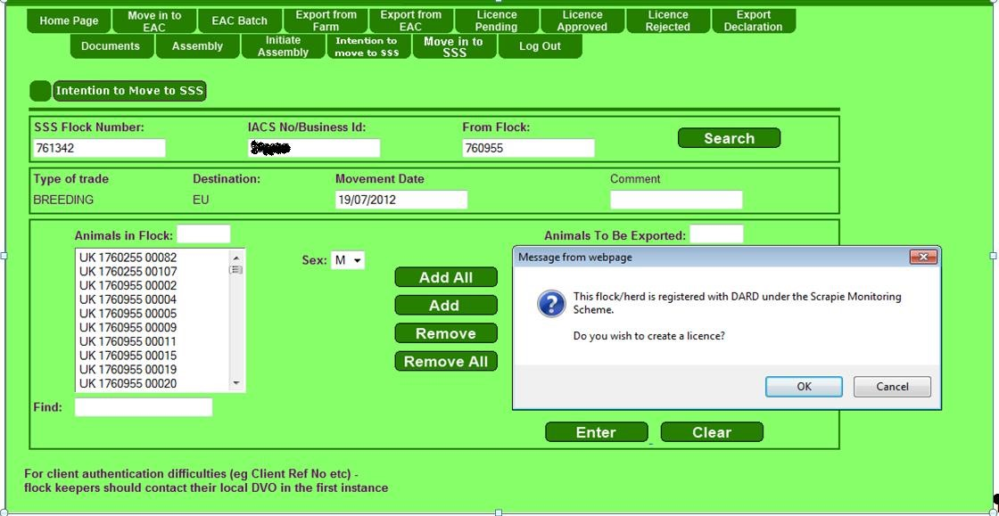

If the flock is not registered under the Scrapie Monitored Flock scheme the following message appears stating the aPVP must be in possession of Scrapie genotype certificates which confirm the animals to enter the sale are genotyped.

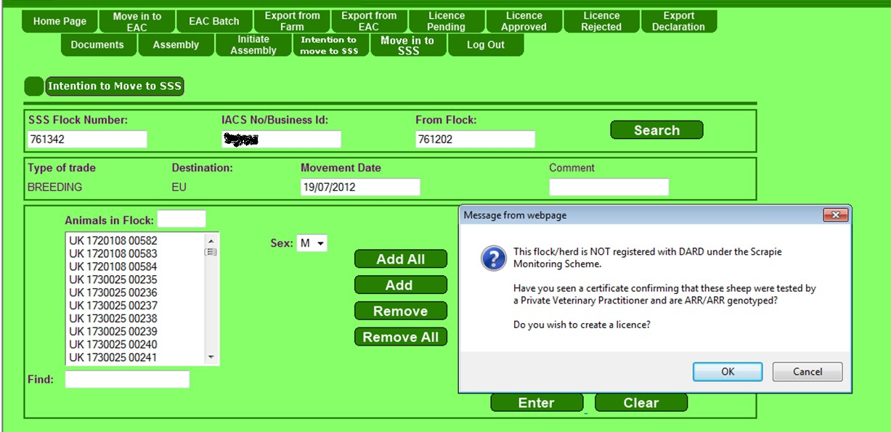

If the aPVP clicks **OK** to create a licence, the following message will appear to state that the licence has been created.

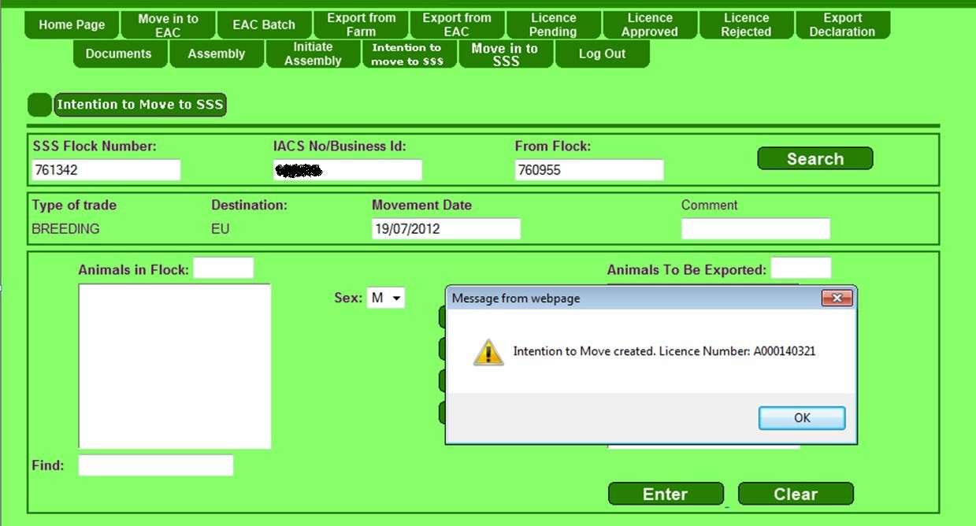

Click **OK.**

When the intention to move is created, it will then appear on the ‘**Licence Approved**’ tab from where the licence and support certificate can be printed. The notification will be valid for 10 days from the date it was created.

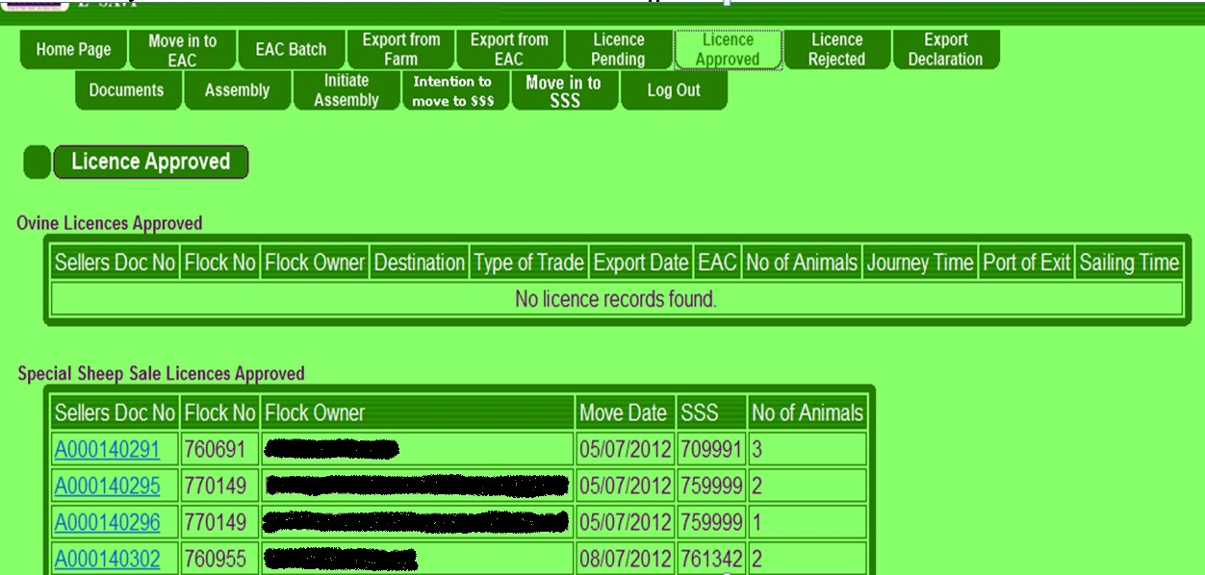

The documents can be accessed and printed by clicking on the **Sellers Document No**. which is the blue ‘**A’ number** underlined in the left hand column.

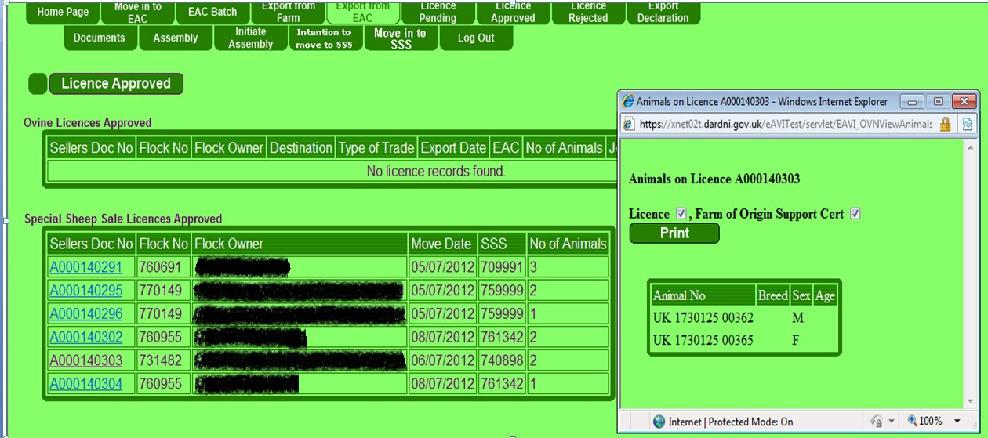

By clicking ‘**Print**’ the movement licence and farm of origin support certificate can be printed.

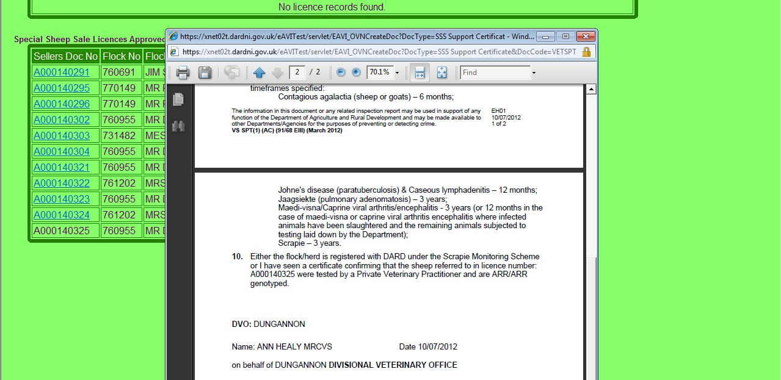

Once approved, the animals can be presented to the SSS any day up until 10 days after the notification was created. Animals can be presented before or after the proposed move date, within the 10 day validity of the ‘A’ document.

When the animals are actually presented at the SSS, the export checks will be carried out again to ensure nothing has changed to affect movement eligibility and the animals can then move into the SSS.

# 4. Procedure for Initiation of Special Sheep Sale by the Sale aPVP

The special sheep EAC sale must be pre-initiated and should be set to a **Destination** of **‘EU’** for **Type of Trade** ‘**Breeding**’.

Hit **‘Initiate Assembly’** on eSAVI. Enter **EAC Number** and **Business ID**

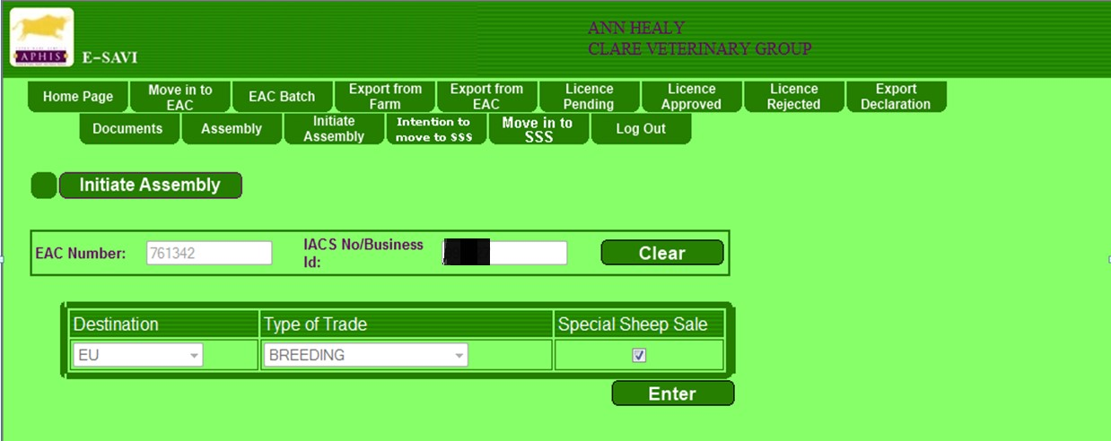

This brings up a screen with a check box **Special Sheep Sale**. Click on this check box so that a tick appears. The “**Destination**” drop-down will default to **EU** and the “**Type of Trade**” drop-down will default to **BREEDING**. It will not be possible to edit either drop-downs while the Special Sheep Sale check box is selected.

Hit “**Enter**”. A message will appear showing that the application has been sent to the DVO for approval.

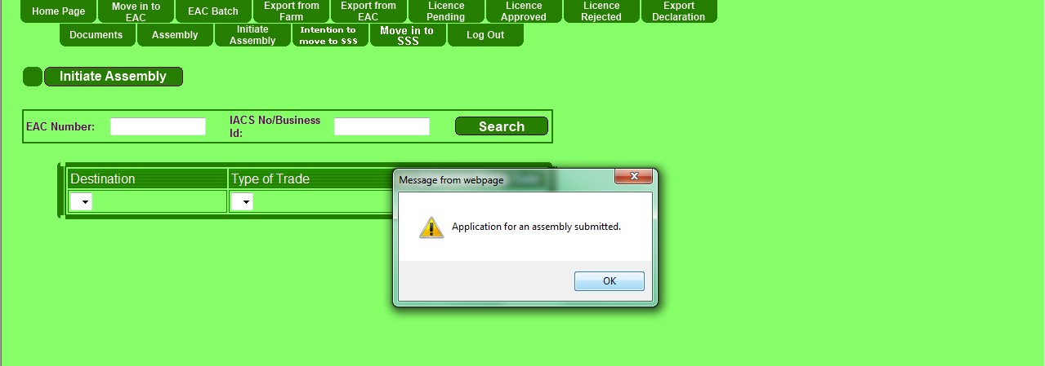

**It will not be possible to move sheep to an SSS either by eSAVI or the web service, until the sale has been approved at the DVO on main APHIS.**

Once approved by a Veterinary Officer of DAERA, the assembly centre support certificate will be available for printing via the ‘**Assembly**’ tab.

On clicking the ‘**Assembly**’ tab the following screen appears (hit “**ok**” on the message which flashes up to confirm the name and address of the SSS).

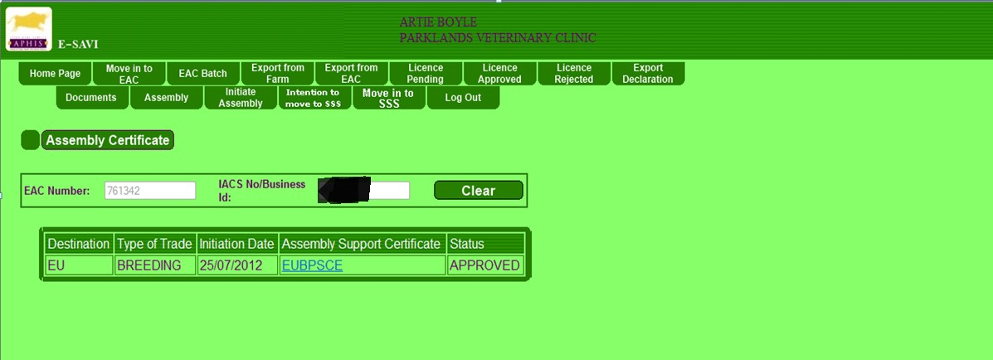

Click on “**EUBPSCE**” in the **Assembly Support Certificate** column. This will bring up the Assembly Centre Support certificate for printing.

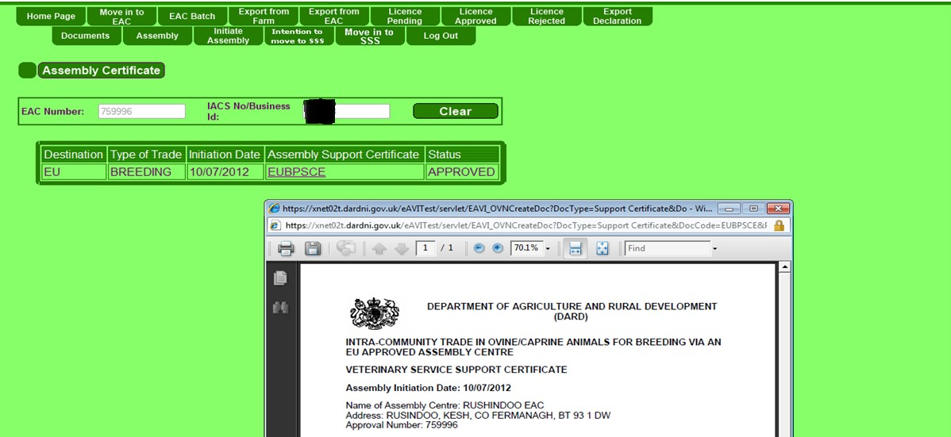

**5. Procedure for entry of animals to a CPR EAC**

**N.B.** a **CPR EAC** isA WEB ENABLED export assembly centre which meets the conditions for approval as a Central Point of Recording and **has the software** to electronically **scan the animals tags** numbers and upload them to the EAC flock/herd on APHIS thereby performing the **eligibility checks for export of breeding sheep & goats to the EU** in the process.

The animals should arrive at the EAC accompanied by:

* 1. Veterinary Service Support Certificate (VSSPT)
  2. Movement Licence (No longer a need for a self-written SG2 document)
  3. Owner’s Declaration
  4. A certificate of Scrapie Monitored Flock Scheme (SMFS) Controlled Risk status or Scrapie Monitored Flock Scheme (SMFS) Negligible Risk status or a Scrapie genotyping certificate.
  5. Results of Brucella ovis testing of rams (if done on farm –at some sales this can be done if required at the EAC)

* **Prior to entry** of the animals to the EAC the operator scans the tags on to the EAC system and uploads to APHIS.

* APHIS checks IDs against Movement Licence and confirms eligibility for export.

**These steps should be done prior to entry of the animals into the EAC to ensure that ineligible animals do not enter the EAC and jeopardise the whole sale.**

* If all in the batch are OK, all may physically enter the EAC.

* If any in the batch are ineligible, then none should be allowed to physically enter the EAC.

**6. Procedure for entry of animals to a Non CPR EAC**

**N.B**. a **Non CPR EAC** is an Export Assembly Centre which does **not** meet the definition of a CPR EAC given at **Section 5**

The animals should arrive at the EAC accompanied by:

* 1. Veterinary Service Support Certificate (VSSPT)
  2. Movement Licence (No longer a need for a self-written SG2 document)
  3. Owner’s Declaration
  4. A certificate of Scrapie Monitored Flock Scheme (SMFS) Controlled Risk status or Scrapie Monitored Flock Scheme (SMFS) Negligible Risk status or a Scrapie genotyping certificate.
  5. Results of Brucella ovis testing of rams (if done on farm –at some sales this can be done if required at the EAC)

* **Prior to entry to the EAC** the operator should read the tag numbers and check off against the movement licence.
* If the numbers are correct the aPVP for the EAC using eSAVI should move the animals into the EAC flock/herd (see section 6.1)
* At this point APHIS will again carry out eligibility checks.

**These steps should be done prior to entry of the animals into the EAC to ensure that ineligible animals do not enter the EAC and jeopardise the whole sale.**

* If all in the batch are eligible, all may physically enter the EAC.
* If any in the batch are ineligible, then none should be allowed to physically enter the EAC otherwise the animals already in the EAC will become ineligible.

## 6.1 eSAVI Procedure for entry of animals to Non-CPR EAC

A new tab “**Move in to SSS**” has been added to eSAVI to allow the animals to be moved into the EAC flock/herd.

/herd.

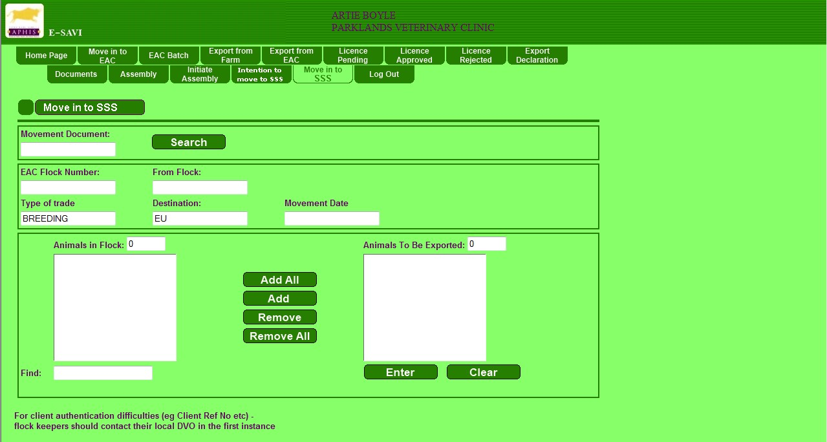

The user only needs to key in the “Advance Notification Number” into the ‘**Movement Document**’ box and hit **Search**. All the other boxes will be automatically completed by the system using the information already provided by the aPVP or DVO.

When the ‘**Search**’ button is selected, the system will ensure that the movement is to an SSS that has been initiated and approved; and the movement document is valid i.e. unused and created within the last 10 days.

If the movement document is not valid an error message will be displayed.

If the movement is valid, then the SSS name and address will be displayed for confirmation.

(All boxes are pre-populated with the information retrieved from the system).

On the actual movement screen, it will be possible to de-select animals so that they are not moved into the SSS, but it will not be possible to add any animals to the movement.

Select those animals moving into the SSS and add them across to the box on the right hand side.

When you click ‘**Enter**’ the eligibility checks will be done again to ensure the animals are still eligible for entry. If the animals are still eligible you will get a message saying the movement has been recorded.

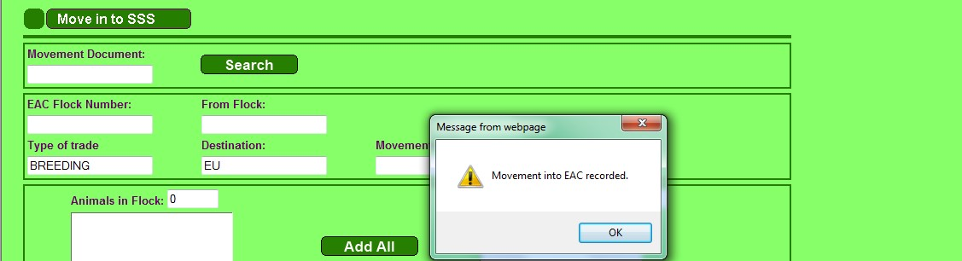

## 7. Procedure for Moving Animals out of a Special Sheep Sale

The user will need to select the **Type of Trade** and **Destination** from the drop-downs.

In other words animals can be permitted out of the EAC to EU or GB at any time without the need for GB animals to wait until all animals to EU/ROI are processed first.

Please note: the **Type of Trade** drop-down will not contain Slaughter or Fattening since animals in an SSS will only be exported for Breeding,

Hit “**Export from EAC**” tab. When the flock/herd number and business id is inputted**,** the name and address of the sale is displayed for confirmation.

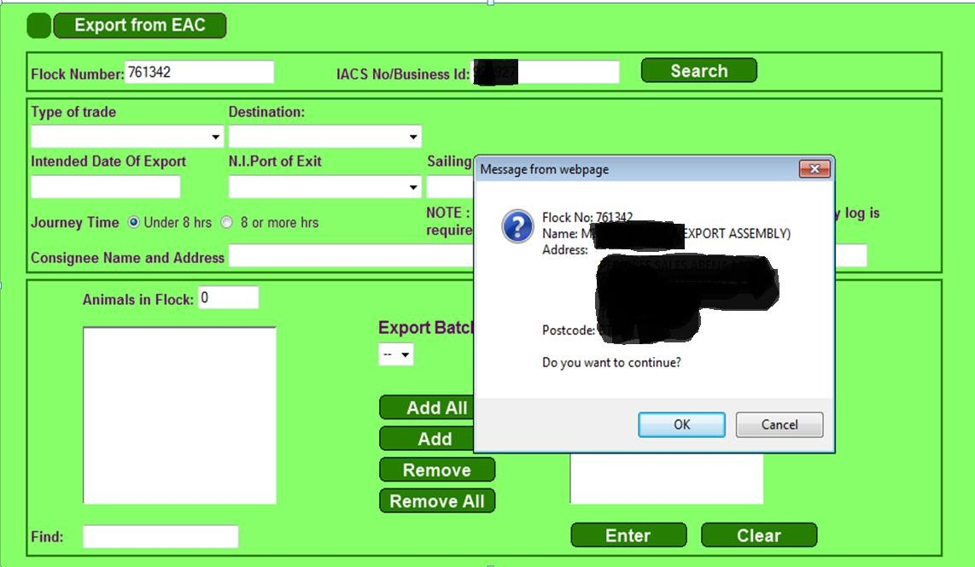

Click “**OK**” and the following screen appears.

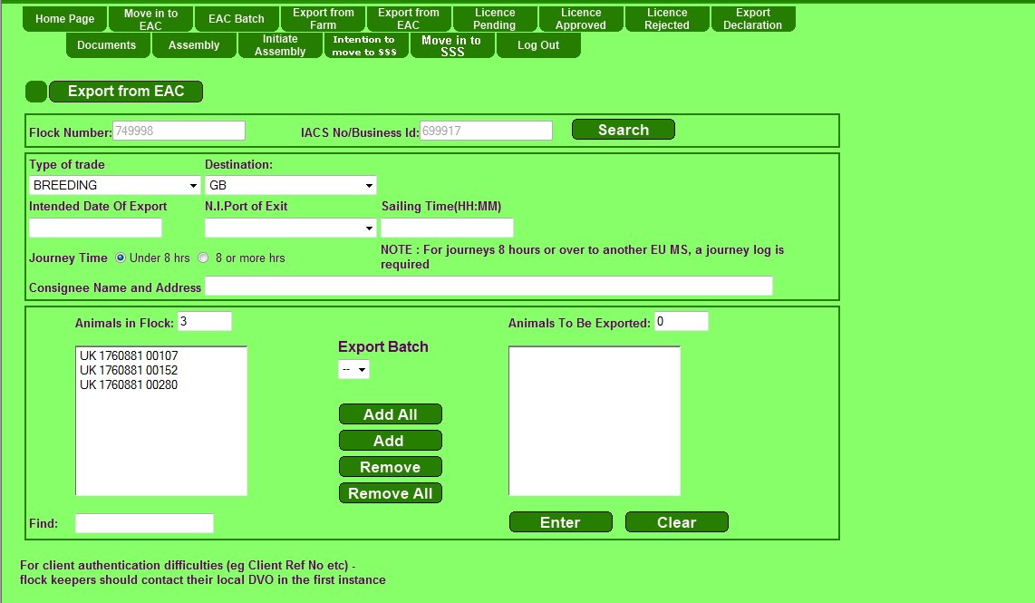

This screen allows the aPVP to change the **Type of Trade** and **Destination**. The screen default which automatically appears is GB and breeding. **Be careful, you must change this every time as this screen default will be the wrong combination!**  Choose either EU with Breeding OR GB with Breeding and Production.

Select the required animals from the SSS flock/herd list on the left and use the “**Add**” button to transfer them across to the ”**Animals to be exported**” box on the right as shown below:

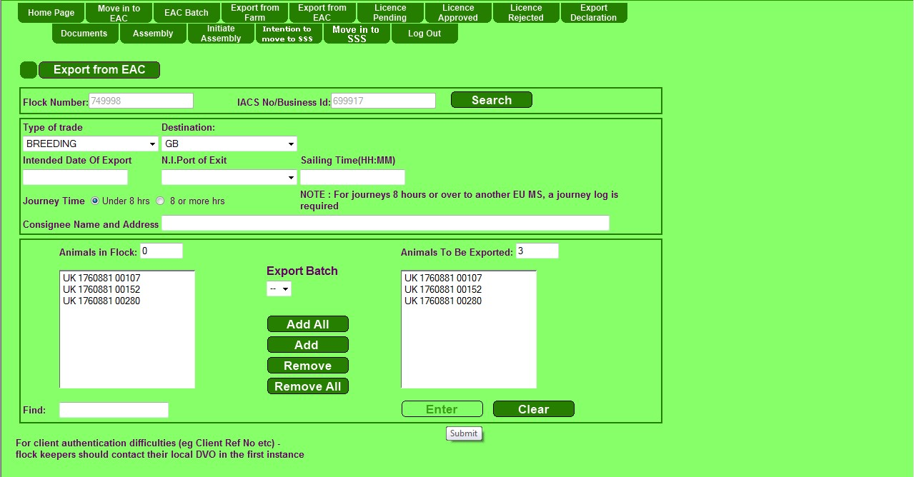

Complete the additional details for the move out of the sale; **Intended date of Export**, **Consignee Name and Address** (this is the destination name and address that will appear on the licence) and (if applicable) **NI Port of Exit** and **Sailing Time**.

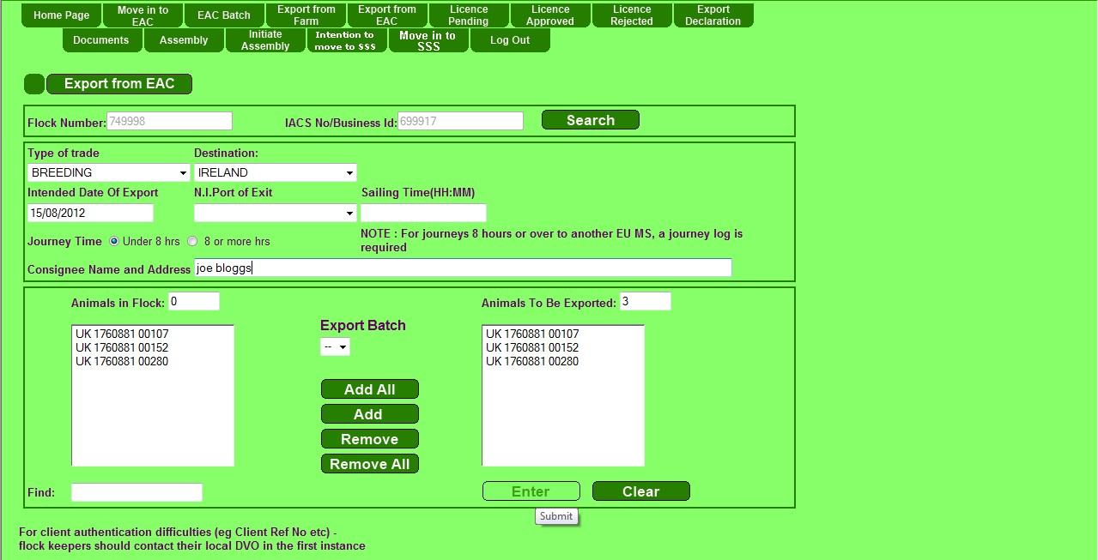

Hit “**Enter**” and a message will appear telling you that the licence for the move out of the sale is ready for printing.

Open the “

**Licence Approved**

” tab and the licence will appear as a blue “A”number.

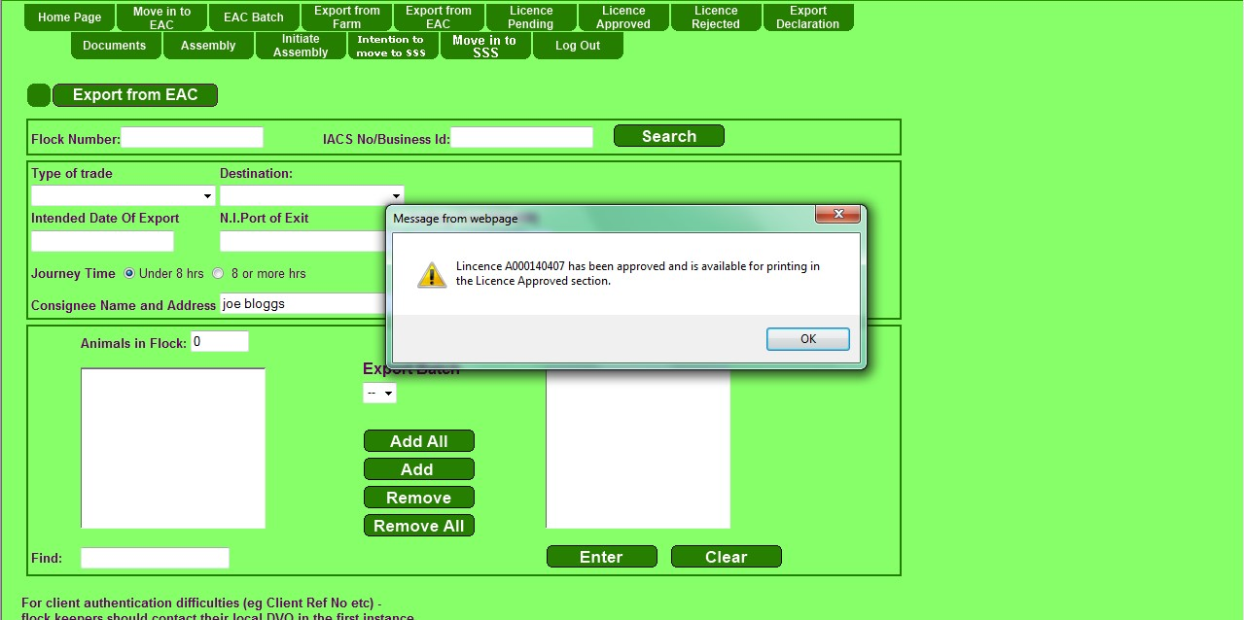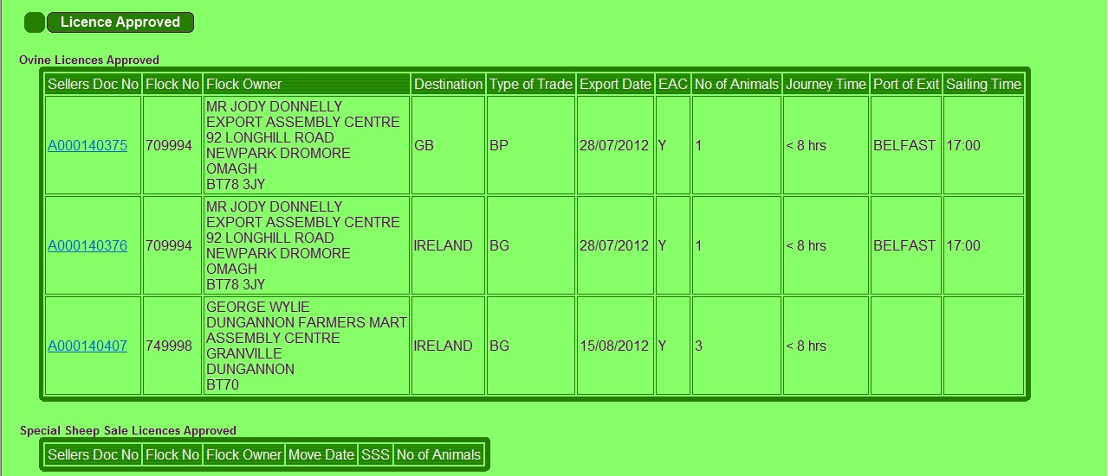

Click on the blue licence number to allow printing. A pop up screen will show the animals on the licence. Click “**Print**” to print licence.

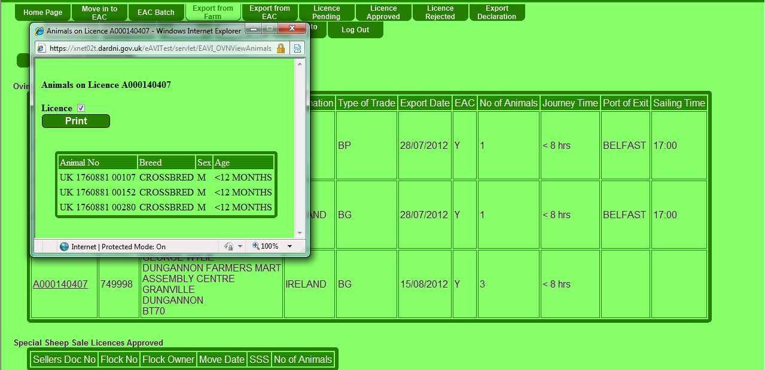

This licence should be signed and the original must accompany the exported animals along with the original Export Health certificate. These are the only two aPVP generated documents that travel with the exported animals. A “true” copy of each should be retained by the aPVP - (The exporter will need either an Animal Transport Certificate or a Journey Log, depending on the destination, to fulfil welfare requirements).

The export health certificate can be obtained for GB exports by printing directly from the eSAVI website using the “**Documents**” tab. For Exports to the EU the Intra Trade Animal Health Certificate must be printed off from the TRACES NT website. For all exports a TRACES number is required to complete the final stage, which is the declaration confirming the movement out of the sale.

## 8. Declaration of the Export

The final step in the process is the declaration of the export. This must be done after the aPVP has inspected the animals for fitness for export.

Open the “

**Export Declaration tab**

”

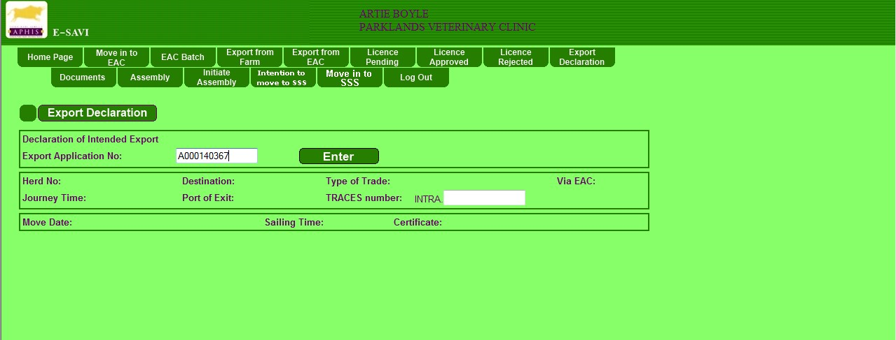

Input the Licence number for the move out of the SSS and hit “**Enter”**. This will bring up the screen below.

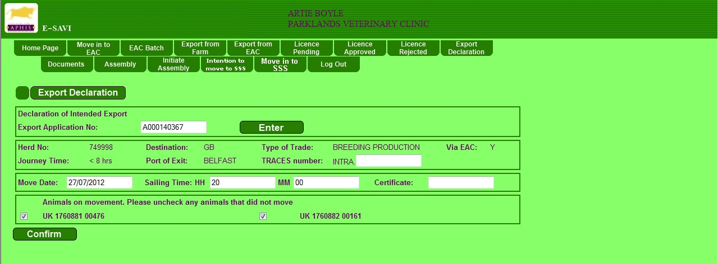

Enter the TRACES number in the box marked “INTRA”, in the format AA.1234.1234567 as TRACES no longer used for GB exports enter dummy ref, i.e. **GB.1234.1234567**. Enter the certificate number of the GB or EU export health certificate.

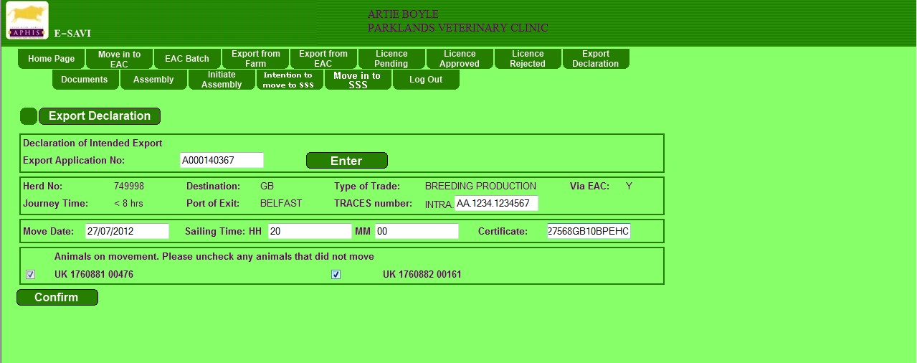

Any animals which were not exported should be removed by unticking the small box which appears beside their number. **Note, these animals will remain in the sale flock list until a fault report requesting their removal has been sent to APHIS SUPPORT UNIT and has been processed**.

Hit confirm to move the animals out of the SSS to export.

Before the system will confirm the move it requires you to complete the **Annex 10 Checklist** as per the screenshots below.

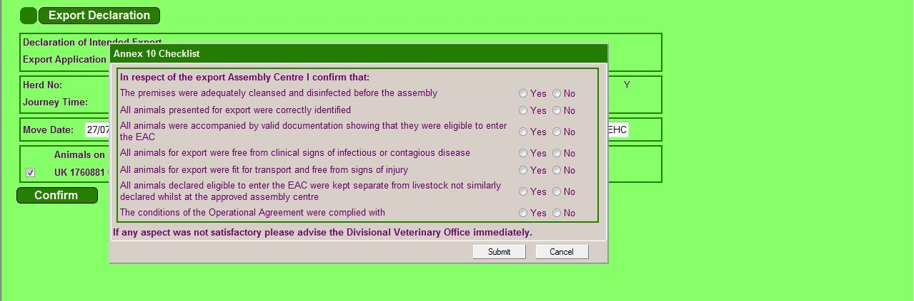

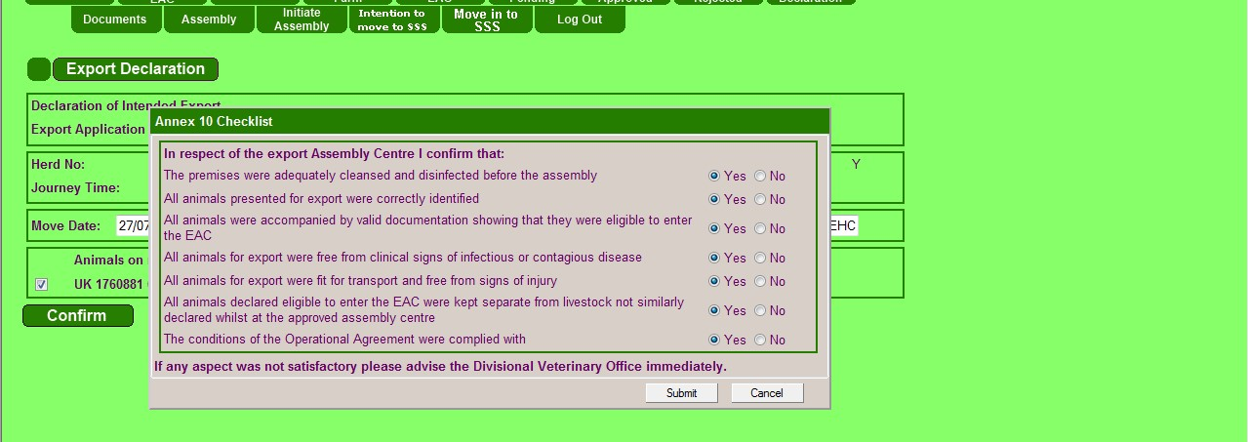

When the **Annex 10 Checklist** has been submitted the following message will appear, allowing you to print the Annex 10 document.

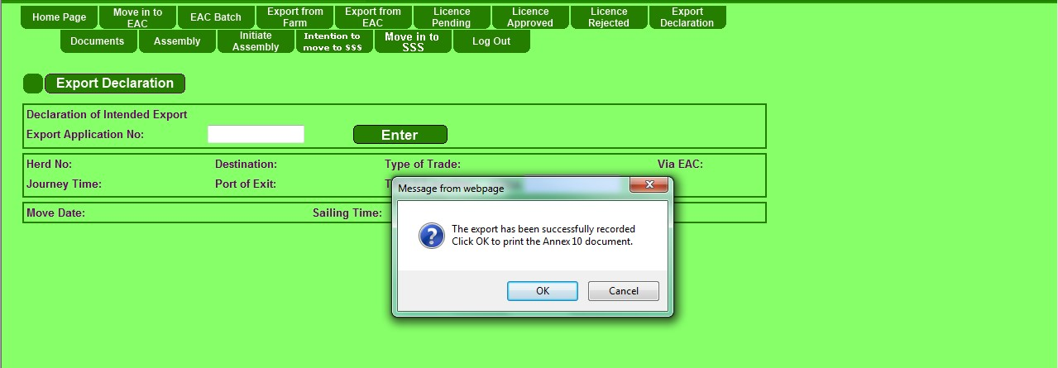

The system will produce a message that the export has been successful. When there are no remaining animals it will invite you to close the assembly.

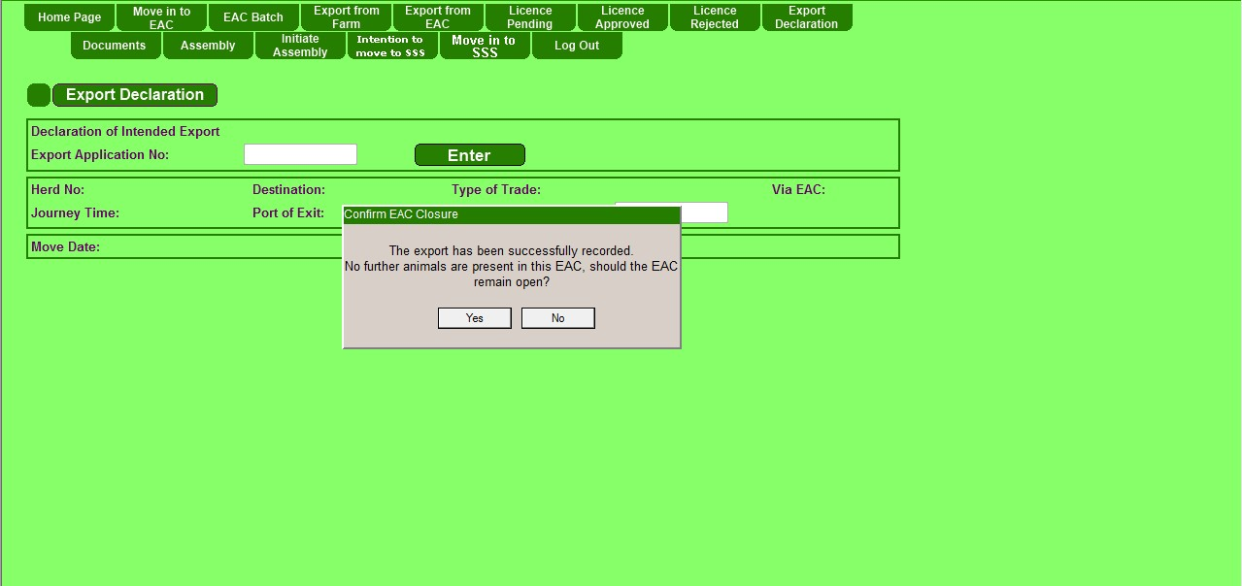

1. CPR = Central Point of Recording