Authorised Laboratory –
Monthly Test Summary

The Control of Salmonella in Poultry Flocks

Animal Disease Control and Policy  Jubilee House  111 Ballykelly Road  Ballykelly  Limavady, BT49 9HP | 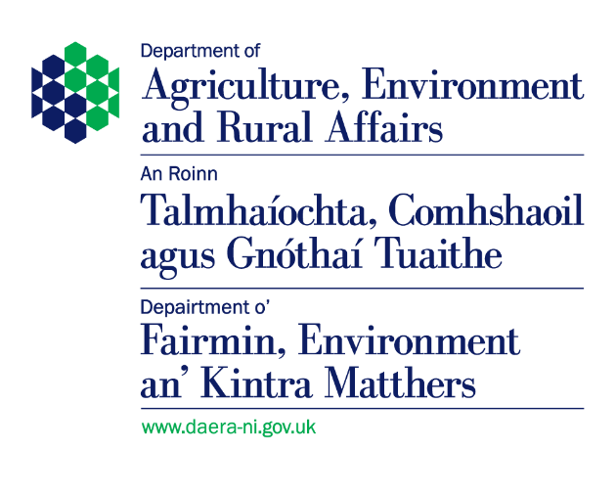

1. Month:
2. Name of
Laboratory:
3. Full postal
address:

The Control of Salmonella in Poultry Scheme Order (Northern Ireland) 2008
.
4.1 Registered chicken breeding flocks: Grandparent

Sample details* | Type of sample  (No. pooled for  analysis) | Number of  composite  samples tested | Total No.  Salmonella  positive | No.  Salmonella  Typhimurium | No.  Salmonella  Enteritidis | No.  Salmonella  Hadar | No.  Salmonella  Infantis | No.  Salmonella  Virchow
bird age
Day old | box liners (min. 10 per supply source)
Day old | dead on arrival  (all - up to max 60)
4 weeks  of age | 2 pairs boot swabs OR
 | composite faeces (min 60)
Pre  point-of-lay | 2 pairs boot swabs OR
composite faeces
(min 60)
Production  Period (every 2 / 3 weeks) | 5 pairs bootswabs OR
1pair bootswabs plus 900 cm² dust swab
OR
 | composite faeces (min 300)

4.2 Registered chicken breeding flocks: Parent

Sample details* | Type of sample  (No. pooled for  analysis) | Number of  composite  samples tested | Total No.  Salmonella  positive | No.  Salmonella  Typhimurium | No.  Salmonella  Enteritidis | No.  Salmonella  Hadar | No.  Salmonella  Infantis | No.  Salmonella  Virchow
bird age
Day old | box liners (min. 10 per supply source)
Day old | dead on arrival  (all - up to max 60)
4 weeks  of age | 2 pairs boot swabs OR
 | composite faeces (min 60)
Pre  point-of-lay | 2 pairs boot swabs OR
composite faeces
(min 60)
Production  Period (every 2 / 3 weeks) | 5 pairs bootswabs OR
1pair bootswabs plus 900 cm² dust swab
OR
 | composite faeces (min 300)

The Control of Salmonella in Poultry Scheme Order (Northern Ireland) 2008

5. Registered commercial egg-laying laying flocks:

Sample details* | Type of sample  (No. pooled for  analysis) | Number of  composite  samples tested | Total No.  Salmonella  positive | No.  Salmonella  Typhimurium | No.  Salmonella  Enteritidis | No.  Salmonella  Hadar | No.  Salmonella  Infantis | No.  Salmonella  Virchow
bird age
Day old | delivery box liners (min 10 per supply source)
Day old | dead on arrival  (all - up to max 60)
Pre  point-of-lay | 2 pairs boot swabs OR
 | composite faeces (min 60)
Production  Period (every 15 weeks from 22-26 weeks of age) | composite faeces (2x150g naturally pooled  OR
 | 2 pairs boot swabs

Please note section 6 is not compulsory and can be filled in on a voluntary basis.

6. Registered chicken hatcheries:

Sample  details | Type of sample  (No. pooled for  analysis) | Number of  composite  samples tested | Total No.  Salmonella  positive | No.  Salmonella  Typhimurium | No.  Salmonella  Enteritidis | No.  Salmonella  Hadar | No.  Salmonella  Infantis | No.  Salmonella  Virchow
bird age
Day old | meconium (min 250)
Day old | mortalities or culls (min 50 – or all available if less)
Egg | dead in shell (min 50 – or all available if less)
Fluff/  hatchery debris | sample, or fabric swab from hatchery at take-off

The Control of Salmonella in Broiler Flocks Scheme Order (Northern Ireland) 2009

7. Registered broiler flocks:

Sample details | Type of sample  (No. pooled for  analysis) | Number of  composite  samples tested | Total No.  Salmonella  positive | No.  Salmonella  Typhimurium | No.  Salmonella  Enteritidis | No.  Salmonella  Hadar | No.  Salmonella  Infantis | No.  Salmonella  Virchow
bird age
Within 3 weeks before slaughter | 2 pairs boot swabs

The Control of Salmonella in Turkey Flocks Scheme Order (Northern Ireland) 2010

8. Turkey Fattening Flocks:

Sample details* | Type of sample  (No. pooled for  analysis) | Number of  composite  samples tested | Total No.  Salmonella  positive | No.  Salmonella  Typhimurium | No.  Salmonella  Enteritidis | No.  Salmonella  Hadar | No.  Salmonella  Infantis | No.  Salmonella  Virchow
bird age
Within 3 weeks before slaughter in holdings >500 | 2 pairs boot swabs – (samples may be pooled for testing)  OR
1 pair boot swabs and 1 900 cm² dust swab (samples may be pooled for testing)
OR
 | Four hand held 900 cm² faecal swabs if <100 turkeys and boot swabbing is impractical

9.1 Turkey Breeding Flocks (Rearing):

Sample details* | Type of sample  (No. pooled for  analysis) | Number of  composite  samples tested | Total No.  Salmonella  positive | No.  Salmonella  Typhimurium | No.  Salmonella  Enteritidis | No.  Salmonella  Hadar | No.  Salmonella  Infantis | No.  Salmonella  Virchow
bird age
Day old | 10 poult box liners per hatchery source plus all poults found dead or culled on arrival
4 weeks  of age | 5 pairs boot swabs – submitted as two batches of 5 individual boot swabs  OR
1 pair boot swabs and 1 900 cm² dust swab (submitted separately)
OR
 | Four hand held 900 cm² faecal swabs if <100 turkeys and boot swabbing is impractical
2 weeks  before  moving to  laying unit | 5 pairs boot swabs – submitted as two batches of 5 individual boot swabs  OR
1 pair boot swabs and 1 900 cm² dust swab (submitted separately)
OR
 | Four hand held 900 cm² faecal swabs if <100 turkeys and boot swabbing is impractical

9.2 Turkey Breeder Flocks (Laying) (Adult: Holding):

Sample details* | Type of sample  (No. pooled for  analysis) | Number of  composite  samples tested | Total No.  Salmonella  positive | No.  Salmonella  Typhimurium | No.  Salmonella  Enteritidis | No.  Salmonella  Hadar | No.  Salmonella  Infantis | No.  Salmonella  Virchow
bird age
Every 3rd  Week during laying  period in holdings  >250 | 5 pairs boot swabs (submitted as two batches)  OR
1 pair boot swabs and 900cm² dust swabs (submitted as two batches)
OR
 | Four hand held 900 cm² faecal swabs if <100 turkeys and boot swabbing is impractical (submitted as two batches)
3 weeks before slaughter  (if not  already sampled  as per  laying flock protocol) | 5 pairs boot swabs (submitted as two batches)  OR
1 pair boot swabs and 900cm² dust swabs (submitted as two batches)
OR
 | Four hand held 900 cm² faecal swabs if <100 turkeys and boot swabbing is impractical (submitted as two batches)

9.3 Turkey Breeder Flocks (Laying) (Adult: Hatchery):

Sample details* | Type of sample  (No. pooled for  analysis) | Number of  composite  samples tested | Total No.  Salmonella  positive | No.  Salmonella  Typhimurium | No.  Salmonella  Enteritidis | No.  Salmonella  Hadar | No.  Salmonella  Infantis | No.  Salmonella  Virchow
bird age
Every 3rd  week during laying  period in holdings  >250 | Visibly soiled liners from 5 hatchers baskets - covering 1 m²  OR
900cm² swab from 5 places in hatchers or hatchers baskets
OR
 | 10g broken eggshells from 25 hatchers baskets (i.e. 250g)
3 weeks  before  slaughter  (if not  already sampled as  per laying  flock protocol) | Visibly soiled liners from 5 hatchers baskets - covering 1 m²  OR
900cm² swab from 5 places in hatchers or hatchers baskets
OR
 | 10g broken eggshells from 25 hatchers baskets (i.e. 250g)

Signed: |  | Date:
Name in  BLOCK letters: |  | Status:

Please return your completed form (including a NIL return) via email to ADC@daera-ni.gov.uk

