R083.6 | 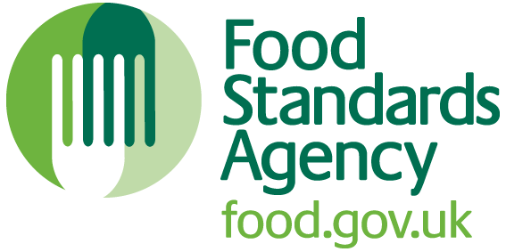

APPLICATION FOR ALTERATION TO A FOOD BUSINESS
ESTABLISHMENT SUBJECT TO REGISTRATION UNDER
REGULATION (EC) NO.852/2004(AS AMENDED)

Please read the following notes carefully before completing the application:

1. Please complete Section A of this form legibly in BLACK INK.
2. This form must only be used by those dairy establishments who are already registered in accordance with the above regulations.
3. Any queries should be addressed to the Inspector at the address below.
4. On completion of this form please return to:

Name and address of AFIB Inspector
[Insert contact details prior to issue]

Telephone:
E-Mail:

- Work should not commence on proposed alterations until the Inspector has agreed to the alterations.

Date received by Milk Inspector: _________ Signed: ____________________

SECTION A

ESTABLISHMENT FOR WHICH ALTERATION IS SOUGHT (current registration details):

Trading name

Registration no.

Postcode:
Full postal
address

FOOD BUSINESS OPERATOR (FBO) DETAILS

FBO Name

Address of FBO

Postcode:
(Where different
from above)

Tel. Number

E-mail

DULY AUTHORISED REPRESENTATIVE OF THE FOOD BUSINESS OPERATOR

Name

Tel. Number

E-mail

DETAILS OF PROPOSED ALTERATION

Does the alteration relate to a change of trading name and/or food business operator? YES NO

If YES provide details in the space below

Does the alteration relate to a change in establishment address or FBO
address?
YES NO

If YES provide details in space below

Does the alteration relate to changing the physical structure of the establishment?
YES NO

If YES provide details in the space provided.

Indicate date of proposed commencement of alterations

SIGNATURE

NAME (Capitals)

POSITION

DATE

DAERA PRIVACY NOTICE
The Department takes data protection, freedom of information and environmental information issues seriously. It takes care to ensure that any personal information received from you is dealt with in a way which complies with the requirements of the General Data Protection Regulations (2016). This means that any personal information you supply will be processed principally for the purpose for which it has been provided.
However, the Department is under a duty to protect the public funds it administers, and to this end may use the information you have provided for this purpose. It may also share this information with other bodies responsible for the audit or administration of public funds, in order
to prevent and detect crime.
In addition, the Department may also use it for other legitimate purposes in line with the General Data Protection Regulations, Freedom of Information Act 2000 and Environmental Information Regulations 2004.
These include:
- administration of the Common Agricultural Policy and other aid schemes
- administration of the Common Fisheries Policy
- the production and safety of food
- management of land and other environmental controls
- animal health and welfare
- statutory schemes and obligations in the areas of plant health and crop certification
- occupational health and welfare
- regulatory and natural resources policy
- environmental policy
- legislation relating to the Northern Ireland Environmental Agency
- the prevention and detection of fraud or maladministration (e.g. use by The Comptroller & Auditor General and HM Revenue & Customs)
- compilation of statistics
- disclosure to other organisations when required by law to do so
- disclosure under the Freedom of Information Act 2000 or the Environmental Information Regulations 2004 where such disclosure is in the public interest
- administration of UK wide schemes on behalf of the Department for the Environment, Food and Rural Affairs in Great Britain
- business development and knowledge advisory service for farmers, growers and food processors
- for corresponding with you in connection with the above activities
The full DAERA Privacy Statement can be viewed on-line at:
https://www.daera-ni.gov.uk/publications/daera-privacy-statement-document

