Animal Disease Control and Policy  Jubilee House  111 Ballykelly Road  Ballykelly  Limavady, BT49 9HP | 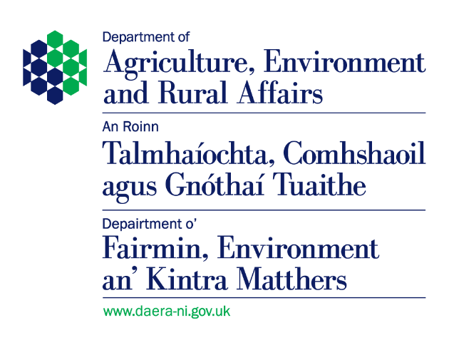

Authorised Laboratory –
Monthly Test Summary

1. Month:
2. Name of
Laboratory:
3. Full postal
address:

4. The Animal By-Products (Enforcement) Regulations (Northern Ireland) 2015
 | Product tested | No. samples tested for salmonella | No. salmonella positive
(a) | Samples received from approved renderer under the EU Regs 1069/2009 and 142/2011

5. The Zoonoses Order (Northern Ireland) 1991
 | Product tested | No. of samples tested | No. salmonella positive
(a) | Samples received from other premises (e.g., a compounder) for other reasons (e.g., code of practice)
(b) | - Vegetable materials:  Oil extracted seed meals  (rape, sunflower, linseed, soya, palm)
 | - All other products of vegetable origin
(c) | Compound feed:  - pig and poultry meals
 | - poultry extrusions
 | - pig extrusions
 | - ruminant compounds
(d) | Protein concentrates
(e) | Minerals/Vitamins/Other additives
(f) | Pet Food

Signed: |  | Date:
Name in  BLOCK letters: |  | Status:

Please return your completed form (including a NIL return) via email to ADC@daera-ni.gov.uk

