daera technical bulletin (2)

September 2017

**This Technical Bulletin aims to provide advice and guidance to farmers and growers affected by the extreme flooding event on 22/23 August 2017, specifically in relation to watercourse management.**

Contents

Introduction 1**.**

Working in Areas of Special Scientific Interest 1

Working in Areas of Fishery Habitat ____________________________________________ 3

Working in Designated Watercourses ___________________________________________ 4

Contact Information  5

## **INTRODUCTION**

At a number of recent flooding meetings, a recurring theme was concerns from farmers and landowners about their uncertainty in relation to watercourse management. This suggested the need for further information/guidance in terms of best practice, the need for permissions/consents and the specific requirements of working in sites that have been designated (for example, Areas of Special Scientific Interest).

This technical bulletin provides additional guidance for farmers along with contact telephone numbers for the relevant government Departments and agencies - Department for Infrastructure (DfI) Rivers, Loughs Agency and the Northern Ireland Environment Agency (NIEA) - who can provide further **site specific advice**.

## **working in areas of special scientific interest (ASSI)**

Areas of Special Scientific Interest (ASSIs) are protected as they represent the best of our wildlife and geological sites.

Before undertaking works in rivers that form part of an ASSI (for example backfilling of river erosion by depositing soil/stones) you may require consent.

If you are unsure whether your land forms part of an ASSI you can check using the DAERA Natural Environment Map Viewer: <https://www.daera-ni.gov.uk/services/natural-environment-map-viewer>.

The online map viewer can be used to locate your land either by scrolling and manually zooming into your land or by inputting a post code or location name close to your area of ownership.

The areas designated as ASSIs can be viewed and activated using the functions on the left side of the map (use button  on the bottom left of the screen to see the applicable functions and to remove them when finished).

If you wish to view more information on the designated site on your land you can click on the area as shown in the screen shot below.

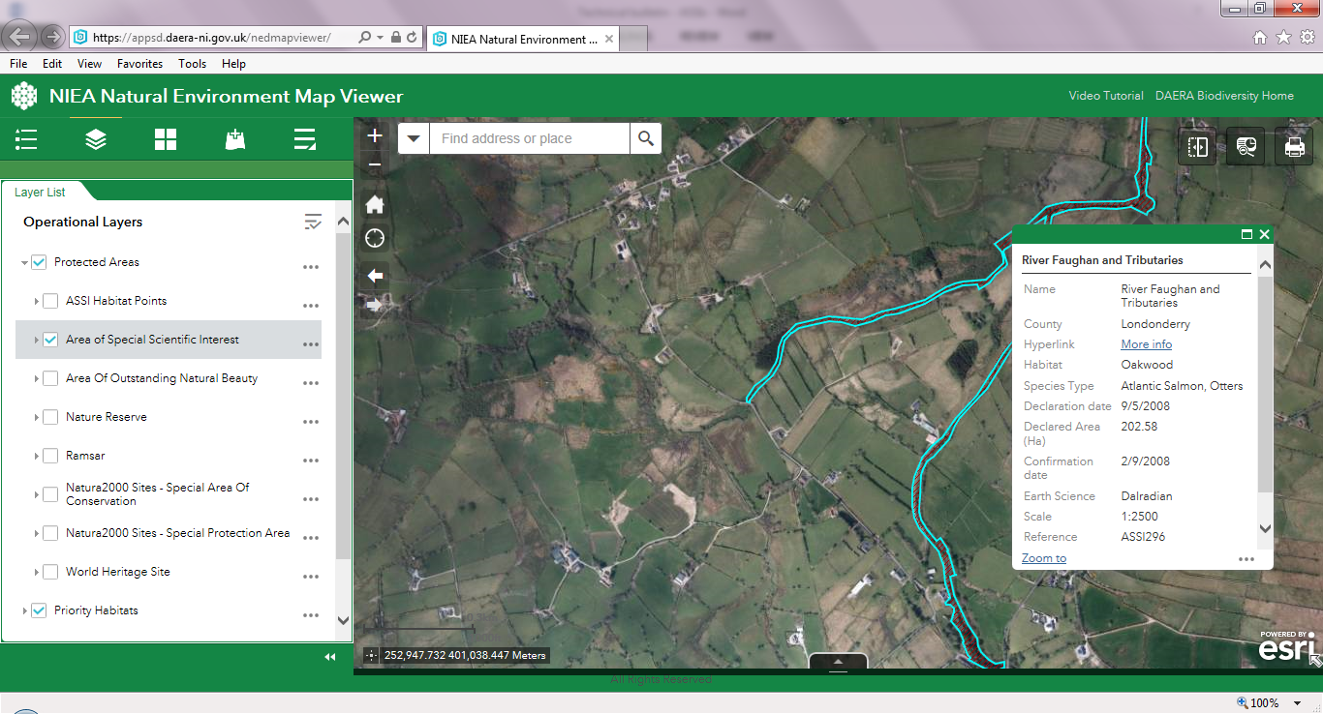

If you require consent, an application form can also be found at: <https://www.daera-ni.gov.uk/publications/request-consent-carry-out-notifiable-operation-assi>.

Hard copies and assistance with completing the application form are available on request by telephoning NIEA Conservation Designations & Protection Team on **028 9056 9516**. **To process your application quickly, provide as much detail as possible including a map**.

## **working in areas of FISHERY HABITAT**

If there are any outstanding issues still to be resolved in relation to getting streams/burns connected to main rivers with a fishery interest, Loughs Agency would appeal to landowners to contact them immediately on[**028 7134 2100**](tel:02871342100) (24 hour number). Loughs Agency staff can offer guidance on how this work needs to be carried out.

On the Owenkillew and Burndennet catchments, which are designated under the Drainage Order, DfI Rivers are currently working on areas that have been blocked or badly affected by landslides.

Where a landowner needs to access the river to remove obstructions, they need to apply to the Loughs Agency for a permit (known as a Section 46 application), in order for the Loughs Agency to access the area and give advice in terms of fishery habitat. The Loughs Agency will endeavour to treat these particular applications as priority.

On the Glenelly Valley catchment, which is not designated under the Drainage Order, there are many obstructions in the main stem. In the case of fallen trees which are causing an obstruction or leading to further flooding, Loughs Agency will allow landowners to remove these from their own lands without having to apply for a Section 46 approval.

In the case of shoals of silt, sand or gravel built up in the main stem channels of fishery rivers, Loughs Agency advice is to leave these, as that substrate is mobile and will eventually get scoured downstream.

## **working in DESIGNATED WATERCOURSES**

There are only two short sections of urban watercourse that are designated in the Glenelly Valley.  These are at Plumbridge village and serve housing developments.  The remaining watercourses including the Glenelly River itself are not designated as defined under the terms of the Drainage (Northern Ireland) Order 1973.   The responsibility for the maintenance of the undesignated watercourses therefore lies with the Riparian/Owners whose lands and property adjoin the respective watercourses.

Affected Riparian/Owners do not need DfI Rivers consent to undertake maintenance on an undesignated watercourse.  However, should someone need to do diversionary works or modify the watercourse that may cause flooding, drainage disadvantage or impede the passage of fish then DfI Rivers approval is required. The application form can be downloaded from <https://www.infrastructure-ni.gov.uk/publications/schedule-6-application-consent-undertake-works-watercourse>

**Farmers/landowners should also be aware of the possible requirement for approvals/consents within an Area of Special Scientific Interest (ASSI). See separate section on working in ASSIs.**

Advice and assistance on individual issues can be offered by DfI Rivers at the local DfI Rivers HQ based in Omagh: **Telephone: 028 8225 4900 or   
Email:** [**rivers.omagh@infrastructure-ni.gov.uk**](mailto:rivers.omagh@infrastructure-ni.gov.uk)

# Contact Information

* NIEA ASSI Advice 028 9056 9516
* Loughs Agency [028 7134 2100](tel:02871342100) (24 hour number)
* Department of Infrastructure Rivers 028 8225 4900 (Omagh office)

# DAERA

DAERA customer helpline is 0300 200 7852 or

[email: daera.helpline@daera-ni.gov.uk](mailto:daera.helpline@daera-ni.gov.uk).

Follow us on Twitter at <http://twitter.com/daera_ni>.

