Final Year students with staff and guests at the 2017 DAERA postgraduate seminar

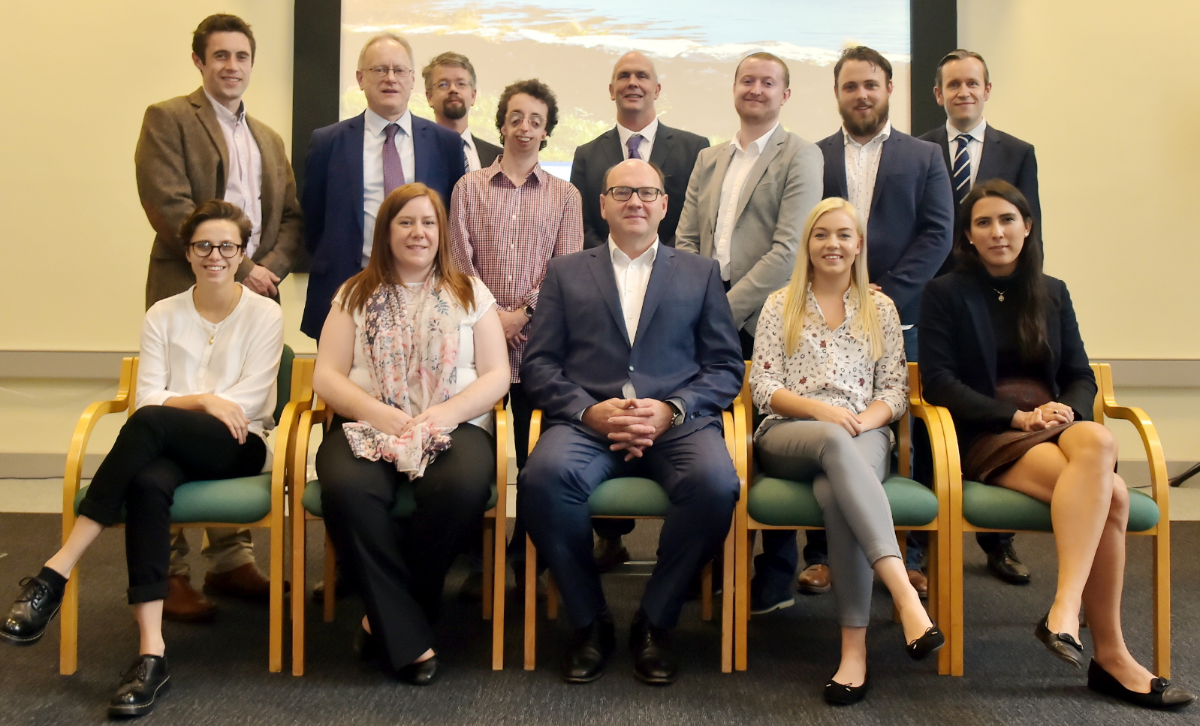Back from left David Johnston, Dr Lance O’Brien (Teagasc), Dr Patrick Murphy (DAERA), James Brown,   
Dr Alistair Carson, (DAERA’s Departmental Scientific Adviser), Kieran Higgins, Donal Griffin, Dr Paul Devine (DAERA).  
Front from left: Josie South, Victoria Murphy, Guest Speaker Professor Nigel Scollan (Director of the Institute for Global Food Security, Queen’s University, Belfast), Christina Mulvenna, Annabel Sharma  
 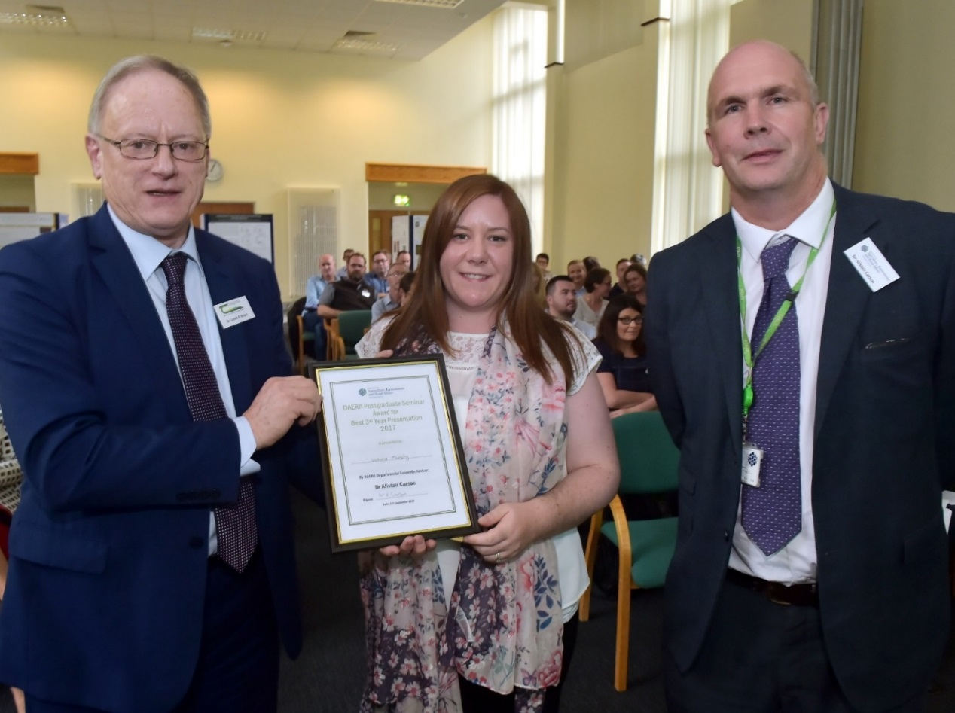

Final Year Student Victoria Murphy receiving her award for Best Presentation from Dr Lance O’Brien, Teagasc.   
 Also pictured is Dr Alistair Carson, Departmental Scientific Adviser who chaired the event.

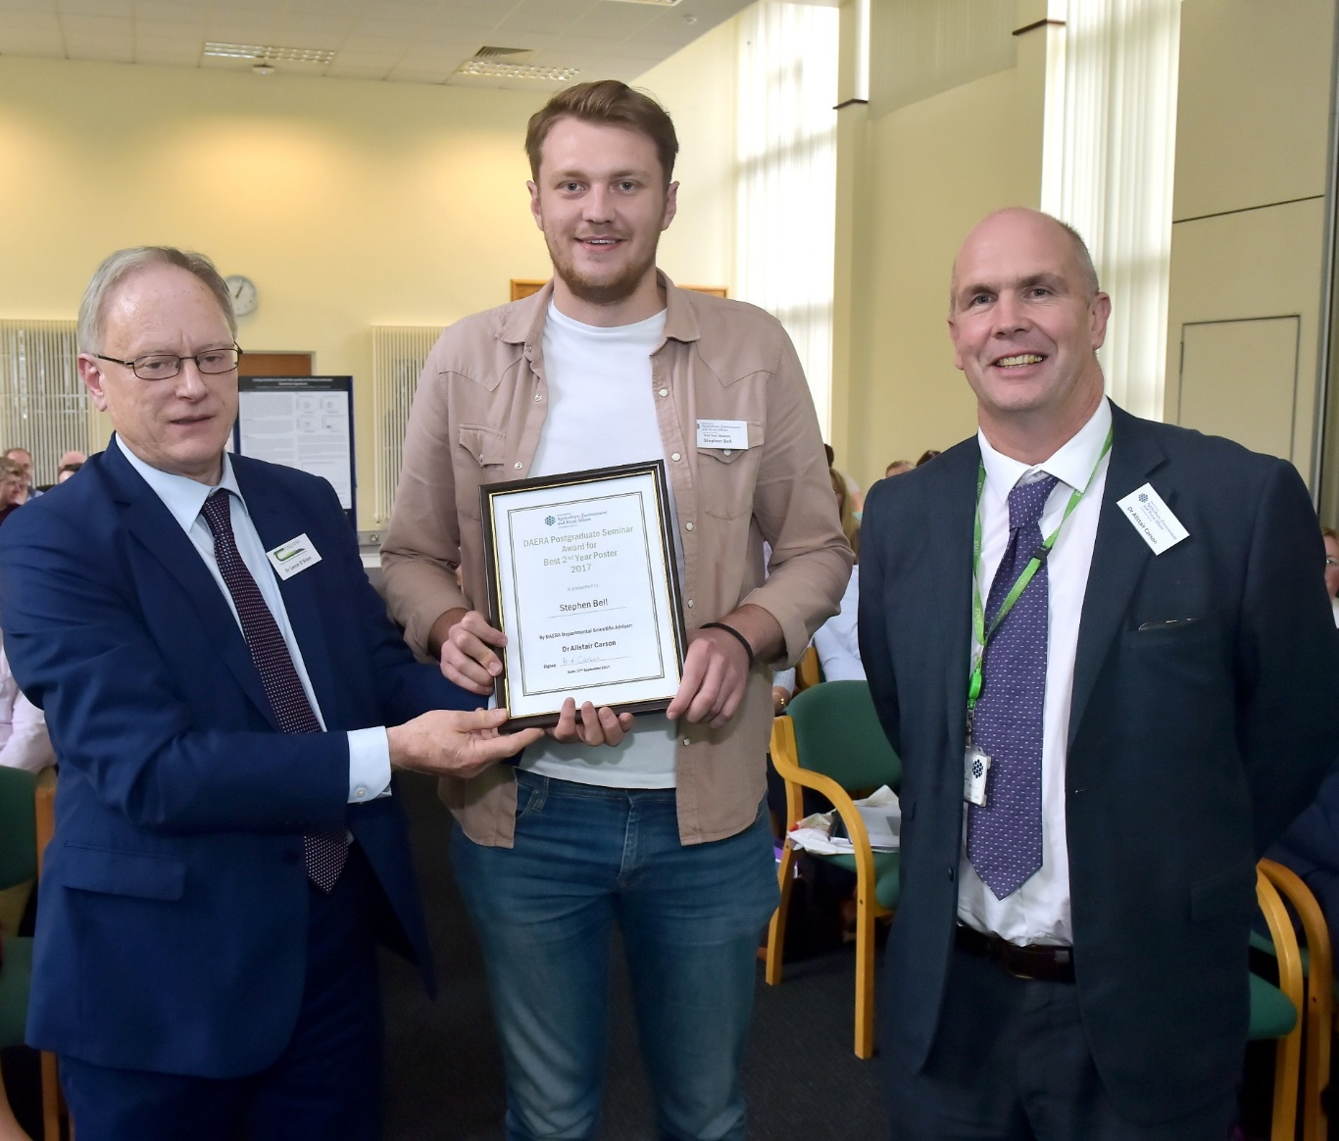

2nd Year Student Stephen Bell receiving his prize for Best Poster from Dr Lance O’Brien from Teagasc.   
 Dr Alistair Carson the Departmental Scientific Adviser is also pictured.