PLANNING CONSULTATIONS

Guidance on the conservation and protection of fisheries and the marine environment

March 2020
This advice note:
- provides an overview of marine policy documents which must be considered when taking development, management or enforcement decisions which affect or might affect fisheries and/or the marine area; and,
- provides guidance on when Marine and Fisheries Division should be consulted.

The UK Marine Policy Statement

The UK Administrations share a common vision of attaining clean, healthy, safe, productive and biologically diverse oceans and seas. To achieve this vision the UK MARINE POLICY STATEMENT was jointly adopted by all administrations in 2011. Other than where it references EU law, it is unaffected by EU Exit. Retained UK law applies.

Accordingly, The UK Marine Policy Statement (MPS) is the key reference document for making decisions capable of affecting the marine area and it is a material consideration. Significantly, this also includes terrestrial decision making by public authorities where those decisions have the potential to affect the marine area.

The UK MPS is explicit regarding integration of terrestrial and marine planning:

1.3.1 The MPS and marine planning systems will sit alongside and interact with existing planning regimes across the UK

1.3.4 Integration of marine and terrestrial planning will be achieved through:

  - Consistency between marine and terrestrial policy documents and guidance;
  - Liaison between respective responsible authorities for terrestrial and marine planning; and
  - Sharing the evidence base and data so as to achieve consistency in the data used in plan making and decisions.
Draft Marine Plan for Northern Ireland

The draft Marine Plan for NI was published for consultation in April 2018. It provides a framework of policies to be considered by public authorities taking decisions which affect or might affect the marine area through decision making processes. It too is a material consideration in this regard.

The plan establishes a vision of “a marine area which is managed sustainably for the economic, environmental and social prosperity of present and future generations” and objectives to realise this vision as follows:

- To promote the sustainable development of productive activities, which support employment at all skill levels while fully considering the requirements of other marine interests.

- To help realise the potential of energy resources and energy storage within the marine area, while fully considering the requirements of other marine interests.

- To promote the development of vibrant, accessible and sustainable coastal communities.

- To promote the marine resource, its recreational value and its wider economic, environmental and social benefits to all.

- To promote the preservation and enjoyment of marine related heritage assets.

- To promote a healthy, resilient and adaptable marine ecosystem and an ecologically coherent network of Marine Protected Areas.

- To contribute towards climate change mitigation and adaptation measures.

- To continue to develop a sound marine evidence base in a co-ordinated manner, to increase understanding and to support the development, monitoring and review of marine plans.

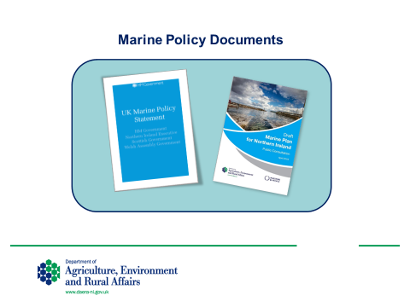

Legal Responsibilities

Of particular relevance to councils and their planning teams are the legal requirements of the Marine & Coastal Access Act 2009 (Art 58), the Marine Act (Northern Ireland) 2013 (Art 8), and the Fisheries Act (NI) 1966. It is detailed in each Act that:

- All public authorities taking authorisation or enforcement decisions that affect or might affect the UK marine area must do so in accordance with the MPS unless relevant considerations indicate otherwise; and
- All public authorities must have regard to the MPS when taking any other decision (e.g. the development of an area plan) which is capable of affecting the UK marine area.

To fulfil the statutory requirements planning officers making authorisation or enforcement decisions that affect or might affect the marine area should fully familiarise themselves with the MPS, available at: https://www.gov.uk/government/publications/uk-marine-policy-statement.

The draft Marine Plan is available at: https://www.daera-ni.gov.uk/sites/default/files/consultations/daera/Marine%20Plan%20for%20NI%20final%2016%2004%2018.PDF

Accordingly, Planning Officers should ensure that the following matters are considered when assessing development proposals:

- Marine ecology and biodiversity (marine flora and fauna; marine habitats or types of marine habitat; features of geological or geomorphological interest).
- Air quality
- Noise
- Ecological and chemical water quality and resources
- Seascape
- Historic environment
- Climate change adaptation and mitigation
- Coastal change and flooding

The detail of these provisions is set out in section 2.6 of the MPS.

Also:
- Protection of fishing waters from poisoning, etc., and pollution
- Protection of young and breeding fish
- Obstructions to passage of fish
- Abstraction of water from rivers and lakes

The detail of these provisions is set out in part IV of the Fisheries Act.

DAERA Marine and Fisheries Division will provide professional advice on sea and inland fisheries, aquaculture and those aspects of the marine area within their policy remit. However, it is for the Planning Authority to ensure that any development capable of affecting fisheries or the marine area is fully assessed in accordance with the Marine Policy Statement and applicable policy, plans and legislation. Marine and Fisheries Division will provide evidence and advice to assist Planning Authorities in making this determination through the NIEA Planning Response Team.

Consulting with DAERA Marine and Fisheries Division on Planning Applications

Consultation with Marine and Fisheries Division is recommended on all applications with the potential to impact sea and inland fisheries (including aquaculture), the marine area, its ecosystem services, and its users. This will require an assessment of land sea interactions (LSI). In using professional judgement to determine if consultation is advisable, Planning Authorities may wish to consider the following definitions:

Land Sea Interactions (LSI)

The land and sea are connected through complex physical, economic and social interactions. There are few activities in the sea that do not have some level of reliance or impact on land. Similarly, activities on land have some level of reliance or impact on the marine area. It is intentional that some proposals should be subject to both marine and land-based licensing/planning regimes. Proposals for ports and harbours, renewable energy and coastal infrastructure, including sewerage services, are some examples where more than one authorisation is required.

Coastal Area

An area of land and sea extending either side of the seashore in which the interaction between the marine and land parts occurs.

Catchment Area

An area of land where rainfall collects and drains into a common outlet, such as into a river, bay, or other body of water, and ultimately into the sea. Land use effects on the water bodies in the catchment often have effects on the coastal area, fisheries, and the marine environment.

Key considerations

You should consider the location and the possible effects of the construction and/or the operation of the proposed activity on marine plan core and activity policies.

Where work is proposed on the coast you should also consider the likely wider impacts on natural coastal processes outside of the site, particular where there is evidence of coastal erosion and/or sea flooding in the area.

Should Marine and Fisheries Division be consulted?

Development type

Does the proposal fall within one of the following development types?

• development involving construction and/or engineering works within or adjacent to marine waters e.g. coastal property and access, marinas, jetties, quays, pontoons, aquaculture, pipelines, and shoreline protection schemes. Any development below the mean high water spring tide mark may require a marine licence from Marine and Fisheries Division (or the UK Marine Management Organisation in the NI offshore area) under the Marine and Coastal Access Act 2009. This intentional overlap with the Planning Act facilitates coordinated joint decision making on intertidal development.

• tidal energy schemes

• dredging and related physical impact activities

• development linked to the marine environment but located inland, for example, a seaweed washing plant located inland but linked to seaweed harvesting, a sand washing facility linked to offshore aggregate extraction, or works at a weir that might impede passage of migratory/ mobile fish to and from the marine area.

Activity

Will the development involve discharge to the marine environment, e.g. via a sea outfall?

Does the development involve works to be conducted in or near marine waters and there is a potential risk that the development will involve construction or operation likely to affect the marine environment as a result of:

• sediment release
• discharge of effluent or spillages of oils/fuels/cement/chemicals or other pollutants
• any temporary or permanent modification to the coastline
• noise disturbance (impacting marine mammals for example)

Further guidance

Guidance relating more specifically to the conservation and protection of salmon and inland fisheries and fish habitat is set out at:

- Conservation and protection of fisheries

Comprehensive guidance is also available on:

- Planning in the Coastal Area
- Salmonid habitat management http://www.nasco.int/pdf/far_habitat/HabitatFAR_NIreland.pdf
- Marine Map Viewer(external link opens in a new window / tab)

Data sources
DAERA Digital Datasets for the Marine Environment:
- WMU Digital Dataset downloads

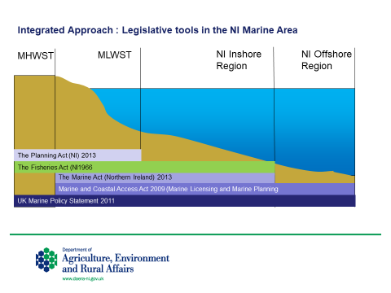
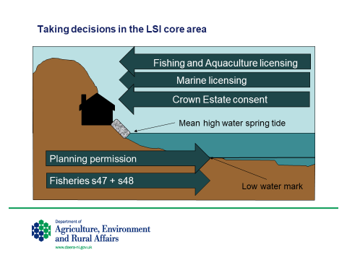
NB) arrows represent the limit of application of the function, e.g. planning permission extends from the land out to low water mark; marine licensing extends from the marine area to high water mark.

http://www.legislation.gov.uk/ukpga/2009/23/part/2
http://www.legislation.gov.uk/nia/2013/10/enacted
http://www.legislation.gov.uk/apni/1966/17/part/IV
Further context is provided in the LSI chapter in the draft NI Marine Plan

