Area-based Schemes Division  Countryside Management Unit |  |  | 
 | Date: 19th March 2024 |  |  | Countryside Management Delivery Branch  2nd Floor,  Molesworth Place  Molesworth Street  COOKSTOWN  Co. Tyrone  BT80 8NX  Telephone: 0300 200 7848  Email: efs@daera-ni.gov.uk  Business ID: xxxxxx

Dear Agreement Holder,
Tranche 7 - Environmental Farming Scheme (EFS) Higher training

You recently accepted an Agreement for the above Scheme with the Department (DAERA). Part of the requirements of the Scheme is that you undertake training for each of the Options and Capital Items that are part of your Agreement. If training is not completed or is not registered correctly, no payment will be made. You must complete the training as soon as possible, and advisably, before you complete the works.

To access your online training, please follow the steps below:

Step 1 Go to https://www.cafre.ac.uk

Step 2 Left click on ‘Student portal (CAFRE Online)’ at the top of the page.

Step 3 You are now on the online log-in page. Your Username is your six figure Business ID (it always starts with 6).

Your Password is PasswordXXX where XXX are the last three characters of your postcode. For example for postcode BT41 4PS, the password will be Password4PS. Where your Business is in the Republic of Ireland the initial is PasswordROI1.

Please note the password is case sensitive e.g. please use both capital and lower case letters where applicable as shown in the example password. When you log in for the first time, you will be prompted to change your password. Make sure you remember this new password.

Step 4 Left click on the ‘Log in’ bar

When you log in to the training website, it will show only the training modules for your individual EFS Scheme Agreement. Please note that if training is not completed or is not registered correctly, no EFS payment will be made.

There are four key steps to each training module that you must complete:-

- The Information Sheet – this contains the full details of the ‘Requirements and Controls’ for the Option or Capital Item.
- The Lesson (training video) – you must watch this presentation, which covers the key ‘Requirements and Controls’.
- The Questions – You must answer the questions correctly to show that your training was successful. You can repeat the questions.
- Press the blue ‘Register that you have finished the training’ button at the end of the questions – this is important as it is used to validate payment.

Once a training module is completed a corresponding badge will appear on your training screen. If you have supplied a valid e-mail address you will also receive a confirmation email.

For more detailed help on how to navigate the training system, including information on how to reset your password you will find the Tranche 7 EFS On-line Guide on the DAERA website at https://www.daera-ni.gov.uk/publications/online-training-efs-agreements-guidance-documents.

Yours faithfully,

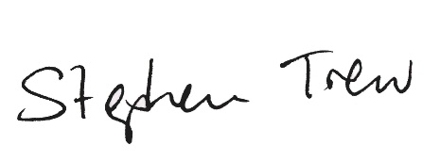

Stephen Trew,
Environmental Farming Scheme Manager

