Strangford Lough Regulation of Anchoring, Mooring and Diving Byelaws 2012
PERMIT APPLICATION FORM FOR DIVING WITHIN THE RESTRICTED ZONE
(Please note there is a separate application form for mooring and anchoring which is available at https://www.daera-ni.gov.uk/publications/strangford-lough-regulation-anchoring-mooring-and-diving-bye-laws)
There are currently no fees for this permit.

It is the responsibility of the applicant to obtain any other consents or authorisations
that may be required e.g., Crown Estate or seabed owner permission. If your proposed development will involve any construction works or deposits on the seabed that will occur within 50 metres of the Mean High Water Spring Tide mark you may require a licence under Part 4 (Marine Licensing) of the Marine and Coastal Access Act. For information on Marine Licensing, please contact the Department of Agriculture, Environment and Rural Affairs (DAERA) Marine Licensing Team MarineLicensingTeam@daera-ni.gov.uk

Important: before completing this form, please read the following documents:

- Location map showing the restricted zone (attached)
- The bye-laws in full can be read and downloaded at: https://www.daera-ni.gov.uk/publications/strangford-lough-regulation-anchoring-mooring-and-diving-bye-laws
- Information on the restoration of Modiolus modiolus (Horse Mussel) reef within Strangford lough: https://www.daera-ni.gov.uk/publications/restoration-and-long-term-monitoring-modiolus-modiolus-strangford-lough

If you require further clarification on issues relating to the Byelaws please contact Marine Conservation and Reporting MarineConservation@daera-ni.gov.uk.

Please allow 4 weeks for us to process your application form. Once we receive your application, we will carry out a site survey to inform our assessment.

PLEASE CHECK CAREFULLY THE INFORMATION YOU HAVE GIVEN AND THAT ALL ENCLOSURES (INCLUDING COPIES) HAVE BEEN INCLUDED (PLEASE TICK)

- Completed application form

- Project drawings (if applicable)

- Maps/charts

- Public Register

Is there any information contained within or provided in support of this application that you consider should not be included on the Public Register on the grounds that its disclosure:

- would be contrary to the interests of national security YES NO

- would prejudice to an unreasonable degree your or some
other person’s commercial interests or those of a third party? YES NO

If YES, to either (a) or (b), please provide full justification as to why all or part of the information you have provided should be withheld.

- Applicant Details

The person, company or organisation making the application.

Title Initials: Surname:
Organisation/Institution to which applicant is affiliated

Department

Position of applicant

Name of supervisor

Address:

Name of contact:

(If different from above)

Telephone number:
(inc. code)

Email address:

- Diving Operator (if applicable)

Any person, company or organisation acting on behalf of or accompanying the applicant during the dive(s).

Title Initials Surname

Trading Title (If different from above)

Business Address:

Name of contact:
(If different from above)

Position within company
(If appropriate)

Telephone number:
(inc. code)

Email address:

Company Registration No.

- Location of proposed dive

This should include either 6 figure Irish Grid Reference (IGR) or Latitude and Longitude co-ordinates (WGS84 to 1 decimal minute) defining the extent of the project

It is important that the correct positions are included with this application, as any errors may result in the application being refused or delayed.

To supplement the information given in section 4, the following must be provided with the completed application form:

- A suitably scaled extract from an Ordnance Survey Map (1:2,500 scale but not more than 1:10,000) or Admiralty Chart which should be marked to indicate.

- The full extent of dive
- Latitude and longitude (or 6 figure IGR) co-ordinates defining the area of operation.

- Dive Details

Number of dives
/ /
Expected commencing date
/ /
Expected completion date

Craft details - number, type, length, horsepower and engine type

- Use and specifications of anchor (if necessary)
We consider that anchorage should only be proposed when absolutely necessary. Please give details of the proposed anchorage location, size/ type of anchor and expected duration of anchorage.

- Purpose of dive(s) (please tick)
- Recreational
- Research
- Purpose of dive and objectives (this section is not applicable to recreational dives)

Please continue overleaf if required.

- Particulars of any fauna or flora or structures or equipment to be deposited in the restricted area (please note this may require a Marine Licence under the Marine & Coastal Access Act 2009)

Please continue overleaf if required.

- Statutory Consenting Powers

Do you, or (if appropriate) your client, have statutory powers to consent any aspect of this project?

Yes / No

If yes, please give details

Signature of applicant:
(or agent acting on behalf of applicant)

Name (Block Letters):

Position within company:
(If applicable)

Date:
/ /

Permit Conditions
- To comply with relevant legislation
- To accept that the permission may be withdrawn at any time
- To remedy, if requested, any matter which is considered to breach the conditions of the permit
- To contact the Strangford Lough Marine Protected Area Manager at the commencement and end of the project/ dive
- To comply with all reasonable requirements of the Department
- To use the restricted zone only for the purpose or purposes specified by the permit and for no other purpose unless so authorised by the Department and to seek prior written approval for any proposed change in the applicants activities
- To comply with other terms and conditions which the Department may see fit to apply to the permit and which is notified to the applicant in writing
- To refrain from entering any private land adjoining the MPA without the permission of the owner or occupier thereof
- To acknowledge the co-operation of the Department in any reports, published papers, etc., resulting from activities undertaken at the MPA
- To forward a copy of all publications, articles, papers and theses to the Strangford Lough Marine Protected Area Manager
- To forward a report of the applicant's activities to the Marine Protected Area Manager at the end of the study period covered by permit from the Department
- To submit dive plans involving scuba diving, if any, to the Marine Protected Area Manager in advance and to submit a Dive Log with report of activities at the end of the study period covered by permit from the Department
- To adhere to all speed limits within Strangford Lough and to avoid the use of anchors within the restricted zone if the applicant's research involves the use of boats
- Not to interfere with (except where covered by permit), or damage flora and fauna of the Strangford Lough and to take particular care to avoid damage to habitats while diving and/or using research equipment underwater
- To get the agreement of the Marine Protected Area Manager prior to introducing research equipment, markers, buoys, transect lines, etc., and to remove all such equipment at the end of the study period.

The Divers’ Code of Conduct

This Divers Code of Conduct was developed by BSAC.
Contact the nearest BSAC Branch or the dive operator local to the dive site for their
advice. Seek advice from them about the local conditions and regulations. If
appropriate, have the correct chart and tide tables for the area to be dived.

On the beach, river bank or lakeside

1. Obtain permission before diving in a harbour or estuary or in private water. Thank
those responsible before you leave. Pay harbour dues.
2. Try to avoid overcrowding one site, consider other people on the beach.
3. Park sensibly. Avoid obstructing narrow approach roads. Keep off verges. Pay
parking fees and use proper car parks.
4. Don't spread yourselves and your equipment since you may upset other people.
Keep launching ramps and slipways clear.
5. Please keep the peace. Don't operate a compressor within earshot of other people
- or late at night.
6. Pick up litter. Close gates. Be careful about fires. Avoid any damage to land or
crops.
7. Obey special instructions such as National Trust rules, local byelaws and
regulations about camping and caravanning.
8. Remember divers in wet or drysuits are conspicuous and bad behaviour could ban
us from beaches.

In and on the water

1. Mark your dive boats so that your Club can be identified easily.
2. Ask the harbour-master or local officials where to launch your boat - and do as
they say. Tell the Coastguard, or a responsible person, where you are going and tell
them when you are back.
Page 60 of 63
3. Stay away from buoys, pots, and pot markers. Ask local fishermen where not to
dive. Avoid driving through rafts of seabirds or seal colonies etc.
4. Remember ships have not got brakes, so avoid diving in fairways or areas of
heavy surface traffic and observe the 'International Regulations for the Prevention of
Collisions at Sea'.
5. Always fly the diving flag when diving, but not when on the way to, or from, the
dive site. Never leave a boat unattended.
6. Do not come in to bathing beaches under power. Use any special approach lanes.
Do not disturb any seal or bird colonies with your boats. Watch your boat’s wash in
crowded anchorages.
7. Whenever possible, divers should use a surface marker buoy.

On conservation

1. Never use a spear gun.
2. Shellfish, such as crabs and lobsters, take several years to grow to maturity; over
collecting in an area soon depletes stocks. Observe local Byelaws and restrictions
on the collection of animal and plant specimens. However, BSAC recommends that
you do not collect shellfish, but if you must collect, only take mature fish or shellfish
and then only what you need for yourself. Never take a berried female (a female with
eggs); this is stock for future years. Never sell your catch or clean it in public or on
the beach and do not display your trophies.
3. Ascertain and comply with seasonal access restrictions established to protect
seabirds and seals from disturbance. During the seabird breeding season (1st
March-1st August) reduce noise and speed near seabird breeding sites. Do not
approach seal breeding or haul-out sites. Do not approach dolphins or porpoises in
the water
4. Be conservation conscious. Avoid damage to weeds and the seabed. Do not
bring up sea-fans, corals, starfish or sea urchins - in one moment you can destroy
years of growth.
5. Take photographs and notes - not specimens.

On wrecks

1. Do not dive on a designated wreck site without a licence. Protected wrecks are
indicated on Admiralty charts and marked by buoys, or warning notices on the shore
nearby.
2. Military wrecks should not be disturbed or items removed from them. This includes
the debris field. The debris field is the trail of wreckage that comes away from the
main body of the wreck during the sinking process. This trail can consist of parts of
the ship, the cargo and the personal possessions of the crew.
3. Do not lift anything that may be of archaeological importance.
4. If you do discover what might be an historic wreck do not talk about it, but contact
the Receiver of Wreck (023 8032 9474), who will advise you about your next steps. If
your find is important you may apply for it to be designated a protected wreck site.
You can then build up a well-qualified team with the right qualifications to investigate
your site with the assistance of a qualified archaeologist.
5. If you do lift any material from the seabed, it is a legal requirement to report it to
the Receiver of Wreck as soon as reasonably possible, even if you own the wreck
that the material has come from.
6. Avoid the temptation to take souvenirs. Go wreck diving to enjoy the scenery and
life, or get involved in projects. If you must take something, try photographs or
measurements, and records of marine life.
7. Know and understand wreck law. If you remove material from wreck, which you
then sell for profit, you are diving for reward, which is outside the scope of sport
diving and you must conduct your dives in strict accordance with HSE regulations. A
sound knowledge of wreck law will prevent you breaking the law, perhaps even
ending up with a criminal record where no crime was intended. Members are
reminded that in the light of this policy following any conviction of any BSAC member
for an offence in relation to wreck the member will be liable to have his or her
membership withdrawn for bringing BSAC into disrepute.

Don't let divers down - keep to the diver's code
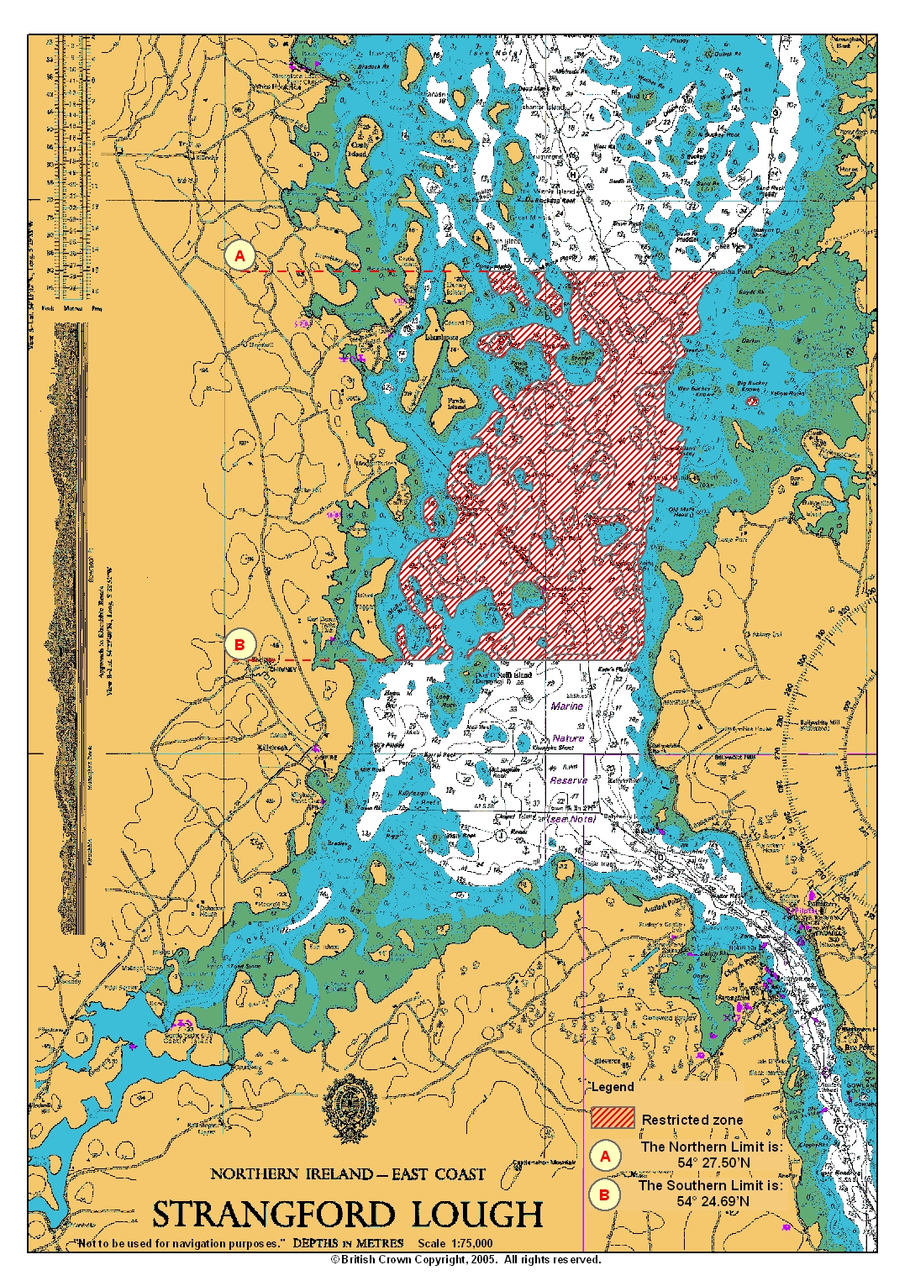
CHART SHOWING RESTRICTED ZONE
