Strangford Lough Regulation of Anchoring, Mooring and Diving Byelaws 2012
PERMIT APPLICATION FORM FOR ANCHORING AND MOORING WITHIN THE RESTRICTED ZONE
(Please note there is a separate application form for diving which is available at https://www.daera-ni.gov.uk/publications/strangford-lough-regulation-anchoring-mooring-and-diving-bye-laws)

There are currently no fees for this permit.

It is the responsibility of the applicant to obtain any other consents or authorisations
that may be required e.g., Crown Estate or seabed owner permission. If your proposed development will involve any construction works or deposits on the seabed that will occur within 50 metres of the Mean High Water Spring Tide mark you may require a licence under Part 4 (Marine Licensing) of the Marine and Coastal Access Act. For information on Marine Licensing, please contact the Department of Agriculture, Environment and Rural Affairs (DAERA) Marine Licensing Team MarineLicensingTeam@daera-ni.gov.uk

Important: before completing this form, please read the following documents:

- Location map showing the restricted zone (attached)
- The bye-laws in full can be read and downloaded at: https://www.daera-ni.gov.uk/publications/strangford-lough-regulation-anchoring-mooring-and-diving-bye-laws
- Information on the restoration of Modiolus modiolus (Horse Mussel) reef within Strangford lough: https://www.daera-ni.gov.uk/publications/restoration-and-long-term-monitoring-modiolus-modiolus-strangford-lough

If you require further clarification on issues relating to the Byelaws please contact Marine Conservation and Reporting MarineConservation@daera-ni.gov.uk.

Please allow 4 weeks for us to process your application form. Once we receive your application, we will carry out a site survey to inform our assessment.

PLEASE CHECK CAREFULLY THE INFORMATION YOU HAVE GIVEN AND THAT ALL ENCLOSURES (INCLUDING COPIES) HAVE BEEN INCLUDED (PLEASE TICK)

- Completed application form

- Project drawings (if applicable)

- Maps/charts

- Public Register

Is there any information contained within or provided in support of this application that you consider should not be included on the Public Register on the grounds that its disclosure:

- would be contrary to the interests of national security YES NO

- would prejudice to an unreasonable degree your or some
other person’s commercial interests or those of a third party? YES NO

If YES, to either (a) or (b), please provide full justification as to why all or part of the information you have provided should be withheld.

- Applicant Details

The person, company or organisation making the application.

Title Initials: Surname:
Organisation/Institution to which applicant is affiliated

Department

Position of applicant

Name of supervisor

Address:

Name of contact:

(If different from above)

Telephone number:
(inc. code)

Email address:

- Agent Details (if appropriate)

Any person, company or organisation acting on behalf of the applicant. They may be acting under contract (or other agreement) on behalf of any party listed in the answer to question 2, and have responsibility for the control, management or physical deposit of materials anywhere below the tidal limit of the mean high-water springs (MHWS).

Title Initials Surname

Trading Title (If different from above)

Business Address:

Name of contact:
(If different from above)

Position within company
(If appropriate)

Telephone number:
(inc. code)

Email address:

Company Registration No.

- Location of proposed Mooring/Anchor

This should include either 6 figure Irish Grid Reference (IGR) or Latitude and Longitude co-ordinates (WGS84 to 1 decimal minute) defining the extent of the project

It is important that the correct positions are included with this application, as any errors may result in the application being refused or delayed.

To supplement the information given in section 4, the following must be provided with the completed application form:

- A suitably scaled extract from an Ordnance Survey Map (1:2,500 scale but not more than 1:10,000) or Admiralty Chart or similar which should be marked to indicate:

- The full extent of works/anchoring/mooring;
- Latitude and longitude (or 6 figure IGR) co-ordinates defining the area of operation.

- Duration of Mooring/ Anchor (please circle)

Number of moorings/ anchor points
/ /
Expected commencing date
/ /
Expected completion date

Duration of required moorings/anchorage

- Mooring/ anchorage design (please circle)
Please provide the detail of the proposed mooring/ anchor design. (Please include the length of the proposed riser chain). It is important that the length of riser chain should ensure that the potential area of impact for the depth of the mooring is as small as possible.
Mooring buoys must be marked with a unique number which will be specified in the permit agreement.

- Statutory Consenting Powers
Do you, or (if appropriate) your client, have statutory powers to consent any aspect of this project?

Yes / No

If yes, please give details

Signature of applicant:
(or agent acting on behalf of applicant)

Name (Block Letters):
Position within company:
(If applicable)
/ /
Date

Permit Conditions
- To comply with relevant legislation
- To accept that the permission may be withdrawn at any time
- To remedy, if requested, any matter which is considered to breach the conditions of the permit
- To contact the Strangford Lough Marine Protected Area (MPA) officer at the commencement and end of works
- To comply with all reasonable requirements of the Department
- To use the restricted zone only for the purpose or purposes specified by the permit and for no other purpose unless so authorised by the Department and to seek prior written approval for any proposed change in the applicants activities
- To comply with other terms and conditions which the Department may see fit to apply to the permit and which is notified to the applicant in writing
- To refrain from entering any private land adjoining the restricted zone without the permission of the owner or occupier thereof
- To acknowledge the co-operation of the Department in any reports, published papers, etc., resulting from activities undertaken at the MPA
- To forward a copy of all publications, articles, papers and theses to the Strangford Lough MPA officer
- To forward a report of the applicant's activities to the MPA officer at the end of the study period covered by permit from the Department
- To submit dive plans involving scuba diving, if any, to the MPA officer in advance and to submit a Dive Log with report of activities at the end of the study period covered by permit from the Department
- To adhere to all speed limits within Strangford Lough and to avoid the use of anchors within the restricted zone where possible
- Not to interfere with (except where covered by permit), or damage flora and fauna of the Strangford Lough and to take particular care to avoid damage to habitats while diving and/or using equipment underwater
- To get the agreement of the MPA officer prior to introducing equipment, markers, buoys, transect lines, etc. and to remove all such equipment at the end of the works period.

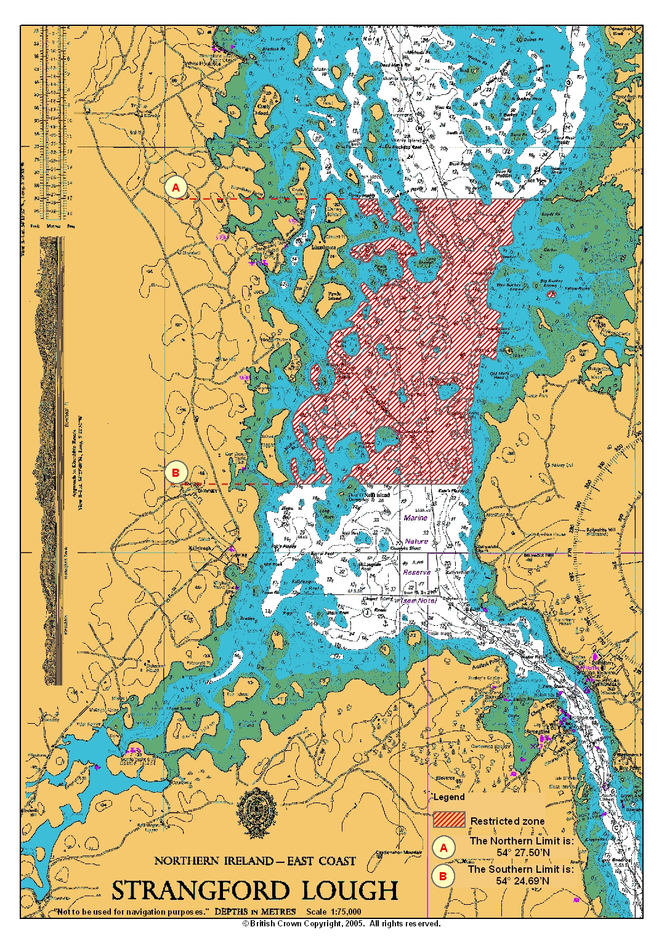
CHART SHOWING RESTRICTED ZONE
