**STATISTICAL PRESS RELEASE**

**09 July 2024**

**Northern Ireland agricultural incomes in 2023**

The Department of Agriculture, Environment and Rural Affairs (DAERA) has published the first (provisional) estimate for farm incomes in 2023. Revisions have been made to previous years.

## Aggregate Agricultural Income

Provisional figures indicate that the ‘Total Income from Farming’ (TIFF) in Northern Ireland decreased by 44.0% (47.8% in real terms) from £609 million in 2022 to £341 million in 2023.

**Graph 1: Northern Ireland Total Income from Farming 1990-2023**

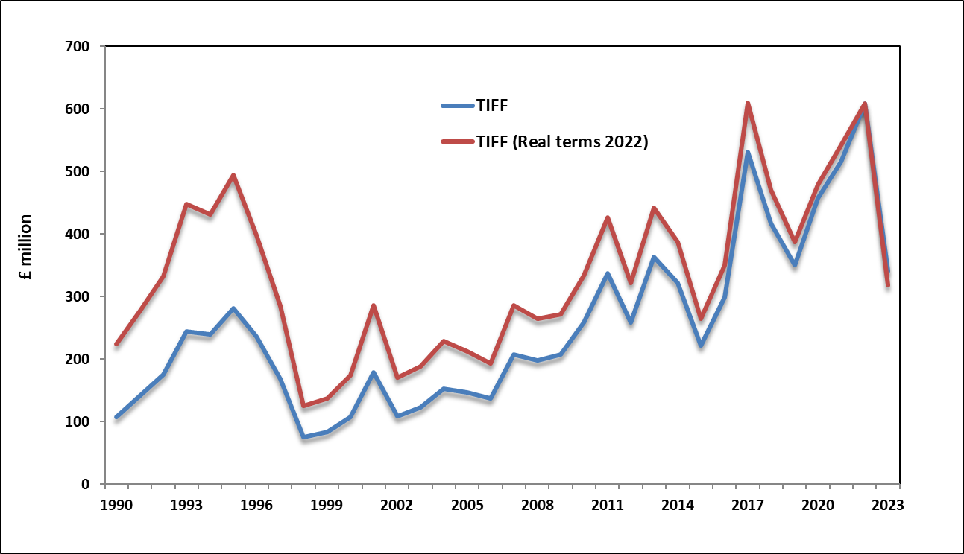

TIFF represents the return on own labour, management input and own capital invested for all those with an entrepreneurial involvement in farming. It represents farm income measured at the sector level.

Total Gross Output for agriculture in Northern Ireland was 7% lower at £2.87 billion in 2023. There was a 6% decrease in the value of output from the livestock sector, while field crops decreased by 21% and horticulture decreased by 27%. These figures are for the calendar year and therefore they represent the outturn across two harvest years.

Dairying remains the largest contributor to the total value of Gross Output at £892 million in 2023; a decrease of 21% between 2022 and 2023. The annual average farm-gate milk price decreased by 21% to 35.1 pence per litre while the volume of raw milk produced in Northern Ireland decreased by 0.2% to 2.5 billion litres.

The output value of cattle was 6% lower at £568 million in 2023. The total number of animals slaughtered decreased by 5.8% in 2023, whereas the average carcase weights for clean and cull animals were 1.3% and 2.3% lower respectively. These changes resulted in the volume of meat produced being 7.1% lower in 2023. The average producer price for finished clean cattle was £4.60 per kilogram in 2023 while the average producer price for cull animals was £3.24 per kilogram. These prices were 10% and 3% higher than their respective averages for 2022. In addition to these changes, there was also a stock change of minus £48 million due to a reduction in the number of cattle on ground between 2022 and 2023.

The value of output from sheep decreased by 0.5% to £109 million in 2023. The total number of sheep slaughtered increased by 4% in 2023 whereas the average carcass weight decreased by 2% to 22 kilograms. Volume of sheep meat produced increased 2% in 2023. The average producer price increased by 3% to £5.50 per kg.

All intensive sectors recorded an increase in their output. The value of output in the poultry sector increased by 2% to £380 million in 2023 while the egg sector increased by 47% to £223 million. The value of pig output also increased by 15% to £297 million. The poultry sector recorded a 8% increase in its production volume for 2023, whereas the pigs and eggs sectors recorded a 4% and 0.3% decrease in their respective production volumes when compared with their previous year levels. Producer prices in the pigs and eggs sectors increased by 20% and 43% respectively, whereas, the producer price for poultry decreased by 3%.

The total output value for field crops decreased by 21% in 2023 to £86 million. This was due to decreases in both grain prices and yields in 2023. The value of output for cereals decreased by 37% to £40 million whereas the value of output for potatoes increased by 15% to £31 million. Output values for field crops are across a calendar year and include production from two harvests.

The value of output recorded in the Horticulture sector was lower year on year for 2023, at £70 million. Mushrooms and vegetables are the main contributors to this sector in value terms, with a combined estimated output value of £46 million.

**Graph 2: Northern Ireland Agricultural Gross Output 1990-2023**

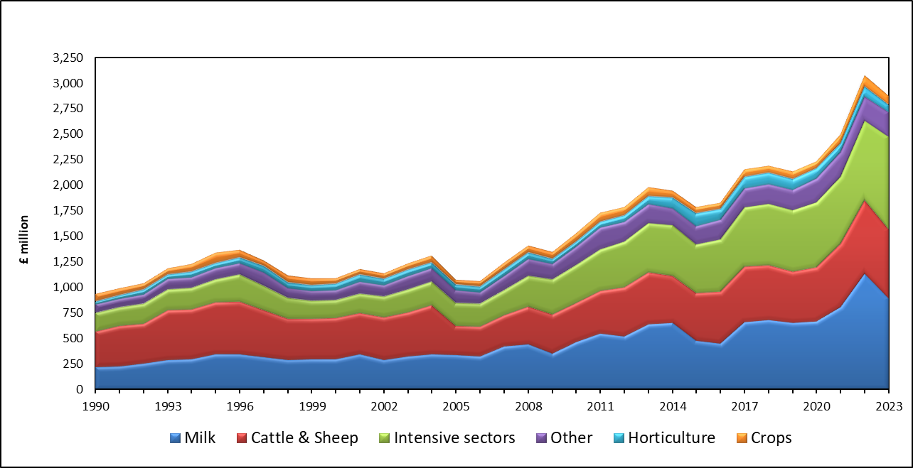

The estimated value of the 2023 direct payments (Basic Payment Scheme and Young Farmers’ Payment) was £298 million, representing an increase of 0.4%, when compared with the 2022 payments.

The total value of Gross Inputs decreased by 0.4% in 2023, to £2.17 billion. Feedstuffs costs, which accounted for 57% of the total Gross Input estimate, increased by 5% to £1.24 billion in 2023. There was a 3.3% increase in the volume of feedstuffs purchased and a 1.6% increase in the average price paid per tonne.

The total cost of fertilisers in 2023 decreased by 43% with a 14% decrease in the volume purchased and a 33% decrease in the average price paid per tonne. There was also a 36% fall in the value of total lime purchases, with the result that total expenditure on fertilisers and lime decreased by 42% to £112 million.

Total machinery expenses decreased by 2% to £199 million in 2023, mainly as a result of a 10% decrease in the cost of fuel and oils.

**Graph 3: Northern Ireland Agricultural Gross Input 1990-2023**

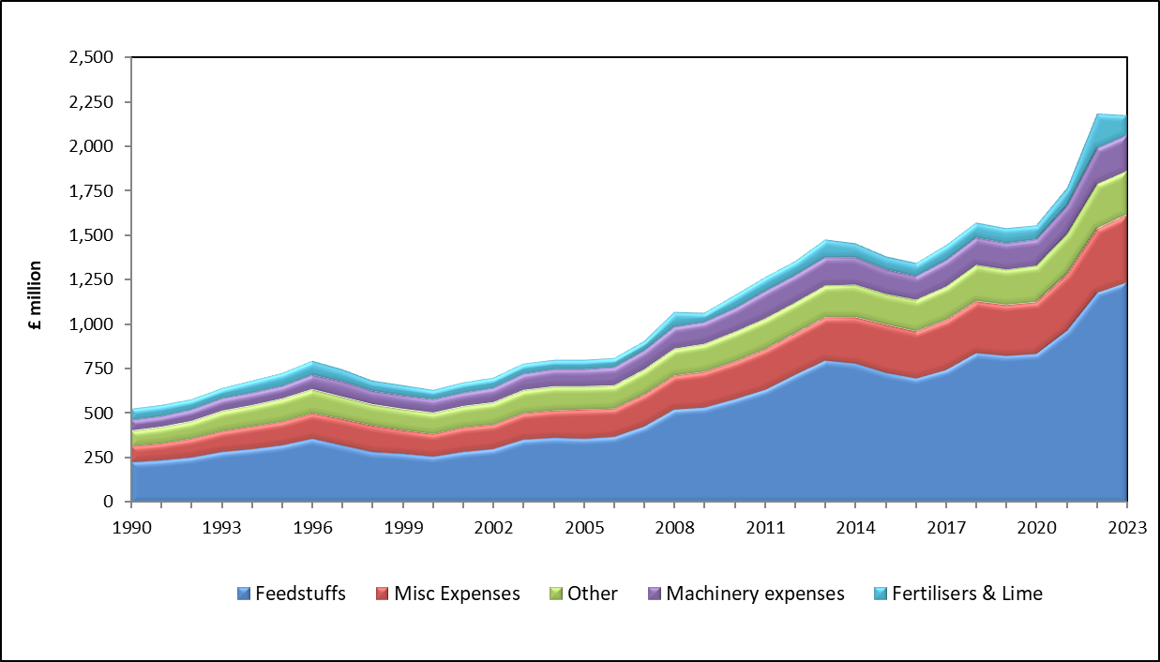

A detailed document covering the period 2018–2023 and containing all the key figures used to derive TIFF in Northern Ireland can be downloaded from the [DAERA website](https://www.daera-ni.gov.uk/articles/ni-agricultural-incomes).

## Estimates for the United Kingdom were released on 06 June 2024 and can be downloaded from the [DEFRA website](https://www.gov.uk/government/statistics/total-income-from-farming-in-the-uk).

# Farm level incomes

Farm Business Income by farm type for 2022/23 with forecasts for 2023/24 are presented in Table 1. These income results are based on farm accounts collected as part of the Northern Ireland Farm Business Survey (FBS). This is a representative sample of farms larger than 0.5 Standard Labour Requirements. The income figures presented are for accounting years with an average end date of mid-February.

Farm Business Income measured across all farm types is expected to decrease from an average £51,043 in 2022/23 to £27,345 in 2023/24, i.e. a decrease of £23,699 or 46% per farm.

**Graph 4: Average Farm Business Income by type of farm (£ per farm)**

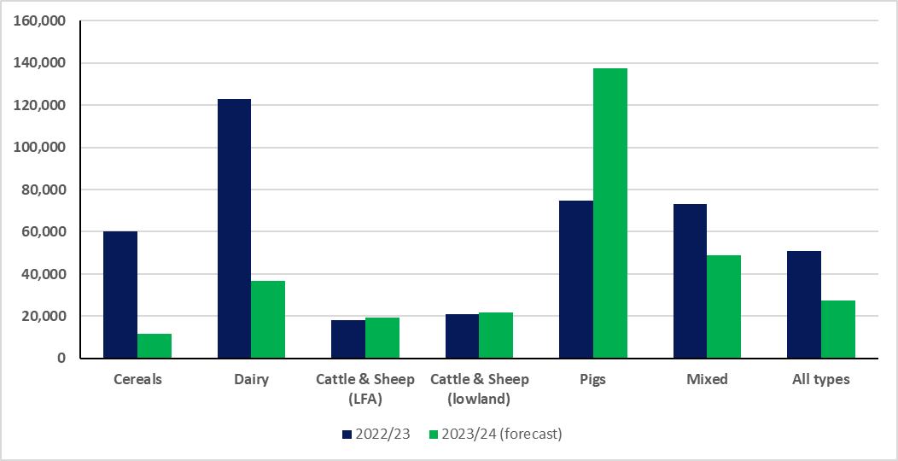

**Table 1: Average Farm Business Income by type of farm (£ per farm)**

|  |  |  |  |
| --- | --- | --- | --- |
|  |  |  |  |
| **Farm Type** | **2022/23** | **2023/24 (forecast)** | **% change** |
| Cereals | 60,251 | 11,521 | -81 |
| Dairy | 122,861 | 36,671 | -70 |
| Cattle & Sheep (LFA) | 18,052 | 19,412 | 8 |
| Cattle & Sheep (lowland) | 21,089 | 21,647 | 3 |
| Pigs | 74,718 | 137,364 | 84 |
| Mixed | 73,203 | 48,928 | -33 |
| All types | 51,043 | 27,345 | -46 |
|  |  |  |  |

Note: The ‘All types’ category excludes poultry and horticulture farm types

Farm Business Income is expected to increase (by varying amounts) for Cattle & Sheep (LFA), Cattle & Sheep (lowland) and Pig farm types between 2022/23 and 2023/24. For these farms, the upturn in their incomes is attributable to higher beef and pig prices in the 2023/24 year. Whereas, Farm Business Incomes for Cereals, Dairy and Mixed farm types are expected to fall by 81%, 70% and 33% respectively due to lower grain and milk prices in the 2023/24 year.

A detailed analysis of farm incomes by type and size of farm in 2022/23 will be provided in the report ‘Farm Incomes in Northern Ireland 2022/23’ which will be published on the [DAERA website](https://www.daera-ni.gov.uk/articles/farm-incomes-northern-ireland) in August 2024.

**Notes for Editors**

1. A wide range of statistics are available on the [DAERA website](https://www.daera-ni.gov.uk/topics/statistics) and also via Twitter: [@DAERAstats](https://twitter.com/DAERAstats).
2. Provisional aggregate income figures for the UK were issued in June 2024 on the government portal [Total income from farming in the UK - Publications - GOV.UK](https://www.gov.uk/government/statistics/total-income-from-farming-in-the-uk)
3. The Northern Ireland estimates were prepared using provisional figures and are subject to revision when more complete data becomes available later in the year.
4. ‘Total Income from Farming’ measures the return to farmers, partners and directors, their spouses and other family workers for their labour, management input and own capital invested. It, therefore, represents the total income of all those with an entrepreneurial involvement in farming.
5. Farm level income estimates by farm type are based on the Department’s Farm Business Survey, for which the account year ends on average in mid February, whereas the aggregate income estimate – Total Income from Farming - is compiled on a calendar year basis.
6. Farm Business Income is the return to all unpaid labour (farmer, spouses and others with an entrepreneurial interest in the farm business) and to their capital invested in the farm business which includes land and buildings.
7. As income estimates by farm type are based on data collected from a sample of the farm population, they are subject to sampling error. To give an indication of this, the Farm Business Income results by Farm Type for 2022/23 and their associated 95% confidence intervals (as range bars) are shown in Figure 1.

For each farm type, Figure 1 shows the estimated average Farm Business Income and the range of values that apply to it, i.e. we are 95% confident that the true average Farm Business Income for the farm type falls within the range shown. It is important to note that the size of a confidence interval is influenced by a variety of factors such as number of farms sampled and the variability of incomes within sampled farms.

**Figure 1: Average Farm Business Income (£’000s) by farm type, with 95% confidence limits, Northern Ireland 2022/23.**

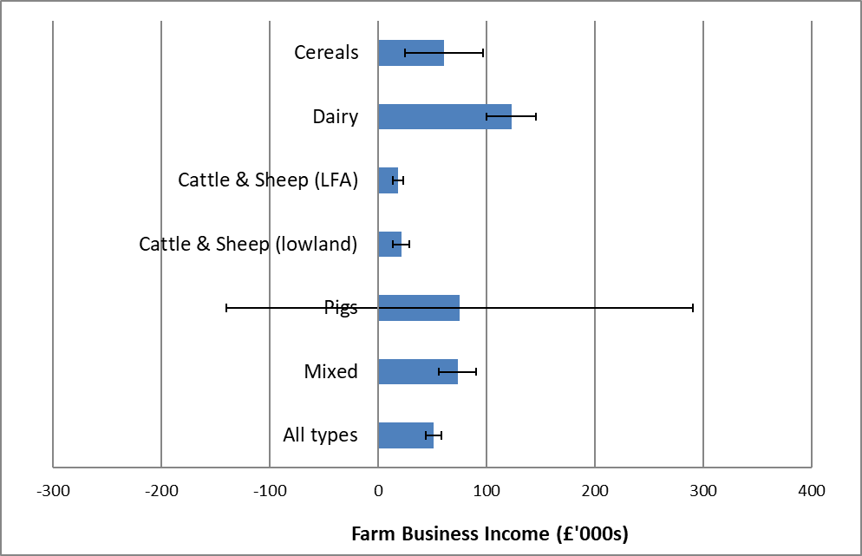

1. For UK statistical purposes, farms are grouped into 10 ‘robust’ farm types which have particular relevance to UK conditions i.e. Cereals, General Cropping, Horticulture, Specialist Pigs, Specialist Poultry, Dairy, Cattle & Sheep (LFA), Cattle & Sheep (Lowland), Mixed and Other. The system for the classification of farms into these types is based on that set out in Commission Implementing Regulation (EU) 2015/220 and explained in greater detail in the EU Farm Accountancy Data Network (FADN) Typology Handbook RI/CC 1500 rev.4.
2. The EU and UK system for classification of farms was revised in 2011. Farms are now classified in terms of Standard Output (SO) compared to Standard Gross Margin (SGM) used previously. Further details of the impact of this change are presented in the report ‘Farm Incomes in Northern Ireland 2010/11’ which is available on the [DAERA website](https://www.daera-ni.gov.uk/articles/farm-incomes-northern-ireland).
3. For UK statistical purposes, farms are also grouped into size categories based on their total Standard Labour Requirement (SLR). The total SLR for each farm business is calculated by multiplying its crop areas and livestock numbers by the associated SLR coefficients and then summing the results for all enterprises on the farm. This is then divided by 1900 to determine the number of standard labour requirements for the farm (i.e. 1 SLR is equivalent to 1900 hours).
4. At June 2022 there were 26,089 farms in Northern Ireland of which 9,870 were above 0.5 SLRs.
5. The *‘Statistical Review of Northern Ireland Agriculture, 2023’,* due to be issued on the [DAERA website](https://www.daera-ni.gov.uk/articles/statistical-review-ni-agriculture) during August 2024, will contain details of the output, input and income estimates for 2023, as well as information on livestock numbers, crop areas and yields, farm structure, employment and farm business performance.
6. The UK Statistics Authority has confirmed these statistics as accredited official statistics. Accredited official statistics are called National Statistics in the Statistics and Registration Service Act 2007. Accreditation signifies production is in accordance with this act and that these statistics comply with the Code of Practice for Statistics.

This accreditation means that the statistics:

* meet identified user needs;
* are well explained and readily accessible;
* are produced according to sound methods; and
* are managed impartially and objectively in the public interest.

Once statistics have been accredited it is a statutory requirement that the Code of Practice shall be observed regarding them.

Our statistical practice is regulated by the Office for Statistics Regulation (OSR). OSR sets the standards of trustworthiness, quality and value in the Code of Practice for Statistics that all producers of official statistics should adhere to.

These accredited official statistics were independently reviewed by OSR in 2011. They comply with the standards of trustworthiness, quality and value in the Code of Practice for Statistics and should be labelled ‘National Statistics’. National Statistics are accredited official statistics

You are welcome to contact us directly with any comments about how we meet these standards. Alternatively, you can contact OSR by emailing regulation@statistics.gov.uk or via the OSR website at [Accredited official statistics – Office for Statistics Regulation (statisticsauthority.gov.uk)](https://osr.statisticsauthority.gov.uk/accredited-official-statistics/)

Further information on accredited official statistics can be accessed at:

www.statistics.gov.uk; and from the UK Statistics Authority at [The UK](https://www.statisticsauthority.gov.uk/)

[Statistical System - The UK Statistical System (statisticsauthority.gov.uk)](https://www.statisticsauthority.gov.uk/)