**STATISTICAL PRESS RELEASE**

**27 April 2023**

**Northern Ireland agricultural incomes in 2022**

The Department of Agriculture, Environment and Rural Affairs (DAERA) has published the first (provisional) estimate for farm incomes in 2022. Revisions have been made to previous years.

## Aggregate Agricultural Income

Provisional figures indicate that the ‘Total Income from Farming’ (TIFF) in Northern Ireland increased by 17.4% (11.3% in real terms) from £515 million in 2021 to £605 million in 2022.

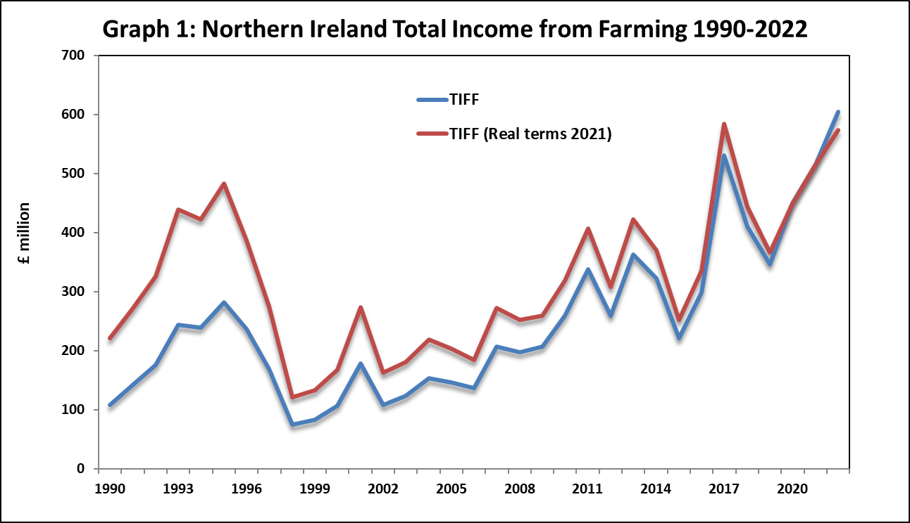

TIFF represents the return on own labour, management input and own capital invested for all those with an entrepreneurial involvement in farming. It represents farm income measured at the sector level.

Total Gross Output for agriculture in Northern Ireland was 23% higher at £3.07 billion in 2022. There was a 26% increase in the value of output from the livestock sector, while field crops increased by 31% and horticulture increased by 12%. These figures are for the calendar year and therefore they represent the outturn across two harvest years.

Dairying remains the largest contributor to the total value of Gross Output at £1.13 billion in 2022; an increase of 40% between 2021 and 2022. The annual average farm-gate milk price increased by 41% to 44.5 pence per litre while the volume of raw milk produced in Northern Ireland decreased by 0.6% to 2.5 billion litres.

The output value of cattle was 16% higher at £603 million in 2022. The total number of animals slaughtered increased by 9.3% in 2022, whereas the average carcase weights for clean and cull animals were 0.9% and 1.9% lower respectively. These changes resulted in the volume of meat produced being 8.0% higher in 2022. The average producer price for finished clean cattle was £4.17 per kilogram in 2022 while the average producer price for cull animals was £3.15 per kilogram. These prices were 9% and 17% higher than their respective averages for 2021. In addition to these changes, there were also a decrease in the number of store cattle imported to Northern Ireland in 2022.

The value of output from sheep increased by 6% to £106 million in 2022. The total number of sheep slaughtered increased by 6% in 2022 whereas the average carcass weight increased by 0.8% to 22 kilograms. Volume of sheep meat produced increased 7% in 2022. The average producer price decreased by 0.1% to £5.35 per kg.

The value of output in the poultry sector increased by 16% to £376 million in 2022 while the egg sector increased by 18% to £148 million. The value of pig output also increased by 24% to £259 million. The poultry sector recorded a 6% decrease in its production volume for 2022, whereas the pigs and eggs sectors recorded a 4% and 5% increase in their respective production volumes when compared with their previous year levels. All intensive sectors recorded an increase in their producer prices for 2022 with poultry up 25%, eggs up 13%, and pigs up 19% when compared to the previous year.

The total output value for field crops increased by 31% in 2022 to £109 million. This was mainly as a result of increases in grain and potato prices in 2022. The value of output for cereals increased by 35% to £64 million whereas the value of output for potatoes increased by 37% to £27 million. Output values for field crops are across a calendar year and include production from two harvests.

The value of output recorded in the Horticulture sector was higher year on year for 2022, at £96 million. Mushrooms and flowers are the main contributors to this sector in value terms, with a combined estimated output value of £57 million.

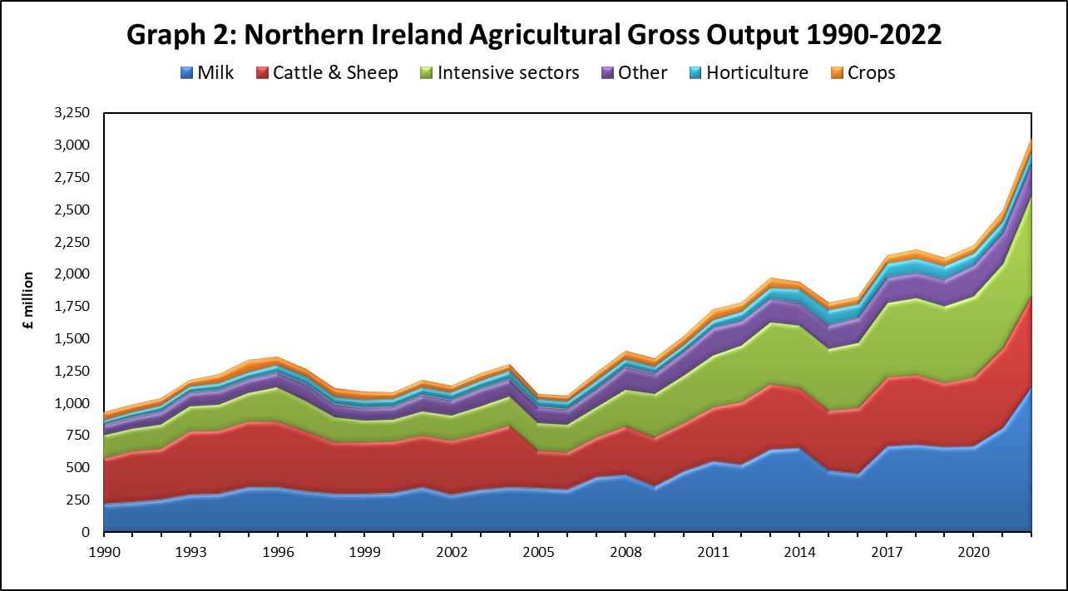

The estimated value of the 2022 direct payments (Basic Payment Scheme and Young Farmers’ Payment) was £297 million, representing a decrease of 4%, when compared with the 2021 payments.

The total value of Gross Inputs increased by 24% in 2022, to £2.18 billion. Feedstuffs costs, which accounted for 54% of the total Gross Input estimate, increased by 22% to £1.18 billion in 2022. There was a 1.3% decrease in the volume of feedstuffs purchased and a 24% increase in the average price paid per tonne.

The total cost of fertilisers in 2022 increased by 109% with a 16% decrease in the volume purchased and a 148% increase in the average price paid per tonne. There was also a 24% rise in the value of total lime purchases, with the result that total expenditure on fertilisers and lime increased by 102% to £194 million.

Total machinery expenses increased by 31% to £208 million in 2022, mainly as a result of an 58% increase in the cost of fuel and oils.

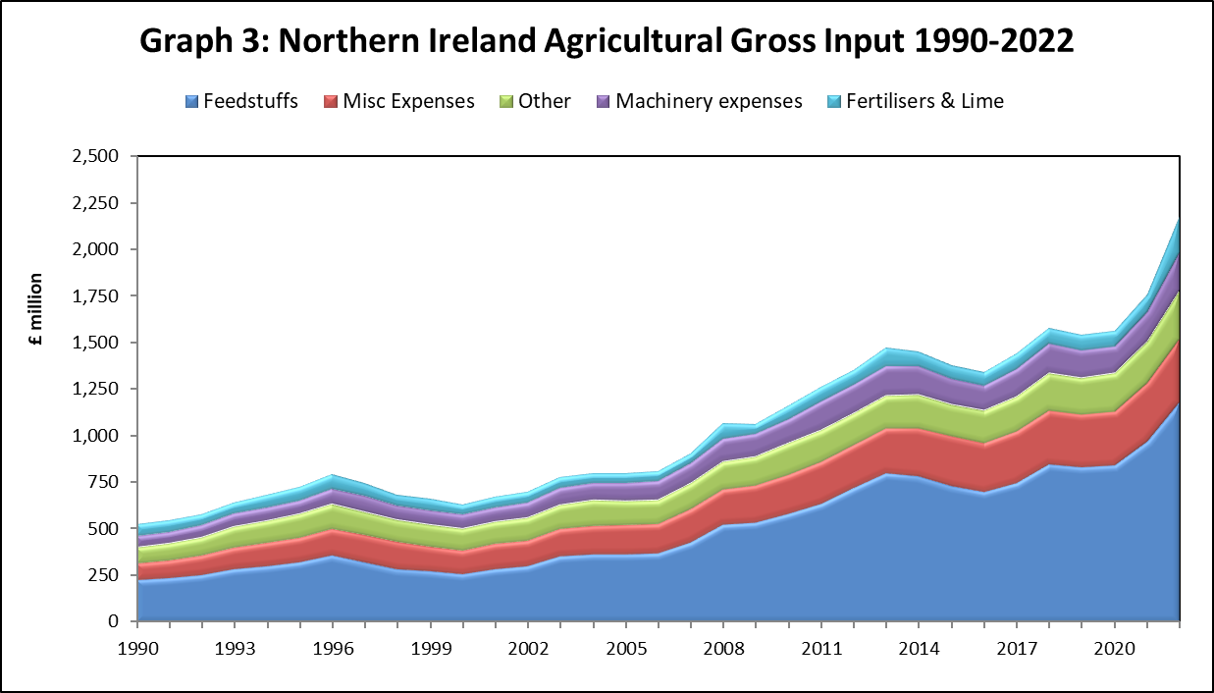

A detailed document covering the period 2017–2022 and containing all the key figures used to derive TIFF in Northern Ireland can be downloaded from the [DAERA website](https://www.daera-ni.gov.uk/articles/ni-agricultural-incomes).

## Estimates for the United Kingdom will not be released until 25 May 2023 and a breakdown of TIFF for the UK will not be available until then.

# Farm level incomes

Farm Business Income by farm type for 2021/22 with forecasts for 2022/23 are presented in Table 1. These income results are based on farm accounts collected as part of the Northern Ireland Farm Business Survey (FBS). This is a representative sample of farms larger than 0.5 Standard Labour Requirements. The income figures presented are for accounting years with an average end date of mid-February.

Farm Business Income measured across all farm types is expected to increase from an average £43,100 in 2021/22 to £47,305 in 2022/23, i.e. an increase of £4,205 or 10% per farm.

**Table 1: Average Farm Business Income by type of farm (£ per farm)**

|  |  |  |  |
| --- | --- | --- | --- |
|  |  |  |  |
| **Farm Type** | **2021/22** | **2022/23 (forecast)** | **% change** |
| Cereals | 122,591 | 82,643 | -33 |
| Dairy | 83,190 | 132,305 | 59 |
| Cattle & Sheep (LFA) | 23,084 | 7,927 | -66 |
| Cattle & Sheep (lowland) | 24,085 | 11,103 | -54 |
| Pigs | 37,371 | 38,110 | 2 |
| Mixed | 82,860 | 83,639 | 1 |
| All types | 43,100 | 47,305 | 10 |
|  |  |  |  |

Note: The ‘All types’ category excludes poultry and horticulture farm types

Farm Business Income is expected to increase for Dairy, Pigs and Mixed farm types between 2021/22 and 2022/23. The increase is particularly marked for Dairy farms with the higher raw milk price more than offsetting increases in input costs. Despite increases in output prices, it is forecast that the average income of pig producers in 2022/23 is only marginally higher compared to the low levels experienced in 2021/22. Cereal, Cattle & Sheep (LFA) and Cattle & Sheep (lowland) farm incomes are expected to fall by 33%, 66% and 54% respectively. It is forecast that increases in cereal and beef prices are insufficient to offset the higher input costs for these farm types. A detailed analysis of farm incomes by type and size of farm in 2021/22 will be provided in the report ‘Farm Incomes in Northern Ireland 2021/22’ which will be published on the [DAERA website](https://www.daera-ni.gov.uk/articles/farm-incomes-northern-ireland) in June 2023.

**Notes for Editors**

1. A wide range of statistics are available on the [DAERA website](https://www.daera-ni.gov.uk/topics/statistics) and also via Twitter: [@DAERAstats](https://twitter.com/DAERAstats).
2. Provisional aggregate income figures for the UK will be issued in May 2023 on the government portal [Total income from farming in the UK - Publications - GOV.UK](https://www.gov.uk/government/statistics/total-income-from-farming-in-the-uk)
3. The Northern Ireland estimates were prepared using provisional figures and are subject to revision when more complete data becomes available later in the year.
4. ‘Total Income from Farming’ measures the return to farmers, partners and directors, their spouses and other family workers for their labour, management input and own capital invested. It, therefore, represents the total income of all those with an entrepreneurial involvement in farming.
5. Farm level income estimates by farm type are based on the Department’s Farm Business Survey, for which the account year ends on average in mid February, whereas the aggregate income estimate – Total Income from Farming - is compiled on a calendar year basis.
6. Farm Business Income is the return to all unpaid labour (farmer, spouses and others with an entrepreneurial interest in the farm business) and to their capital invested in the farm business which includes land and buildings.
7. As income estimates by farm type are based on data collected from a sample of the farm population, they are subject to sampling error. To give an indication of this, the Farm Business Income results by Farm Type for 2021/22 and their associated 95% confidence intervals (as range bars) are shown in Figure 1.

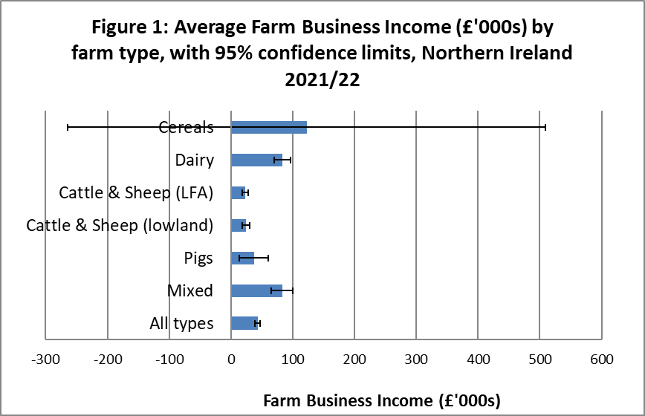

For each farm type, Figure 1 shows the estimated average Farm Business Income and the range of values that apply to it, i.e. we are 95% confident that the true average Farm Business Income for the farm type falls within the range shown. It is important to note that the size of a confidence interval is influenced by a variety of factors such as number of farms sampled and the variability of incomes within sampled farms.

1. For UK statistical purposes, farms are grouped into 10 ‘robust’ farm types which have particular relevance to UK conditions i.e. Cereals, General Cropping, Horticulture, Specialist Pigs, Specialist Poultry, Dairy, Cattle & Sheep (LFA), Cattle & Sheep (Lowland), Mixed and Other. The system for the classification of farms into these types is based on that set out in Commission Implementing Regulation (EU) 2015/220 and explained in greater detail in the EU Farm Accountancy Data Network (FADN) Typology Handbook RI/CC 1500 rev.4.
2. The EU and UK system for classification of farms was revised in 2011. Farms are now classified in terms of Standard Output (SO) compared to Standard Gross Margin (SGM) used previously. Further details of the impact of this change are presented in the report ‘Farm Incomes in Northern Ireland 2010/11’ which is available on the [DAERA website](https://www.daera-ni.gov.uk/articles/farm-incomes-northern-ireland).
3. For UK statistical purposes, farms are also grouped into size categories based on their total Standard Labour Requirement (SLR). The total SLR for each farm business is calculated by multiplying its crop areas and livestock numbers by the associated SLR coefficients and then summing the results for all enterprises on the farm. This is then divided by 1900 to determine the number of standard labour requirements for the farm (i.e. 1 SLR is equivalent to 1900 hours).
4. At June 2021 there were 26,077 farms in Northern Ireland of which 9,882 were above 0.5 SLRs.
5. The *‘Statistical Review of Northern Ireland Agriculture, 2022’,* due to be issued on the [DAERA website](https://www.daera-ni.gov.uk/articles/statistical-review-ni-agriculture) during June 2023, will contain details of the output, input and income estimates for 2022, as well as information on livestock numbers, crop areas and yields, farm structure, employment and farm business performance.