**Schedule 7: AVS Approval Processes and Approval Maintenance**

**Introduction : Application for approval as an Approved Veterinary Surgeon (AVS) to carry out Bovine Tuberculin Testing**

**1.0 Application for approval as an Approved Veterinary Surgeon (AVS) to carry out Bovine Tuberculin Testing**

* 1. A veterinary surgeon who wishes to TB test on behalf of the Authority must be a principal / partner / director / veterinary manager (a veterinary manager is a veterinary surgeon appointed to manage other veterinary surgeons in the practice/business) / employee or freelance worker working for a veterinary practice/business. A veterinary surgeon who wishes to TB test must work for a Contractor.

1.2 A veterinary surgeon who wishes to be approved for the first time (or to be approved again after a lapse in approval as occurs 3 years when no tests have been carried out) to carry out tuberculin testing must make a written application for approval using firstly form **VP4 Part A**, which is an application to sit the Online TB Theory Test based on Schedule 11 of the contract, and, following successful completion of the Theory Test, application form **VP4 Part B** must be submitted, which is an application for the Approval Practical Test. VP4 parts A and B are attached as Appendix 1 and the current version can be obtained online (<https://www.daera-ni.gov.uk/publications/form-vp4>) and fromAA the local Divisional Veterinary/DAERA Direct Office on application:

DV/DDO, e-mail:-

[Post.Armagh-DVO@daera-ni.gov.uk](mailto:Post.Armagh-DVO@daera-ni.gov.uk);

[Post.Ballymena-DVO@daera-ni.gov.uk](mailto:Post.Ballymena-DVO@daera-ni.gov.uk);

[Post.Coleraine-DVO@daera-ni.gov.uk](mailto:Post.Coleraine-DVO@daera-ni.gov.uk);

[Post.Dungannon-DVO@daera-ni.gov.uk](mailto:Post.Dungannon-DVO@daera-ni.gov.uk);

[Post.Enniskillen-DVO@daera-ni.gov.uk](mailto:Post.Enniskillen-DVO@daera-ni.gov.uk);

[Post-Strabane-DVO@daera-ni.gov.uk](mailto:Post-Strabane-DVO@daera-ni.gov.uk);

[Post.Mallusk-DVO@daera-ni.gov.uk](mailto:Post.Mallusk-DVO@daera-ni.gov.uk);

[Post.Newry-DVO@daera-ni.gov.uk](mailto:Post.Newry-DVO@daera-ni.gov.uk);

[Post.Newtownards-DVO@daera-ni.gov.uk](mailto:Post.Newtownards-DVO@daera-ni.gov.uk);

[Post.Omagh-DVO@daera-ni.gov.uk](mailto:Post.Omagh-DVO@daera-ni.gov.uk)

* 1. Where the applicant is an employee in a Veterinary Practice the application form **VP4** for approval must be countersigned by a Practice Principal /Partner / Director or Veterinary manager.
  2. The applicant must send the **VP4** with Part A completed to the Divisional Veterinary Officer (DVO) at the local DAERA Direct Office. The DVO in that office will liaise with the Contractor to arrange the TB Theory Test based on Schedule 11 of the TB Contract.
  3. The Candidate Instructions are attached as Appendix 2. At the time of the Theory test, the candidate must show photographic identification to confirm their identification. This should be in the form of a recognised formal means of identification (driving licence, passport).

* 1. When the Theory Test has been passed and all the required practical training completed and the Contractor is satisfied that the applicant is ready to do the practical assessment, the **VP4** with Part B completed must be sent to the DVO. The DVO will liaise with the Contractor to arrange the practical assessment within 15 working days of receipt of the **VP4** Part B.

1.7 Note that as a condition of approval, attendance at a day’s classroom-based training course is compulsory. This will be provided by the Authority (separate from the annual TB training for Approved Veterinary Surgeons) and is usually held annually in the Autumn. This can be attended before or after the Theory test or practical assessment.

1.8 Following satisfactory completion of both the Theory and practical assessments an approval document (**VP6**) will be issued by the Department.

1.9 If an AVS does not carry out any TB testing in Northern Ireland for a period of more than three years their approval will lapse and the veterinary surgeon will be required to apply for approval, as above, in the normal way.

1.10 Approval may be suspended or terminated forthwith if the **AVS** infringes the conditions of approval, performs procedures unsatisfactorily, fails to carry out the tuberculin tests in accordance with **Schedule 11** or if his/her conduct, in the opinion of the Authority, makes immediate suspension or termination of approval desirable in the public interest.

1.11 Veterinary surgeons who have been TB testing cattle herds in GB within the last 12 months do not have to do an Approval test but must do the Theory Test and the practice SAVS must be content that the new veterinary surgeon is proficient at TB testing.

**2. Initial assessment of eligibility by the Contractor**

The veterinarian seeking to be approved must do so through a Contractor and must be assessed by the Contractor to be:

1.A Member or Fellow of the Royal College of Veterinary Surgeons;

2.Fit and physically able to complete TB testing safely;

3.Capable of effective communication with local animal Keepers. This must include fluency in the English language, both written and verbal. This can be evidenced by the applicant;

* + having undertaken undergraduate veterinary training in English; or
  + having achieved the following scores in the academic International English Language Testing System (IELTS Academic) within 24 months at time of application – Overall 7, Speaking 7, Listening 7, Reading 7, Writing 7; or
  + being assessed by the Contractor as having adequate communication skills but does not fit one of the above requirements. She/he must assess their ability and be satisfied that it is sufficient.

4.Knowledgeable and have the skills to carry out inspections and clinical examinations of bovine animals.

If the Contractor is satisfied that the candidate is eligible, the Contractor must return a completed Form VP4 Part A to the local DVO.

1. **Attendance at the TB Training Seminar for applicant / recently approved AVSs**

As a condition of Approval, all applicants must attend a TB Training Seminar for applicant / recently approved AVSs. This training seminar must be attended either before or after the Theory and Practical tests but must be attended before 12 months have elapsed following approval. This training seminar is in addition to the annual TB training for Approved Veterinary Surgeons and is usually held annually in the Autumn.

.

The scientific and legislative framework for the TB Eradication Programme and requirements of the contract are communicated to the attendees.

Failure to attend the TB Seminar within 12 months of approval will lead to suspension of approval.

**4.The applicant sits the Online Theory Test based on Schedule 11**

The Contractor can proceed to have the applicant sit the Theory Test as the first step for approval before the Training course but the Theory test must be completed successfully before the practical test.

Applicants must have a working knowledge of the technical details of completing the TB test and interpreting the readings. Practice trainers must ensure that applicants have a working knowledge of the test procedures and corrective actions when issues such as inadequate animal identification or pre-existing clinical disease problems are found.

This knowledge will be assessed through a computer-based questionnaire at the local DAERA Direct Office/Divisional Veterinary Office. The applicant will be presented with 20questions in a multiple choice style. Each correctly answered question is worth 1 point and a score of at least 17 points must be achieved to pass the test. Candidates will be allowed a maximum of 30 minutes for each attempt of the test, and multiple attempts will be permitted within an hour total allowance. If after the hour the candidate has still failed to achieve the pass mark a new appointment at the next convenient time will be required.

See Appendix 1 for instructions for sitting a Theory Test in a DAERA Direct office.

When the applicant has passed the Theory Test the local DVO completes Form VP4 A and issues Form VP4 Part B to the Contractor.

**5.The applicant is trained in TB testing**

The applicant is trained by experienced TB testers under the supervision of the Contractor. Training must involve the testing, under supervision, of cattle and the SAVS for the practice must be confident that the applicant is proficient at TB testing before the applicant does the Approval Test.

Once the training is complete, the Contractor must progress the applicant’s approval process by returning a completed Form VP4 Part B to the local DVO.

**6.The Practical Assessment (Approval Test)**

6.1 Prior to the Approval test the Contractor must be satisfied that the applicant seeking approval:

* is familiar with the operating procedures set out in the Schedule 11;
* can appropriately fit a new needle to a McLintock syringe;
* is competent to carry out tuberculin tests;
* is sufficiently proficient to test at least 30 cattle during the test assessment period in no more than one hour on both day 1 and day 4 (this does not include time spent moving cattle from pens to the crush *etc*);
* is familiar with practice health and safety policies and practices; and
* understands DAERA health and safety advice, in particular the Department’s cattle handling and dynamic risk assessment guidance.

See the following guidance:

[Safe Cattle Handling Guidance | Department of Agriculture, Environment and Rural Affairs (daera-ni.gov.uk)](https://www.daera-ni.gov.uk/publications/safe-cattle-handling-guidance)

[Working with cattle on farm – dynamic risk assessment guidance | Department of Agriculture, Environment and Rural Affairs (daera-ni.gov.uk)](https://www.daera-ni.gov.uk/publications/working-cattle-farm-%E2%80%93-dynamic-risk-assessment-guidance)

6.2 The Approval test is supervised by a DAERA Veterinarian (Veterinary Assessor) who has been trained in inspection of field compliance in TB testing.

6.3 When the candidate is ready for assessment the Contractor will contact the local DVO to discuss the arrangement of the Practical Assessment (Approval Test). The Contractor must select a herd for the Approval Test in conjunction with the DAERA Veterinary Assessor. The herd must have at least 40 animals eligible for TB testing. If it is not possible to find one herd of 40 cattle the assessment can be done over 2 herds.

6.4 **Prior to the assessment, the Contractor and the certifying vet (*i.e*. the Contractor`s representative) should have confidence in the applicant`s clinical and practical aptitude.** The Approval Test is submitted under the NIFAIS code of the Contractor AVS attending the Approval Test **and to the specified standard of the Contract. The Contractor`s Representative must be aware that they are certifying correct application of the Test and must be prepared to take corrective action if required.**

6.5 The same Contractor AVS representative must be present on both days of the Approval Test. If the candidate fails to achieve the required standards, at any stage of the practical assessment, the Contractor must be in a position to continue and finish the test. Failing this the Contractor may be liable for any losses as referred in Schedule 1 Paragraph 9.17. See also Paragraph 8.2 of Schedule 7 below.

* 1. On Day 1 of the Practical Assessment, a flyer outlining the assessment process is given to the veterinarian seeking approval prior to the start of the Approval Test (Appendix 3a). Approved AVSs are provided with Appendix 3b.

6.7 The Compliance Assessment Parameters and Tolerances for the test are shown in Appendix 4. Serious non-compliances such as inadequate cleansing and disinfection (C & D), dirty personal protective equipment (PPE) or lack of spare equipment as specified in the Contract at the Approval Test will result in the assessment being stopped and recorded as a failure.

6.8 The applicant will be observed fitting a new needle to a McLintock syringe before the start of the test on Day 1.

6.9 During the Approval Test the applicant’s knowledge of the required technique and procedures as detailed in Schedule 11 will be assessed.

6.10 The Approval Test has a pre-assessment section on day 1. This consists of Day 1 procedures being carried out on 5 animals prior to the assessment section (candidates have the option to be assessed on a further 5 animals if they so request).

Procedures carried out on each of the 5 pre-assessment section animals are observed on Day 1 by the DAERA Veterinary Assessor and any testing deficiencies observed (*e.g.* site visibility/location, measuring technique and pea palpation *etc.*) are noted. Observations made during the pre-audit section are recorded but are not considered in the assessment. However, should the DAERA Veterinary Assessor conclude that the applicant is not sufficiently proficient during the pre-assessment stage the Approval Test can be stopped.

6.11 Day 1 Approval Test involves the applicant clipping, measuring, injecting and palpating the injection sites of at least 30 cattle. Skin measurements and any observations (lumps on skin *etc.*) are recorded against the ear tag numbers listed on BT15s. Differences in identification compared to that recorded on the BT15 should also be recorded and appropriate action taken and advice given where necessary. Hard copy BT15s must be used for recording during the Approval Test, hand held electronic devices (PDAs) are not to be used.

6.12 At the start of Day 4 the applicant must have the relevant BT15 test sheets and BT23 Notices and DNA tags and taggers before the test commences.

* 1. Day 4 Approval Test involves the applicant identifying, palpating and measuring the clipped sites of the animals tested on Day 1. Skin measurements and, where applicable, swelling description (circumscribed, oedema, pain, heat *etc.*), are recorded against the ear tag numbers listed on BT15s with results of clinical inspection of animals with positive or inconclusive readings. Positive Reactor animals and animals deemed to be reactors due to having clinical signs of TB are to have DNA tags applied to them. Appropriate advice (*e.g*. isolation of animals with inconclusive and positive reactor readings) and a completed BT23 are to be given to the herd keeper.
  2. DNA tags are to be applied to reactors
  3. A summary of the assessment is as follows but the detailed assessment is found in Appendix 4:

|  |  |  |
| --- | --- | --- |
| **Procedure** | **Day 1** | **Day 4** |
| C & D and hygiene of equipment and PPE | **🗸** | **🗸** |
| Presence, maintenance and use of required equipment including spares | **🗸** | **🗸** |
| DNA tagger and DNA tags |  | **🗸** |
| Tuberculin storage and currency | **🗸** |  |
| Eligibility of animals to be tested | **🗸** |  |
| Animal identification requirements and corrective actions | **🗸** | **🗸** |
| Location and visibility of clip marks | **🗸** | **🗸** |
| Measurement technique and accuracy | **🗸** | **🗸** |
| Injection technique | **🗸** |  |
| Palpation to confirm the presence of an intra-dermal pea and corrective action | **🗸** |  |
| Recording on BT15 skin measurements and incidental findings *e.g.* lumps on neck on day 1 which could cause confusion for measurements on day 4 | **🗸** |  |
| Clinical signs and recording of these and clinical examination conclusions | **🗸** | **🗸** |
| Palpation of sites, measurement technique and accuracy |  | **🗸** |
| Recording of skin measurements on BT15 and clinical reactions, pain, heat, oedema, etc |  | **🗸** |
| Interpretation of readings, including use of interpretation chart |  | **🗸** |
| Advice given to herd keeper | **🗸** | **🗸** |
| Advice given to herd keeper when inconclusive or positive test readings are recorded |  | **🗸** |

**7. Health and Safety assessment**

7.1 As part of the proficiency practical assessment the DAERA assessor will also complete a Health and Safety Assessment of the candidate, which will encompass knowledge of safe cattle handling and ability to make dynamic risk assessment.

The DAERA Veterinary Assessor will adhere to safe working procedures. The points assessed are as listed on the **Health & Safety Supervision – PVP TB Test** document attached at Appendix 5.

7.2 The H&S assessment will be considered separately from the TB testing assessment. Where there is a clear breach of specific safety requirements which is not adequately corrected by the Applicant and which the Approving officer considers unsafe, this could result in the end of the approval assessment.

7.3 When there is a clear breach or breaches of specific safety requirements the breach or breaches will be highlighted immediately to the applicant who MUST seek a suitable solution immediately.  Where a suitable solution can be found, the approval test can proceed as normal and a note made on the H & S Supervision form.

7.4 Where the applicant is unable to identify a satisfactory solution and continues to tolerate an unacceptable level of risk or where the applicant disregards safety concerns highlighted by the DAERA Veterinary Assessor, the DAERA Veterinary Assessor MUSTsuspend the test.

**8. Outcome of the Approval Test**

8.1 On completion of the Approval Test the DAERA Veterinary Assessor will complete a report form and give a copy to the applicant explaining the outcome.

There are two possible outcomes from an Approval Test

* Approval Test fully satisfactory and approval is recommended
* Approval Test unsatisfactory, approval is not recommended at this time.
* **Satisfactory Approval is dependent on a Fully Satisfactory Test supervision – and any findings (Not Fully Satisfactory / Not Acceptable) will usually result in a failed application. The approval report to TBCM will allow assessment of the final outcome.**

**8.2 A charge of £150 if the applicant is considered insufficiently trained**

If, in the judgement of the DAERA Veterinary Assessor, either on Day 1 or Day 4 of the Approval Test, the applicant is found not to have been trained sufficiently to do the Approval Test, a charge of £150 pounds can be imposed. As a guide, if the applicant has committed 4 Not Fully Satisfactory faults, or 2 Not Acceptable faults or 1 Not Acceptable and 2 Not Fully Satisfactory faults that is sufficient for DAERA to impose the charge of £150.To clarify if the applicant is not proficient at TB testing as per 6.1 and tests <20 cattle in 1 hour this will considered a “ Not Acceptable” fault or tests 21-29 cattle within 1 hour this will be considered a “Not Fully Satisfactory” fault.

**8.3Recommendation for Approval and Confirmation of Approval**

Following a successful Approval Test, the DVO will send a completed VP4 Part C to the Contract Manager recommending approval.

The final decision on approval will be made in DAERA HQ on the basis of the report and compliance with other criteria, *e.g.* RCVS membership verification and completion of the NIFAIS Access Form.

When all the requirements for approval have been met a VP6 form ‘Confirmation of Approval as an Approved Veterinary Surgeon for tuberculosis testing’ is issued to the candidate by the Contract Manager.

**9. Maintaining Approval**

* 1. **Contractor Monitoring of AVS’s**

A Contractor Senior AVS is responsible for ensuring that at least one annual supervision of an employee or freelance TB tester against the requirements of Schedule 11 is carried out. This can be done by the Contractor or a third party auditor using the attached proforma at Appendix 6 (or equivalent) with injection site chart (Appendix 7). Results of the supervision, including necessary corrective actions, must be recorded and provided to the Authority auditors or Contract Manager on request.

Contract Manager e-mail address: [TB.CM@daera-ni.gov.uk](mailto:TB.CM@daera-ni.gov.uk)

* 1. **Completing the annual TB training**

Annual TB training for Approved Veterinary Surgeons is referred to in Schedule 1: Specification, under Section 6. Contract Requirements Paragraph (i): **The business undertakes, at its own expense, to release all Approved Veterinary Surgeons for one half day online TB training per year. This training will be delivered by the Authority. The training is currently delivered online.**

* 1. **Testing within 3 years**

To maintain AVS approval the AVS must test cattle within a three year period.

**10. Modulation**. Applications from Veterinary Surgeons who are accredited to TB test in other Regions of the United Kingdom (Modulation):

The Department recognises that there is a broad similarity in the requirements of TB testing throughout the UK and respects the qualification and abilities of experienced veterinarians who have been accredited by the regional authorities. However, Northern Ireland is a separate Competent Authority with responsibility to control and maintain standards. In particular there are specific procedures and technical requirements and the Department expects a good understanding and knowledge of these.

The Approval process ensures that Veterinary Surgeons have the knowledge and the skills requisite to deliver a quality service. Training to the approval standard is the responsibility of the Contractor and the applicant.

To modulate to an AVS the Department requires:

1. The applicant can demonstrate that they have a current “UK OV” approval
2. The applicant completes and passes the Schedule 11 Theory Test (at a local DAERA office.) Application form VP4A.
3. The Contractor completes and certifies in house supervision and remedial training if necessary to the extent that the applicant is proficient at TB testing VP4B.
4. DAERA will approve on the basis of these two conditions.
5. The new AVS will be supervised by DAERA usually within the first 6 months to assure competence.

Note: In these cases the Department will not carry out a full Approval practical assessment prior to approval.

**11. Forms and documents relating to approval of veterinarians for TB testing**

|  |  |
| --- | --- |
| **Schedule 11 Document** | Instructions to Approved Veterinary Surgeons in Northern Ireland – Procedure to be followed at tuberculin tests |
| **VP4 Form** | Part A: Application for approval to carry out tuberculin testing. Part A is the application to sit the Theory Test  Part B: Application to undertake the Practical Approval TB test assessment. This can be completed when the applicant has successfully completed the Theory assessment and completed the required training to the satisfaction of the Senior AVS.  Part C: Recommendation for approval |
| **VP6 Form** | Confirmation of approval as an Approved Veterinary Surgeon for tuberculosis testing |
| **Compliance Assessment Parameters and Tolerances** | Form used during TB Testing Compliance Assessment Inspection |
| **Injection site chart** | Used in TB Testing Compliance Inspections |
| **Health and Safety Supervision at AVS TB Test** | Health and Safety Compliance form |

Appendix 1

Appendix 1

DVO Address

Contractor Address

Date

VP4

**PART A**

**Application for Theory Test – Schedule 11 of TB testing Services Contract**

I __________________________________________(full name in capitals) am a Member of the Royal College of Veterinary Surgeons* and wish to apply to the Department of Agriculture, Environment and Rural Affairs (DAERA) for a Theory test assessment of Schedule 11 of the contract for the **PROVISION OF BOVINE TUBERCULOSIS TESTING, ITS ASSOCIATED SERVICES AND BIO-SECURITY ADVICE**.

SIGNATURE: ____________________________ DATE: _________________

I __________________________________________(full name in capitals) am a Member of the Royal College of Veterinary Surgeons and a Contractor under the terms of the contract for the **PROVISION OF BOVINE TUBERCULOSIS TESTING, ITS ASSOCIATED SERVICES AND BIO-SECURITY ADVICE**. As a Contractor, I wish to apply to the Department of Agriculture, Environment and Rural Affairs (DAERA) for

to be assessed for the Theory test of the Approval process as described in Schedule 7 of the contract named above.

DVO Office use only:

I receipt application of this completed VP 4 A and can confirm that

___________ (Insert name) attended the Office at and that a successful TB Theory test result was recorded. I have issued a VP 4 B Application for the Practical Assessment.

SIGNATURE: ______________________ (VO / DVO). DATE:

* The Divisional Veterinary Officer/Supervisory Veterinary Officer/Veterinary Officer must verify RCVS membership. The applicant must provide formal photographic identification at the time of the theory test. When part VP 4 A is completed this form must be forwarded urgently to Veterinary Service Animal Health Division, TB Contract Manager, Jubilee House, Ballykelly Road, Ballykelly, Limavady BT49 9HP

VP4

**PART B**

**Application for Practical Assessment – Schedule 11 of TB testing Services Contract**

I ________________________________________ (name in capitals) request

that _______________________________ (name in capitals) be supervised for approval to carry out tuberculin tests allocated to my practice by the Department of Agriculture, Environment and Rural Affairs (DAERA) in accordance with the terms and conditions of the TB Testing Contract and related Schedules.

I certify that __________________ candidate is competent.

The completion dates and locations of these herd tests are listed below:

|  |  |  |
| --- | --- | --- |
| Date | Herd number | No. tested |
|  |  |  |
|  |  |  |
|  |  |  |
|  |  |  |
|  |  |  |
|  |  |  |
|  |  |  |

I undertake to ensure that he/she will attend a seminar on the Department’s tuberculosis eradication scheme when invited to do so.

SIGNED: _____________________________MRCVS DATE: __________

Contractor: : ____________________ PRACTICE CODE: _________

VP4

**PART C APPROVAL OF A VETERINARY SURGEON TO CARRY OUT TUBERCULIN TESTING ON BEHALF OF A CONTRACTOR**

**(To be completed by the field DVO/VO/VI)**

_______________________________ (name) has successfully completed the Theory test on .

_______________________________ (name) been supervised carrying out a tuberculin test on behalf of the Contractor, (practice code). This test was carried out in accordance with the conditions laid down by the Department. The Practice was represented at the approval inspection by an approved veterinary surgeon, __________________________ (name in capitals and Code).

I recommend approval / Approval at this time is not recommended (delete as appropriate).

SIGNATURE: DVO/VO DATE:_______

Please note: When parts A, B and C are completed this form must be forwarded urgently to Veterinary Service Animal Health Division, TB Contract Manager, Jubilee House, Ballykelly Road, Ballykelly, Limavady BT49 9HP

**Appendix 2. Candidate Instructions for TB Theory Test**

1. You need to be familiar with the contents of Schedule 11 of the TB Testing Contract (Tuberculosis Testing Procedural Instructions) prior to attempting this test.
2. Before you start the test you must ensure that your phone is turned off, stored out of sight and that you do not have any portable devices or notes on your person.
3. Use of portable electronic devices, such as a phone or PDA, or use of notes to access information is prohibited during the test. If use of portable devices or notes is observed during the test a report will be made to the TB Contract Manager and any result obtained from attempting the test will be invalid.
4. You will be provided with a Username and Password for Moodle.
5. Enter your Username and Password and in the Home Page click on the ‘My Courses’ tab and select the option ‘TB Tester Approval’. This will open the test ‘TB Theory Test based on Schedule 11’. When you are ready click on ‘Begin’. DAERA staff will help you get set up for the test. The DAERA staff monitoring the test will start timing you as soon as you have reached this level.
6. There are 20 questions and each correct answer is worth 1 point.
7. You are allowed up to 30 minutes per attempt and you are allowed multiple attempts. You must complete all your attempts within an hour. At the end of each test you can find out your score by clicking on the OK button on the bottom right hand corner of the screen.  You will be presented with all the correct answers and you will see any incorrect answers you have made.
8. If you experience any difficulty with the equipment please inform the DAERA staff monitoring the test who will stop the clock until the issue is resolved.
9. You must get at least 17 points in order to pass the Theory Test.   An achievement badge will appear on the TB Theory Test Page. When you reach the pass mark of 17 you must notify the DAERA staff monitoring the test before moving on from the screen.
10. Your score is automatically sent to Veterinary Service Animal Health Division Headquarters.
11. Once you pass the test you will given form VP4B, an application for the Practical Assessment. Please complete this form with your employer and when you are ready your employer will make an arrangement for your assessment.
12. If you do not achieve a score of >=17 within an hour of starting the first attempt you must make another appointment to take the test.

**Appendix 3a**

**FLYER TO BE GIVEN TO EACH APPLICANT AT AN APPROVAL TEST**

1.This is an official inspection by a DAERA Veterinary Assessor of your tuberculin testing technique following your application for approval as an Approved Veterinary Surgeon.

2.Your testing technique is being assessed against the requirements of Schedule 11 using DAERA’s normal audit process.

3.A health and safety supervision of your work will be carried out in conjunction with this official assessment. Where there is a clear breach of specific safety requirements which is not adequately corrected by the Applicant and which the DAERA Veterinary Assessor considers unsafe this could result in the end of the approval assessment

4.You should conduct the tuberculin test in your normal manner, and you must be accompanied by the contracting Practice Principal or practice trainer who is an AVS throughout the test.

5.Before the Approval Test starts you will be asked to change a needle on one of the syringes that you will use for the test. You will be expected to be familiar with the procedure and to have received instruction in this from your contracting Practice Principal or practice trainer who is an AVS.

6.Deficiencies not relating to test technique, such as no spare equipment, or dirty clothing will be recorded and result in failure of the assessment. Remember that any fault whether Not Fully Satisfactory or Not Acceptable results in failure in an Approval Test.

7.The DAERA Veterinary Assessor will observe your technique and complete a supervision audit report form.

8.You will be observed testing 5-10 animals prior to the beginning of the audit phase of the supervision. Any deficiencies observed in your testing technique will be recorded but not used in the assessment. Should the DAERA Veterinary Assessor conclude that you are not sufficiently proficient during the pre-assessment 5-10 animals the Approval Test can be stopped.

9.During the audit phase of the official supervision you will NOT be given any feedback, advice, direction or prompting unless it is required because of a health and safety risk.

10.The DAERA Veterinary Assessor will observe and record relevant details of at least thirty cattle being tested during the assessment phase.

11.At least 30 animals per hour are expected to be tested during the approval test and this will be a consideration in the assessment. Excessively slow testing can be the basis of failure of the assessment. The DAERA Veterinary Assessor will take account of any disruptions beyond your control during the assessment period.

12.During the audit phase of the assessment the DAERA Veterinary Assessor, will record the ear tag number(s) of any animals not tested to the required standard.

13.Any non-compliances will be recorded.

14.You will be asked to read, comment on and sign the supervision form at the end of the assessment and a copy of the form will be given to you.

15,The final decision to approve a candidate remains with the Contract Manager or authorised DAERA representative at DAERA Veterinary Service HQ.

16.Following your assessment you may wish to complete and return a feedback form to VETNI. Forms are available from the VETNI website ([www.vetni.co.uk](http://www.vetni.co.uk)) and the information provided will be used to improve the process where necessary.

**FLYER TO BE GIVEN TO AVSs AT THE COMMENCEMENT OF**

Appendix 3b

**TB TESTING FIELD COMPLIANCE INSPECTION**

1. This is an official inspection by DAERA Veterinary Officers of your tuberculin testing.

2. Your testing technique is being inspected by requirement of DAERA’s normal audit process.

3. The inspection is being conducted so that DAERA is content that you comply with the terms and conditions laid out in the PVP contract (Schedules 1 and 11).

4. Health and Safety compliance is also being inspected

5. You should conduct the tuberculin test in your normal manner.

6. The Veterinary Officers/Inspectors will observe your technique and complete an inspection report form.

7. You will be observed testing 5-10 animals prior to beginning the audit phase of the inspection. Any deficiencies observed in your testing technique will be pointed out to you and not recorded in the inspection report form. Deficiencies not relating to test technique, such as no spare equipment, or dirty clothing will be recorded.

8. During the audit phase of the official inspection you will NOT be given any feedback, advice, direction or prompting unless it is required because of a health and safety risk.

9. Veterinary Officers will observe approximately thirty cattle being tested during the audit phase.

10. During the audit phase of the inspection the Veterinary Officers/Inspectors will record the ear tag number(s) of any animals not tested to the required standard.

11. At the end of the inspection the Veterinary Officers will inform you of the findings of their inspection. If there are any concerns they will indicate, at this stage, the likely outcome of their findings and the next steps in the process. Serious deficiencies may lead to repercussions for your client as a test or part of a test may be declared invalid

12. You will be asked to read, comment on and sign the inspection form at the end of the inspection and a copy of the form will be given, or posted, to you.

13. Following your inspection you may wish to complete and return a feedback form to VETNI (*via* their website).

**Appendix 4 Compliance Assessment Parameters and Tolerances**

|  |  |  |  |
| --- | --- | --- | --- |
| **Schedule 11 Parameter** | **Satisfactory** | **Not Fully Satisfactory (NFS)** | **Not acceptable (NA)** |
| Timing of arrival  This is now assessed as part of the KPI 1 assessment – not as part of the AVS performance except for where a Not Acceptable performance is detected |  |  | DAY 4 –  > 4 hours either side of the notified DAY 1 start time on NIFAIS |
| Hygiene of equipment and Personal Protective equipment | No visible faeces.  Waterproof Leg protectors and boots are compulsory. | not wearing waterproof leggings and boots  No surgical spirit swabs in holsters | Clothing soiled with faeces on arrival.  Other equipment soiled with faeces on arrival. |

|  |  |  |  |
| --- | --- | --- | --- |
| **Schedule 11 Parameter** | **Satisfactory** | **Not Fully Satisfactory (NFS)** | **Not acceptable (NA)** |
| Cleansing and Disinfection Cleansing and Disinfection to be assessed at each out farm of each holding  Recommended where possible | As per Schedule 11  The disinfectant must be in an original labelled container to allow for verification and used to the correct dilution. | C& D incomplete  Or  Incorrect dilution of approved disinfectant used | No attempt to clean and/or disinfect PPE  Or  Failure to use an approved disinfectant |
| Equipment used for test | As per Schedule 11 | No measuring vessel for disinfectant  Or  1 syringe not clearly identified | Equipment not functioning properly, or essential equipment missing |

|  |  |  |  |
| --- | --- | --- | --- |
| **Schedule 11 Parameter** | **Satisfactory** | **Not Fully Satisfactory (NFS)** | **Not acceptable (NA)** |
| DNA taggers and tags available on Day 4 | Available | N/A | Not available |
| Spare equipment | As per Schedule 11 | Spare equipment missing or not functional | Not applicable |
| Tuberculin storage and currency Day 1 | As per Schedule 11 | Incorrect storage  Or  Failure to provide details of the tuberculin used for the test to the herd keeper | Out of date tuberculin  Or  Not using PPDA and PPDB from the same Lelystad kit  Or  Using tuberculin supplied by DAFM |
| BT15 /PDA download generated for test is present | As per Schedule 11 | Not applicable | Not present  Or  PDA not functional and no replacement BT15 /PDA with herd details available or not sourced |
| All eligible animals | As per Schedule 11 | Animals tested that are ineligible | Eligible animals present but not tested/ Failure to adequately investigate missing animals |
| Identification of animals | As per Schedule 11 | Incorrect advice given regarding tagging | Ear tags not read or not checked against BT15/PDA  Or  Readings for an animal with no tag at the time of presentation recorded against a tag number pre-printed on the BT15/PDA |
| Site location | As per Schedule 11 | 5-10% of the animals not sited appropriately (including subsequent attempts) | >10% of the animals not sited appropriately (including subsequent attempts) |
| Site visibility | All clip marks visible and of adequate size | 5-10% of the animals not clipped as per Schedule 11 | >10% of the animals not clipped as per Schedule 11 |

|  |  |  |  |
| --- | --- | --- | --- |
| **Schedule 11 Parameter** | **Satisfactory** | **Not Fully Satisfactory (NFS)** | **Not acceptable (NA)** |
| Measurement - Accuracy | As per Schedule 11 | Inaccurate measurement not affecting the outcome of the test | Inaccurate measurement affecting the outcome of the test |
| Measurement- Technique | As per Schedule 11 | 5-10% of the animals measured Day 1 after injection of tuberculin | >10% of the animals measured Day 1 after injection of tuberculin  Or  Not all skin thicknesses measured  Or  Single handed technique |
| Use of equipment | As per Schedule 11 | Stabbing action  Or  5-10% of the animals declared “not tested”  Or  5-10% of the animals have no evidence of intradermal injection  Or  5-10% of the animals injected “off site” | Double handed injection technique using both guns simultaneously  Or  Failure to use holsters between injections  Or  Failure to inject obliquely into the skin  Or  >10% of the animals declared “not tested”  Or  >10% of the animals have no evidence of intradermal injection  Or  >10% of the animals injected “off site” |

|  |  |  |  |
| --- | --- | --- | --- |
| **Schedule 11 Parameter** | **Satisfactory** | **Not Fully Satisfactory (NFS)** | **Not acceptable (NA)** |
| Pea palpation Day 1 (and action taken) | As per Schedule 11 | 5-10% of the animals do not have correct action taken if no pea identified  Or  5-10% of the animals required more than 2 attempts to attain A or B “Pea” | Failure to touch or manually examine the sites on every animal (visual examination only)  Or  >10% of the animals do not have correct action taken if no pea identified  Or  >10% of the animals required more than 2 attempts to attain A or B “Pea” |
| Palpation of sites Day 4 | As per Schedule 11 | 5-10% of the animals do not have both sites palpated | >10% of the animals do not have both sites palpated |
| Correct interpretation of readings (Day 4) | As per Schedule 11 | Lack of awareness of required level of interpretation | Failure to compare Day 1 and Day 4 measurements  Or  Incorrect interpretation of any animal |
| Clinical examination of Inconclusives or reactors Day 4 | As per Schedule 11 | Failure to identify animals with minor/relevant symptoms | Failure to carry out physical examination (or to declare intention)  Or  Failure to record obvious relevant symptoms |
| DNA tagging of reactors carried out | All available reactors tagged and DNA tag numbers recorded correctly | Incorrect DNA tag number recording | No reactors DNA tagged without acceptable excuse |

|  |  |  |  |
| --- | --- | --- | --- |
| **Schedule 11 Parameter** | **Satisfactory** | **Not Fully Satisfactory (NFS)** | **Not acceptable (NA)** |
| Movement restricted until after Day 4 | As per Schedule 11 | Advice not given  Or  Lack of awareness of the requirement | Misleading or incorrect advice given |
| BT5 (BT15 header  sheet ) signature requested | As per Schedule 11 | Not applicable | Failure to request signature of herd keeper or agent on completion of Day 4 |
| Correct test result information Day 4 | As per Schedule 11 | Failure to inform the herd keeper or agent of reactors and/or inconclusives identified until the end of the test | Failure to inform the herd keeper or agent of reactors and/or inconclusives identified |
| BT23 on Day 4 | As per Schedule 11 | BT23 not correctly completed | BT23 not completed or not available |
| Advice on Public Health and isolation Day 4 | As per Schedule 11 | Insufficient advice provided regarding Public Health risk and/or isolation of inconclusives or reactors | Failure to advise herd keeper of the public health risk associated with bovine TB (at conclusion of test with reactors or inconclusives)  Or  Failure to discuss appropriate measures to overcome the public health risk  Or  Failure to advise herd keeper to isolate Inconclusives/reactors (at conclusion of test)  Or  Failure to discuss arrangements for isolation of inconclusives/reactors |

|  |  |  |  |
| --- | --- | --- | --- |
| **Schedule 11 Parameter** | **Satisfactory** | **Not Fully Satisfactory (NFS)** | **Not acceptable (NA)** |
| BT5 (BT15 header sheet) completed – Day 4 | As per Schedule 11 | Failure to countersign BT15 header sheet  Or  Failure to complete BT15 header sheet correctly | Failure to attempt to complete BT15 header sheet |
| BT15 (PDA download) generated was used for the test | As per Schedule 11 | Out of date BT15 used | Not used |
| Correct completion of BT15 at test | As per Schedule 11 | Minor record query *e.g.* Batches not recorded or location of group not recorded on header sheet as appropriate  Or  Failure to annotate remarks (*e.g*. part tests/description of reactions | Failure to add/ record additional animals or animals of unknown identity properly |
| All measurements recorded on BT15 | As per Schedule 11 | Not applicable | Day 4 readings not adequately recorded  Or  Failure to record all Day 1 measurements |
| Incidental findings recorded on BT15 | As per Schedule 11 | Incidental findings not recorded or not adequately recorded but does not affect outcome of test | Incidental findings not recorded or not adequately recorded which affects the outcome of test |

**Appendix 5**

**Health & Safety Supervision – PVP TB Test**

|  |  |  |  |  |  |  |
| --- | --- | --- | --- | --- | --- | --- |
| Location(s): | | | Herd No: | | | |
| PVP Name: | | Practice Name: | | | **Date:** | |
| Checklist Questions | | | | | | |
| 1. Good personal hygiene observed?   (cuts & abrasions covered, avoided close contact with nostrils of cattle, avoided hand to mouth contact when working, washed hands before eating/drinking/smoking) | | | | | * Yes | * No |
| 1. PPE in good order cleaned and disinfected after use?   (brown dust coat/PVC coat, waterproof trousers, safety wellingtons & disposable gloves where appropriate) | | | | | * Yes | * No |
| 1. Dynamic risk assessment completed and safe system of work agreed?   (considered the working environment, discussed and agreed with the HK and the AHWI (if applicable) how the test will be carried out with a reasonable degree of safety) | | | | | * Yes | * No |
| 1. Safe Cattle Handling principles adhered to?   For example:  (a) Suitable and sufficient handling facilities and assistance provided by HK or test abandoned if inadequate.  (b) Prohibited situations avoided, that is there was no:   * Testing in makeshift facilities or facilities depending on undue human strength; * Testing in byres; * Testing with cattle held by a feed barrier; * Testing in or from corridors or narrow enclosures to which cattle have access; * Entering race or crush to test when animals are contained therein.   (c) Generally working safely and good health and safety awareness e.g. minimising risk of i) bodily contact with animals, ii) kicks/butts from animals and iii) entrapment of body parts. | | | | | * Yes | * No |
| **Auditor (Standards and Compliance Branch) Veterinary Officer Declaration:**  I have carried out this assessment against H&S guidance provided by the CVO to all TB testing veterinary practices.  **a) PVP demonstrated substantive observance of H&S principles listed above**  (all ‘Yes’ answers to 1 – 4 above)  **b) PVP did not observe all H&S principles but key risks were managed**  (‘No’ answer to 1 and/ or 2 above, ‘Yes’ to 3 and 4)  **c) Auditor intervention necessary to highlight significant risks;**  (‘No’ answer to 3 and/ or 4 but auditor concerns were addressed through adjustments  **d)** **Auditor called for test abandonment due to inadequate PVP risk management**  (‘No’ answer to 3 and/ or 4 above; advice ignored; adjustments still not sought).  **Comments** **for all b), c) and d) answers** (continue overleaf if necessary)  ___________________________________________________________________________________________________________________________________________________________________________  **Recommendations** (continue overleaf if necessary) | | | | | | |
| **Auditor**  **Name** ________________________ | **Signature**_______________________ | | | **Date** ____________ | | |
| **PVP under supervision**  **Name** ________________________ | **Signature**_______________________ | | | **Date** ____________ | | |

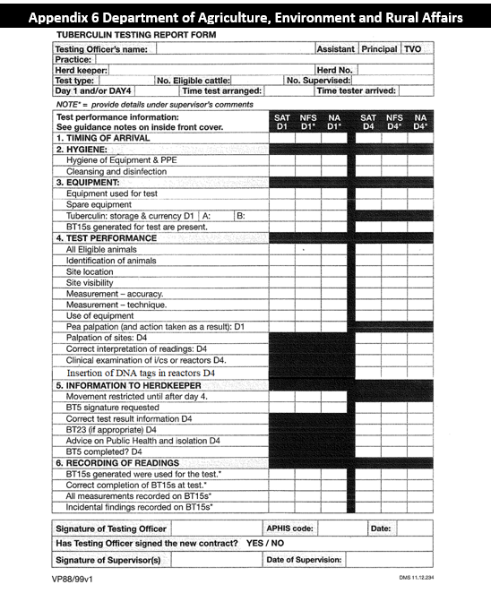

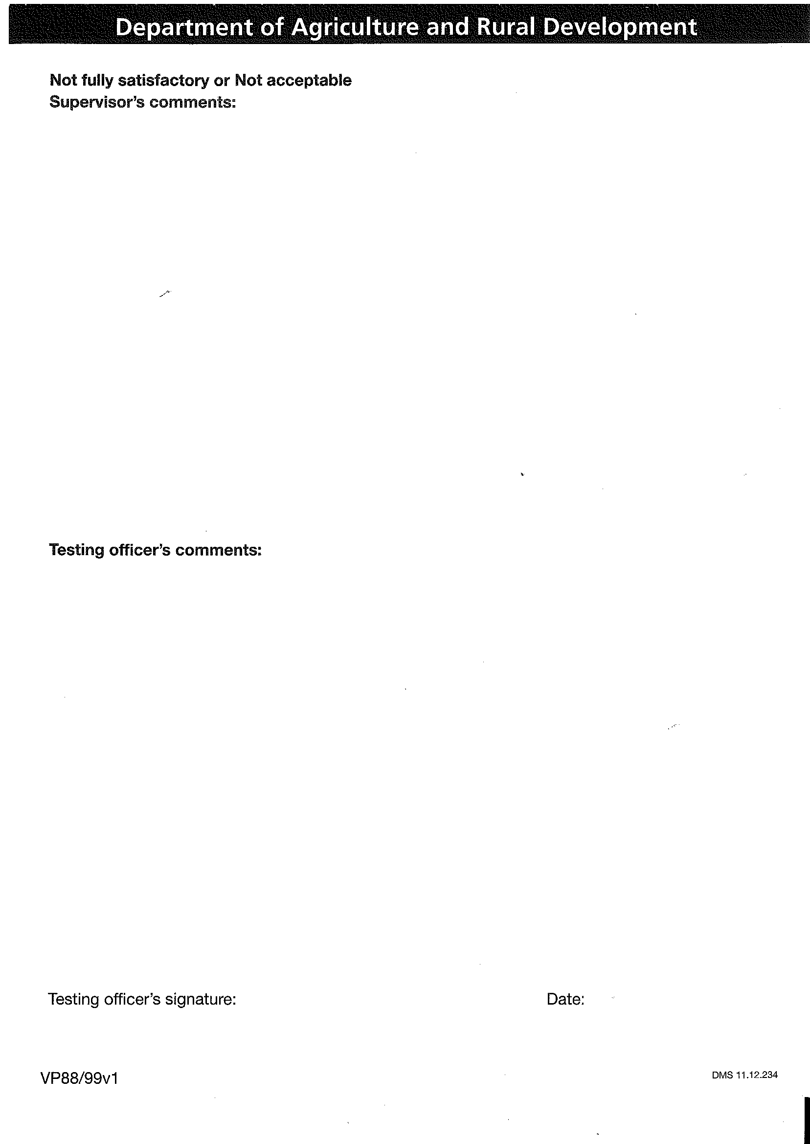

**Department of Agriculture, Environment and Rural Affairs**

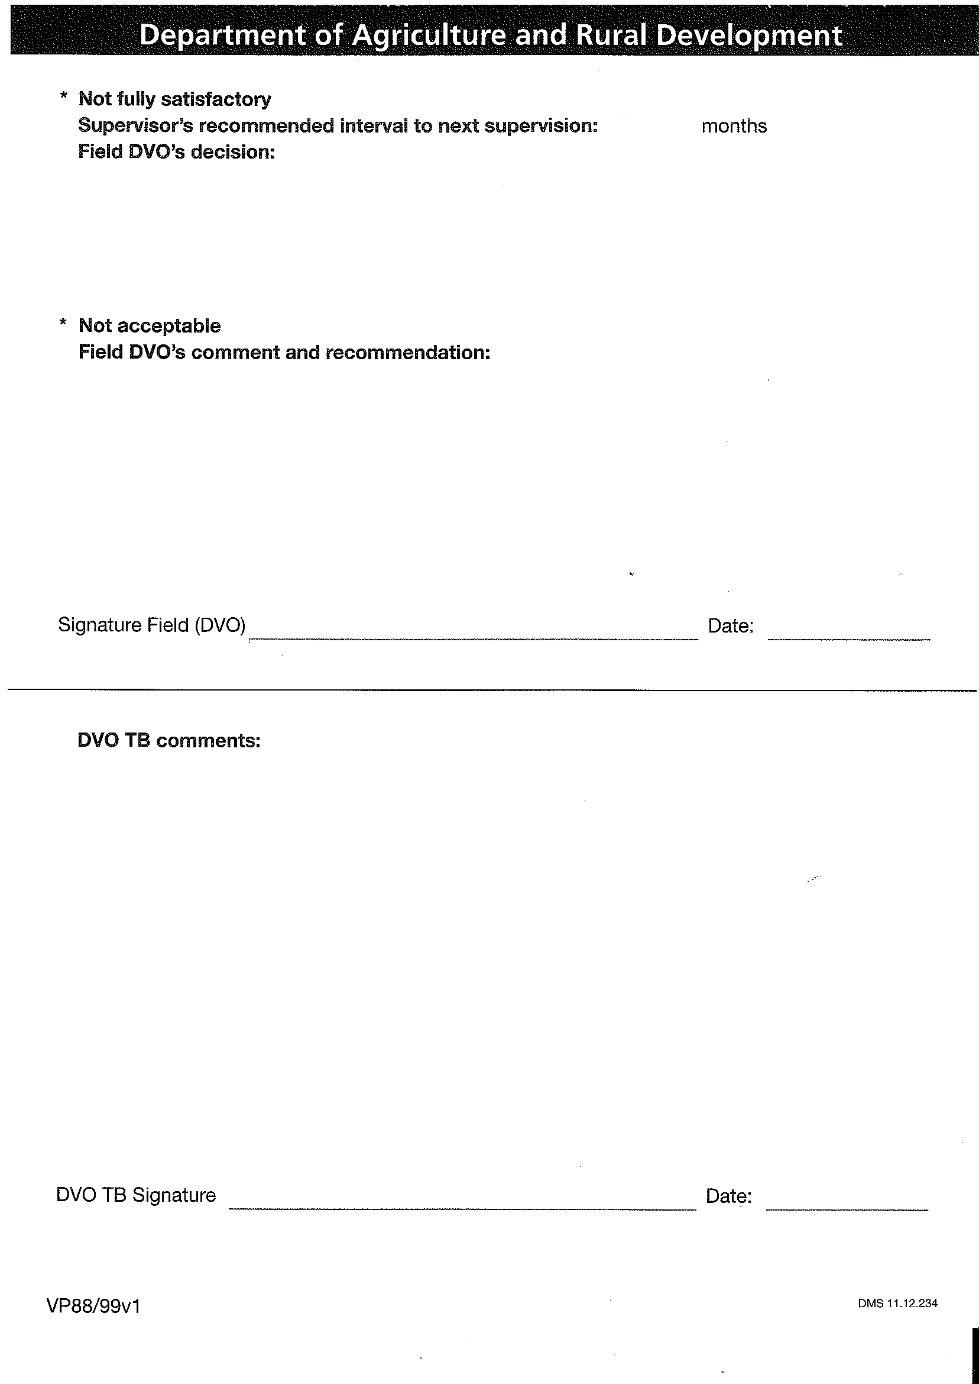

**Department of Agriculture, Environment and Rural Affairs**

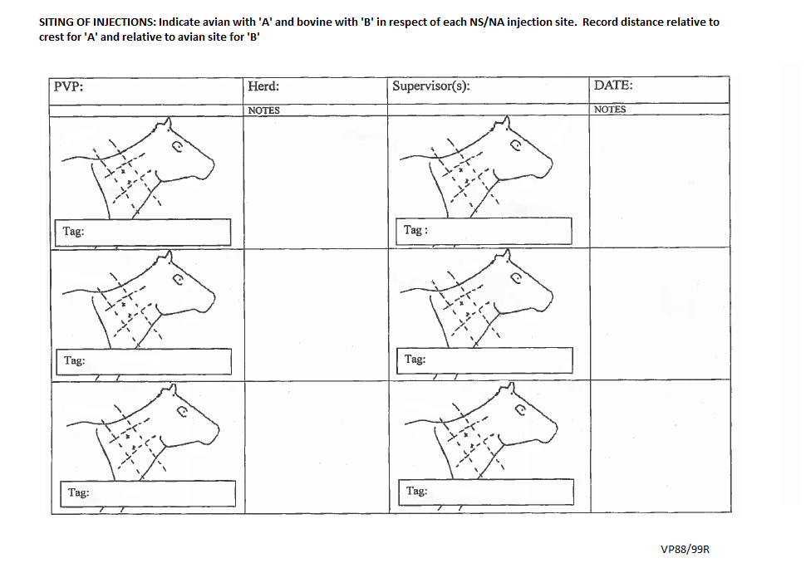

**Appendix 7**

