**How to Maintain an On-Farm Herd Register**

**Introduction**

EC Regulation (EC) 1760/2000 Article 7.4 and the Cattle Identification (Enforcement) Regulations (Northern Ireland) 1998 require herd keepers to maintain a herd register. This legislation requires certain information to be entered into the register for each animal in the keeper’s herd. When properly completed the herd registers available from DAERA enable keepers to comply with the requirements. Herd Keepers however do not have to use one of the registers provided by DAERA. Provided all the required information is recorded this may be done in another book or in a computerised format such as a spreadsheet or as part of a farm management software package.

Keepers may also opt to use the Department’s database (APHIS) as their herd register. For more information on this see links below to documents on Website re use of APHIS as herd register.

<https://www.daera-ni.gov.uk/news/how-maintain-your-herd-register-aphis>

<https://www.daera-ni.gov.uk/publications/online-herd-register-guidance-cattle>

**What information must be recorded in a herd register?**

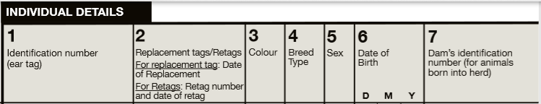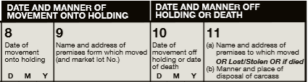

* For all animals born in your herd complete columns **1, 3, 4, 5, 6** and **7**.
* For animals born in another herd complete columns **1, 3, 4, 5, 6** and **8** & **9**

In addition:

* When a replacement tag is inserted or an animal has to be re-identified with a different tag number complete column **2**.
* When animals leave the herd or die complete columns **10** & **11**.

**N.B.** For information on the codes to use for Colour, Breed and Sex for entry in the herd register see the following link:

<https://www.daera-ni.gov.uk/articles/codes-use-herd-register>

**When should information be entered in the herd register?**

The Cattle Identification (Enforcement) Regulations (Northern Ireland) 1998 introduced the following time limits within which a record must be made in the register.

|  |  |
| --- | --- |
| **Animal event to be recorded** | **Time limit** |
| Movement on or off a holding | 36 hours |
| Calf birth (dairy herd) | 7 days |
| Calf birth (other herds) | 30 days |
| Death | 7 days |
| Replacement ear tag | 36 hours |

When all the required information has been entered in a herd register within the above time limits it is referred to as a **“contemporaneous”** register.

Keeping a “contemporaneous” herd register is important if it is to be used to resolve queries regarding animals or to support amendments to information recorded on the DAERA computer system (APHIS).

**When will a herd register be inspected?**

Your herd register will be inspected if you are selected for a cattle identity inspection. In this case the inspector will be checking that the information in your herd register is complete and that the description for each animal in the register matches the description of the animal inspected.

Your herd register may also be inspected in the event of a query on the identity of an animal or a request to change the details of an animal on the Department’s computer system APHIS.

If your herd register is **“contemporaneous”** as described above a check of your herd register may enable queries to be resolved or changes made to the information recorded on APHIS without any adverse statuses being applied to the animal in question.

**Can an Electronic Herd Register be Contemporaneous?**

For an electronic register to be contemporaneous it must have an audit functionality which maintains a record of any changes which have been made to an entry and when they were made.

Many farm software packages will have this facility and so they can be checked to ensure they have been kept contemporaneously. Any which do not have such an audit functionality, while they may enable the keeper to comply with the regulations regarding keeping a register are not so useful in resolving queries or correcting information on APHIS.

Please note that a simple spreadsheet is unlikely to incorporate appropriate audit functionality and therefore could not be considered a contemporaneous record.