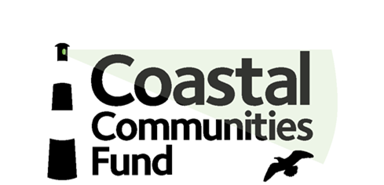

Full cost recovery

Ensuring you apply for all project costs

Overheads and full cost recovery

You can apply to Department of Agriculture, Environment and Rural Affairs (DAERA) for some of your overheads as well as the direct costs of your project. This page explains how to calculate your overheads so that you can apply for all the funding you need for your project.

What is full cost recovery?

Full cost recovery means securing funding for all the costs involved in running a project. This means that you can request funding for direct project costs and for a proportionate share of your organisation’s overheads.

What are the direct and overhead costs of a project?

A project is a specific and distinct piece of work that you would like us to fund.

Direct project costs are the costs that relate clearly and directly to a project. These can include salaries for project workers, volunteer expenses and a dedicated laptop for the project.

Overheads are costs that partly support the project, but also support other projects or activities that your organisation provides. These could be a proportion of salaries of core staff such as administrators. They could also be rent and utilities costs or your organisation’s legal and audit fees.

How do I apply full cost recovery?

- If the project you are looking for funding for is your core work and the only project you run, then you do not need to calculate your overheads separately - just request all your costs as direct project costs.

Example
A small organisation runs a lunch club once a week. It does not run any other work or projects. The lunches, venue hire and any volunteer expenses are direct costs. There are no overheads.

- If you are managing many projects or activities at the same time, you need to work out how to share out your organisation’s overheads to each project.

Example
An organisation runs three projects from one building: a lunch club for elderly people, training sessions for single parents and dance classes for members of the community. The organisation would like funding for the training project. They have worked out that the project’s direct costs include the trainer’s salary, books, stationery, a laptop and a projector. The rent and utilities costs are overheads and must be shared fairly between the organisation’s three projects.

How do I share out the overheads for each project?

The following guidance explains how to calculate the full costs of your project, including the project’s overheads.

•Applying for your project overheads (PDF. 134KB)
•Project overheads spreadsheet guidance notes (PDF. 103KB)

Use the project overheads spreadsheet (Excel. 62KB) to calculate the direct and overhead costs for your project and to estimate how much you would like us to contribute to your project.

