Scheme Year 2022/23

Forest Protection Scheme Ash Dieback

Forest Protection Scheme


Ash Dieback
Application Form
It is strongly recommended that the guidance document (Annex 1) for the Revised Forest Protection Scheme –Ash Dieback is read in advance of completing this application.

- Applicant(s) Details
Title |  | Forename |  |  |  |  | Surname
DAERA Business ID |  |  |  |  |  | Owner or Tenant
Business Name
Business Members |  | 1.  2. |  |  |  | 3.  4.
Contact Tel No |  |  |  |  |  | Mobile Number
Address
Postcode |  |  |  | Email
How would you like us to contact you? |  |  |  |  |  |  |  | Email |  |  | Post

- Agent Details (If you have an agent)

Title |  | Forename |  |  |  | Surname
Company
Contact Tel No |  |  |  | Mobile Tel No
Address
Postcode |  |  |  | Email
Would you like us to copy correspondence to your agent? |  |  |  |  |  |  |  |  | Yes / No

- Eligibility Criteria Checklist
Is Ash dieback disease confirmed within the 10 kilometre square using the map published on the DAERA website?
Is the application area still within the period of commitment* specified in your Forestry Grant Scheme Agreement?
*usually 30 years in the case of predominately broadleaved woodland
Is the application for at least 0.2 hectares of woodland?
Is the ash component more than 20% within each field you are applying for?
Is the average height of the ash component less than 10m within each field?
Your ash woodland does not display semi-natural characteristics and/or is not designated as an ASSI.

- Background Information
Use this section to identify features that are present within your site and where required, on land adjacent to your proposed woodland. NIEA Natural Environment Map Viewer: https://appsd.daera-ni.gov.uk/nedmapviewer/
Feature |  | Within Site | Adjacent to Site
Areas of Special Scientific Interest |  | Yes/No | Yes/No
Special Areas of Conservation |  | Yes/No | Yes/No
Special Protection Area |  | Yes/No | Yes/No
Other (please Specify): |  | Yes/No | Yes/No
Notes

Where appropriate, you should identify the features below on an accompanying map.

Feature | Within Woodland
Water
Watercourses | Yes/No
Lakes | Yes/No
Other (please specify) | Yes/No
Mitigating measures

- Woodland Survey

You must submit your woodland survey form on the template published with this application form and associated guidance.

Part 1 - Proportion of ash trees
To assess the number of ash trees within each field you should provide a representative sample from each field. The recommended technique is to walk a transect diagonally from corner to corner of each field as illustrated in the Transect examples within Appendix 3 – Woodland Survey of the Guidance for the Revised Forest Protection Scheme 2019/20 – Chalara Ash Dieback. If you do not reach 100 trees within the first transect you should take a second diagonal transect and repeat this process until you exceed 100 trees within your field sample. This approach will typically require you to walk a minimum transect length of 200 metres if your initial planting was at 2 metre spacing (2,500 trees per hectare) or 300 metres if your initial planting was at 3 metre spacing (1,100 trees per hectare). You must mark every 10th tree along your transect with either a single tape or a painted band similar to Photo 1 in Appendix 3 – Woodland Survey of the Guidance for the Revised Forest Protection Scheme 2019/20 – Chalara Ash Dieback
Part 2 - Height of ash trees
The scheme cannot provide any grant aid for woodlands where the ash has grown to over 10 metres tall. Therefore, we require you to provide information about the height of ash in your woodland by recording whether the tree is; less than 4m tall, between 4 and 10 m tall or is taller than 10m. We do not require specific measurements for each tree, just the band each measured tree falls into. You should measure the average height of the ash trees identified in part 1 of your woodland survey by estimating the height of 5 ash trees in each field at intervals along your transect. You must avoid selecting the smallest trees and should select 5 that are representative of trees in the canopy. These 5 trees need to be marked at about 1.3 m height from the base of the tree with a double tape or double painted band similar to Photo 2 in Appendix 3 – Woodland Survey of the Guidance for the Revised Forest Protection Scheme 2019/20 – Chalara Ash Dieback.

Forest Protection Scheme - Woodland Survey and Replant Form

- Replanting Form
The species diversity must be maintained or enhanced. Opportunities must be taken to further diversify the species composition. A minimum of 3 tree species with each species component comprising 10% or more on a field by field basis. All replanting must be site appropriate broadleaved species. The exceptions are Scots pine where no more than 30% is allowed within the grant application area and yew.

7.0 Declaration
I/we declare that I/we have read and understood the Forestry Grant Schemes Information Booklets which describe the rules and procedures for the Forestry Grant Schemes.

I/we also declare that the information contained in this application form is correct and complete to the best of my/our knowledge and belief and that there are no legal and/or other restrictions which would prevent the specified work from being carried out.

Applicant Name |  | Signed |  | Date
Applicant Name |  | Signed |  | Date
Applicant Name |  | Signed |  | Date
Applicant Name |  | Signed |  | Date

8.0 Checklist
Completed and signed Forest Protection Scheme – Ash Dieback application form

Map clearly showing fields being applied for grant

Forest Protection Scheme Ash Dieback Woodland Survey and Replant Form (see section 5)

Felling Licence application, if appropriate (guidance link: Applying for a felling licence)

Completed application documents to be posted/emailed to:

Forest Service Headquarters - Grants Branch
Inishkeen House
Killyhevlin Industrial Estate Killyhevlin
Enniskillen
Co. Fermanagh BT74 4EJ

Email: grants.forestservice@daera-ni.gov.uk

Tel: 028 6634 3103

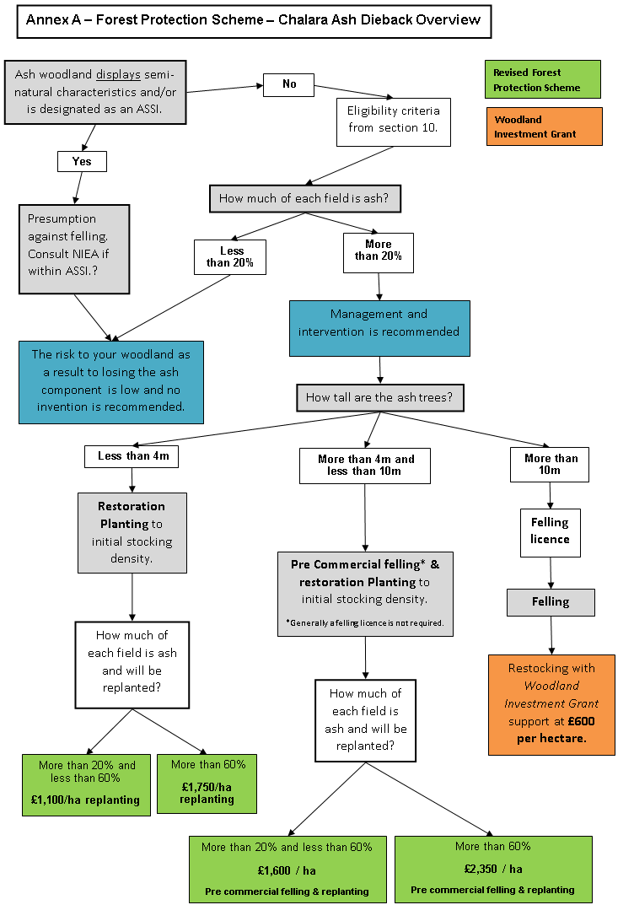

DAERA - Forestry Privacy Notice

This Privacy Notice provides information about Forest Service’s processing of personal information in relation to delivery of our Forestry functions. Forest Service also processes personal information in relation to delivery of our Plant Health functions – a separate Privacy Notice for these functions is available at: www.daera-ni.gov.uk/publications/phib-privacy-note

Data Controller Name:
(Forest Service – An Agency of) The Department of Agriculture, Environment and Rural Affairs

DAERA Data Protection Officer Telephone: 028 7744 2350
Email: dataprotectionofficer@daera-ni.gov.uk

Why are we processing your personal information?

• For the sale of forest products, provision of services, management of facilities, and regulation of forestry activities under the Forestry Act (NI) 2010 (including enforcement of the Byelaws) and the Environmental Impact Assessment (Forestry) Regulations (NI) 2006 (as amended) and the administration of Forestry Grant Schemes under the EU’s Rural Development Programme.
• In addition, we may also process your personal information for other legitimate purposes in line with the General Data Protection Regulations (2016), Freedom of Information Act 2000 and Environmental Information Regulations 2004. We may also process personal information supplied to us in the course of any claim, customer complaint, legal action or any other business transaction initiated by you.

Where do we get your personal data from?

• We will collect your information primarily from applications for services and subsequent information that you provide to us, as the data subject, in relation to the provision of these services. We may also collect additional information from other agencies that is necessary to provide the services requested. We will also maintain and update your data with any information you subsequently share with us in order to ensure your data is factual, accurate and up-to-date.

Do we share your personal data with anyone else?
Data sharing takes place for legitimate reasons, to support the business purposes for which it was supplied. If we need to share your personal data, it will be done so under contract which will require the processor to protect the data and act only in regard to DAERA business purposes. We may also share this information with:
- Other bodies responsible for law enforcement and the audit or administration of public funds, in order to prevent and detect crime or fraud;
- Tax and customs authorities, when requested by them to do so;
- Selected third party processors who we use for processing applications or for making payments to you;
- NI Direct;
- Third party ICT systems to support contractors who maintain our ICT systems which hold your personal data.

Do we transfer your personal data to other countries?
• Should it be necessary to transfer personal information overseas, any transfers made will be in full compliance with all aspects of The Data Protection Act 2018.

How long do we keep your personal data?
• We will retain your data only for as long as necessary to comply with legislation, and/or where there is a business need to do so (i.e. for the administration of your application and/or payment). Your data will be kept in line with our Retention and Disposal Schedule.

Changes to this Privacy Notice
• We will make changes to this notice from time to time, particularly when we change how we use your information or the services we provide. You can always find an up- to-date version of this notice on our website at: www.daera-ni.gov.uk/sites/default/files/publications/daera/fs-forestry-privacy- notice-2018.pdf
• You can also contact the DAERA Data Protection Officer should you require further information (contact details given below).

What rights do I have?
• You have the right to obtain confirmation that your data is being processed and to access your personal data.
• You are entitled to have personal data rectified if it is inaccurate or incomplete.
• You have a right to have personal data erased and to prevent processing, in specific circumstances
• You have the right to ‘block’ or suppress processing of personal data, in specific circumstances
• You have the right to data portability, in specific circumstances
• You have the right to object to the processing, in specific circumstances
• You have rights in relation to automated decision making and profiling

How do I complain if I am not happy?
If you are unhappy with how any aspect of this privacy notice, or how your personal information is being processed, please contact Department Data Protection Officer at:

DAERA Data Protection Officer, Ballykelly House,
111 Ballykelly Road, Limavady, Londonderry
BT49 9HP
Telephone: 028 7744 2350
Email: dataprotectionofficer@daera-ni.gov.uk

If you are still not happy, you have the right to lodge a complaint with the Information Commissioner’s Office (ICO):
Information Commissioner’s Office
Wycliffe House Water Lane Wilmslow Cheshire
SK9 5AF
Tel: 0303 123 1113
Email: casework@ico.org.uk & https://ico.org.uk/global/contact-us/

Changes to this Privacy Notice
We keep this privacy notice under regular review and we will place any updates on this web page. This privacy notice was last updated on 8 May 2018.

How to contact us
If you have any questions about this notice or the information we hold about you, please contact us.

DAERA, Forest Service – June 2022

