**Data Quality Report Administrative Data Source**

**Northern Ireland carrier bag levy statistics – annual publication**

Administrative Source Quality Report last updated on: 22 August 2019

**Overview**

In 2015 the UK Statistics Authority published a regulatory standard for the quality assurance of administrative data. The standard was developed in response to concerns about the quality of administrative data and in recognition of the increasing role that such data is playing in the production of official statistics. The standard encourages risk based judgements and supports a proportionate approach.

The standard is supported with an Administrative Data Quality Assurance Toolkit which provides useful guidance to statistical producers about the practices they can adopt to assure the quality of the data they utilise.

The DAERA Statistics Charter, Pre-release Access Statement and Statement of Administrative Sources[1] set out how the Department of Agriculture, Environment and Rural Affairs for Northern Ireland (DAERA) applies the National Statistics Code of Practice and related Protocols, and the Pre-release Access to Official Statistics Order (Northern Ireland) 2009 to the wide range of agriculture, food, animal health, fisheries and forestry statistics that are produced under this framework. The DAERA [Statement of Administrative Sources](https://www.daera-ni.gov.uk/publications/statement-administrative-sources-used-statistical-purposes-0) on the Departmental website contains information on the data sources utilised by SASB in the production of its statistics. This data quality document provides information on the administrative data source used by the Department of Agriculture, Environment and Rural Affairs (DAERA) Statistics and Analytical Services Branch (SASB) to publish carrier bag levy statistics along with a quality assessment on it.

The Single Use Carrier Bags Charge Regulations (Northern Ireland) 2013 were made on 15 January 2013 and came into operation on 8 April 2013. Following the introduction of the legislation in 2013 all sellers of goods in Northern Ireland were required to charge their customers at least 5 pence (the levy) for every single use carrier bags supplied new. From 19 January 2015, the legislation was extended, by the Carrier Bags Act (Northern Ireland) 2014, to all carrier bags with a retail price of less than 20 pence, regardless of whether they are considered single use or reusable. The carrier bag levy in Northern Ireland is administered and managed by the Carrier Bag Levy Team (CBLT) within DAERA through a customer facing website on NI Direct. The administrative systems and data in place for the levy implementation and management are used to produce annual official statistics on the numbers of bags dispensed by retailers in Northern Ireland.

The quality report for this administrative source is contained in this document. It provides information on the source, provider, quality assurance and audit arrangements of the administrative data source used in the production of carrier bag levy statistics. It also assesses the risk of data quality concerns and the public interest profile of the statistics. The latest published statistics can be found on our website: <https://www.daera-ni.gov.uk/publications/carrier-bag-levy-annual-statistics>.

|  |  |
| --- | --- |
| Data Supplier | Carrier Bag Levy Team in Department of Agriculture, Environment and Rural Affairs (DAERA) |
| Supplier Information | The Carrier Bag Levy Team (CBLT) are responsible for administering the 5 pence levy on all new carrier bags with a retail price below 20p. This is managed through a customer facing online system on NI Direct where retailers can login to declare and make payments for the numbers of bags dispensed by quarter. |
| Data Type | Number of bags per retailer per quarter |
| Data Content | Numbers of carrier bags dispensed in Northern Ireland are gathered on a database with retailer name, quarter and year and some financial data. |
| Supply Schedule | CBLT provide figures on an annual basis. Data are supplied to SASB three months after the end of the financial year. |

|  |  |
| --- | --- |
| Use of Data | SASB use the data to produce official statistics on the numbers of carrier bags dispensed on an annual basis. The CBLT use the data to monitor and manage the implementation and compliance of the levy across all retailers in Northern Ireland. |
| Data Source Information | Retailers use a range of methods to collate data on the numbers of bags dispensed, e.g. spreadsheets, written records, barcodes and till epos reporting systems. The number of bags dispensed are then entered on to the online system (via NI Direct) on a quarterly basis. The online system has integrated some basic validation checks, e.g. ensuring only numbers are entered and there is only one return per quarter. CBLT can then download this information and share it with SASB in order to produce the statistical report. |
| Data Supply and Communication | Retailers keep a record of the number of carrier bags supplied to customers which attract the requirement to charge as well as the net proceeds of the charge.  The CBLT request the seller to supply a record via a declaration on the online portal within 28 days of the end of the quarterly payment period. Records are kept by the seller for a period of six years.  The CBLT maintain a database of retailers which are managed by dedicated case managers who carry out compliance visits across Northern Ireland. During compliance visits CBLT assess procedures used to collate data while examining for accuracy and completeness of information collected. The database includes the name, address, contact details, declaration and payments for bags included in the levy.  Each quarter retailers are required to:   * declare the number of carrier bags they have supplied for which they only charged the 5p levy (lower rate bags) * declare the number of carrier bags they have supplied for which they charged both the 5p levy and their own retail price of less than 20p (upper rate bags) * make the associated payment to DAERA within 28 days of the end of the quarter   Retailers return the above information via NI Direct. Returns that are collated by the CBLT and combined into quarterly and annual files. Files are validated/ checked and audited by the CBLT and SASB. On an annual basis the CBLT provide files detailing all quarterly returns and an annual bag usage file. This is provided in excel format with number of bags for each retailer registered on the system. An annual report is published detailing carrier bag usage. |
| Quality Assurance Carried out by Data Supplier | The CBLT have internal procedures in place and through the legislation can make test purchases and site visits to ascertain compliance with the regulations. Additionally, if the CBLT believe that there has been a failure to comply with the regulations they can question the seller (or their representative) and require that the seller produces documentation regarding the levy. CBLT carry out random record inspections on retailers throughout the year to ensure compliance and validation of the figures supplied. |
| SASB Quality assurance | Quality assurance includes:   * Comparing (the combined) quarterly files to the annual file to check for consistency in terms of numbers of retailers and bag numbers. * Comparing current and historical annual returns for anomalies * Checking for duplicates, outliers, distribution and trends in the numbers of bags * Check that returns are made within the levy period * Checking number of declarations for data completeness |
| Strengths of data source | Due to legal requirements all sellers are required to keep a record of carrier bags dispensed and to pay the levy to DAERA. On an ongoing basis CBLT staff are undertaking daily operational duties whereby they monitor towns throughout the province, identifying new businesses and others that have closed, and updating records accordingly. Sellers make payments for the associated declarations via a number of methods and these are online, cheque by post, cash and through direct payment to the bank. CBLT employ a number of legislation led internal admin processes to target levy payers for non-compliance.  Retailers are required to keep records for 6 years detailing the number of bags dispensed.  The CBLT has dedicated case managers who are responsible for ensuring retailers comply with carrier bag legislation. Returns are validated/checked and audited by the CBLT.  A dedicated helpline and website (www.nidirect.gov.uk/baglevy) is in place to answer retailer queries. |
| Weakness of Data Source | The cut-off date applied for the production of Official Statistics is 30 June each year. Not all companies will meet this deadline. Analysis of previous year’s data show that reported statistics differ from the actual total by on average 3 per cent per year.. |
| Assessment of Level of Assurance Requirements | The risk in quality of this source is low and the public interest is medium.  This suggest that the appropriate level of assurance required for these statistics is A1-Basic Assurance |
| NISRA Assessment of User Needs | The numbers of carrier bags dispensed is an administrative source of good quality and SASB recommends it can be used with no concerns for the publications of carrier bag levy statistics. |

**Risk/Profile Matrix** 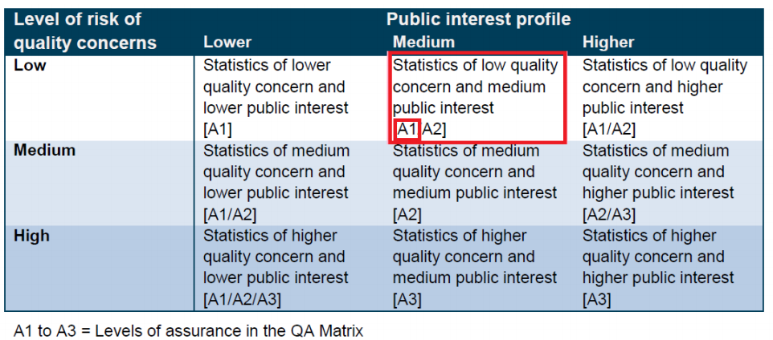

Source: Administrative Data Quality Assurance Toolkit, UK Statistics Authority, <https://www.statisticsauthority.gov.uk/wp-content/uploads/2015/12/images-qualityassurancetoolki_tcm97-44368.pdf>

1. <https://www.daera-ni.gov.uk/articles/dard-statistics-charter-and-pre-release-access-statements>