Food & Farming Group  Area-based Schemes Division |  |  | 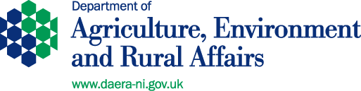
Area-based Schemes Division
Jubilee House
111 Ballykelly Road
Ballykelly
BT49 9HP
Email:crosscompliancereviewconsultation@daera-ni.gov.uk
Date: 20 June 2022

Dear Sir

INVITATION TO RESPOND TO CONSULTATION ON PROPOSED CHANGES TO THE CROSS-COMPLIANCE PENALTY REGIME

I am writing to invite you to respond to a consultation on proposals to amend the Cross-Compliance penalty regime with effect from the 2022 scheme year.

The attached consultation document provides detail on the current process and the proposed changes. It is aimed at key stakeholders who undertake activities or have a general interest in this area.

Consultation Arrangements

The closing date for receipt of the completed Stakeholder Response Template, also attached, is 15 August 2022. This should be sent by email to:

crosscompliancereviewconsultation@daera-ni.gov.uk

Thank you in advance for your help and participation in this consultation. Should you have any queries, please contact me at the email address noted above.

Yours faithfully

GREGOR KERR
AREA-BASED SCHEMES HEAD OF OPERATIONAL POLICY

