**CSO Training for NI Candidates – Registration process**

**Step by Step Guide**

**Step 1**:

The CSO candidate visits the Improve International **Animal Health Paraprofessional (AHP)** [website](https://www.improve-ahp.com/home/) and clicks on the ‘Register’ link on the blue bar at the top.

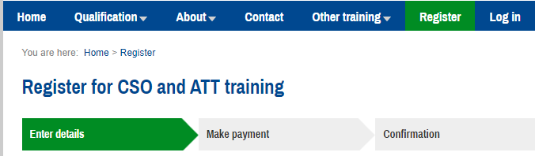

**Step 2**:

The candidate completes the registration form by entering their details, selecting current status option `**new applicant**` and also enter the details of the nominated Certifying Officer (CO), authorised Private Veterinary Practitioner (aPVP) or Food Competent Certifying Officer (FCCO) who will validate their eligibility for application. This must include a personal business email address or where not available a personal email address for direct correspondence. A generic office address is not acceptable. The candidate must also upload a photograph of their signature and make payment in order to complete the registration process.

**It is essential that Northern Ireland is entered as the ‘Region of work’ at this stage.**

The candidate must provide physical evidence of their qualifications in order for their nominated employer/CO to assess their eligibility. Eligibility criteria* can be found [here](https://www.improve-ahp.com/qualifications/cso.php).

*\*Candidates who do not meet the minimum requirements may satisfy eligibility criteria based on relevant practical experience and training. Where a candidate is seeking eligibility on the basis of experience only, it will be assessed by DAERA in the first instance. In these circumstances, candidates are required to submit all relevant information for consideration by DAERA. The information should be sent to: -* [*DAERATradeExports@daera-ni.gov.uk*](mailto:DAERATradeExports@daera-ni.gov.uk) *marked “Eligibility assessment for CSO application”.*

*For applicants who do not meet the minimum requirements DAERA will confirm whether the candidate is eligible to apply for CSO authorisation. If deemed eligible the candidate must provide DAERA`s confirmation of eligibility to the nominated CO in order to progress their application.*

**Step 3**:

The candidate will receive an automated email with a payment receipt and their log in details. If this does not arrive, candidates should check their ‘Junk’ e-mail folder.

**Step 4**:

At the same time, an automated email will be sent to the nominated Certifying Officer, which will prompt the CO to validate the CSO candidate’s eligibility. The CO will then enter their name and professional number (DAERA authorisation number as appears on personal official stamp) on the electronic form accessed through a link in the email, and return it to Improve International for validation.

**Step 5**:

The CSO candidate will receive an email to notify them that their nominated CO has confirmed their eligibility. They can then proceed to enrol on the course and complete the on-line training.

**Step 6**:

If the candidate wants to be officially authorised to work as a CSO in Northern Ireland, they must tick the relevant box on their ‘Training details page’ and must sit and pass the ‘end of course’ online exam.

The exam must be invigilated. To arrange invigilation, the candidate must nominate the CO to act as an invigilator for the exam. This generates an email to the nominated invigilator and, if in agreement, the invigilator inputs their name and their DAERA authorisation number (as appears on personal official stamp) on the electronic form accessed through a link in the email. At this stage the exam link will become available to the candidate and they arrange a convenient time with their nominated invigilator to sit the exam.

Currently invigilation can be carried out via zoom. Alternatively, there is an option to use a Third Party company to invigilate the exam – but this will be at a cost. All information can be found on the [Improve International website](https://www.improve-ahp.com/about/remote-invigilation.php).

**Step 7**:

If the candidate passes the exam, DAERA will be notified automatically, and will then process the candidate’s authorisation. This will include the issue of a DAERA Official CSO stamp accompanied by the terms and conditions of appointment document.

The candidate will receive an authorisation email from Improve International prompting them to log on to the Improve International website where they can view and print a certificate of completion as a downloadable PDF file.

**Step 8**:

CSOs will be contacted via email every 6 months to confirm their status and a reminder to update their details if appropriate. They can do this by [logging in to their AHP Personal Training Dashboard](https://www.improve-ahp.com/login/).

**Step 9**:

Revalidation of CSO training will be required every 3 years. CSOs will receive their first reminder email 6 months prior to the expiry of their qualification and then at frequent intervals after that, so they can enrol on and complete the revalidation training in good time.

Failure to complete the revalidation training will result in the CSO authorisation expiring.

For more information on revalidation go to [Improve International CSO revalidation](https://www.improve-ahp.com/about/revalidation.php).

**Please note: If any changes occur to your working status e.g. change in nominated CO please follow step 8 to update details.**