From: Norman Fulton  Deputy Director, Food and Farming Group |  |  |  | 
 | Dr Sinclair Mayne  Chief Executive  Agri-Food and Biosciences Institute  Newforge Lane  Belfast  BT9 5NX |  | Room 648a, Dundonald House  Upper Newtownards Road  Ballymiscaw  Belfast BT4 3SB  Telephone: 028 9052 4655  Email: Norman.Fulton@daera-ni.gov.uk  29 November 2016

Dear Sinclair

DARD DIRECTED AFBI RESEARCH WORK PROGRAMME 2016/17 (SUPPLEMENTARY B)

The DAERA Directed AFBI Research Work Programme 2016/17 (Supplementary B) is now open for proposals. The programme sets out the Department’s priority needs with regards to the design and implementation of an evaluation framework for the Farm Business Improvement Scheme (FBIS) Capital Scheme & scoping work for a longitudinal study of NI farm efficiency and performance. Attached is a copy of the Work Programme (Supplementary B) document.

For your information the Work Programme (Supplementary B) document is also available to download from the DAERA website at the following address:

https://www.daera-ni.gov.uk/publications/daera-directed-afbi-research-work-programme-201617

The proposal window closes on 20 December 2016 and EIPG will provide final approval for proposals.

Yours sincerely
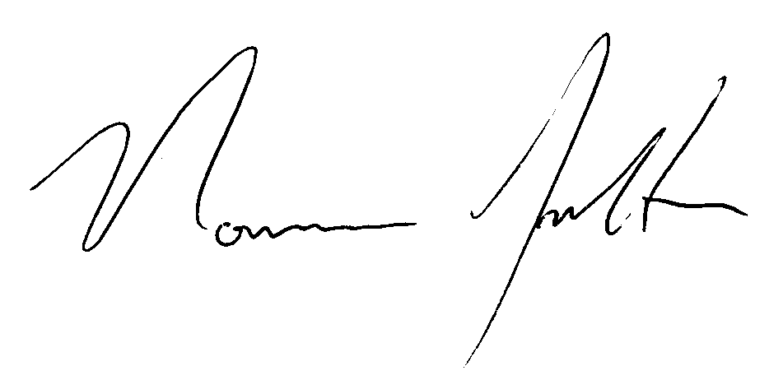
Norman Fulton
Deputy Director, Food and Farming Group

