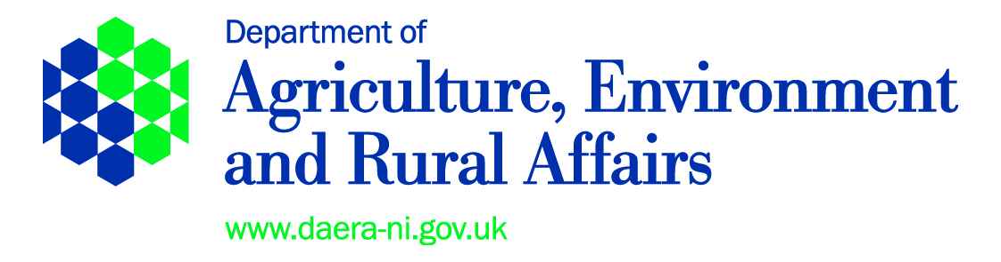

**DEPARTMENT OF AGRICULTURE, ENVIRONMENT AND RURAL AFFAIRS**

**THE ARTIFICIAL REPRODUCTION OF ANIMALS (NORTHERN IRELAND) ORDER 1975**

**(AS AMENDED)**

**ARTIFICIAL INSEMINATION OF CATTLE REGULATIONS (NORTHERN IRELAND) 1988**

**(AS AMENDED)**

**COMMERCIAL INSEMINATOR LICENCE**

The Department of Agriculture, Environment and Rural Affairs (“the Department), in exercise of the powers contained in regulation 3(1)(a) of the Artificial Insemination of Cattle Regulations (Northern Ireland) 1988 (“the Regulations”) hereby authorises:-

|  |
| --- |
| **Name and Address** |

(“the licensee”) the employee of, **Company** to perform artificial insemination of cows on farms in Northern Ireland, subject to the following conditions:-

**1.** The Licensee shall:-

1. in the artificial insemination of a cow use only processed semen from straws which have a traceable identification mark and which have been obtained from the Supply Centre Store at **Address** by the Department;
2. maintain all equipment used and vehicle(s) used for the transport of bovine semen in a clean and hygienic condition at all times;
3. wear suitable protective clothing and, unless gloves are used, wash his hands before he begins insemination;
4. before leaving any premises after carrying out artificial insemination of cattle he:
5. washes his hands;
6. properly disposes of any used disposable equipment, including gloves;

and

1. properly disinfects, using an approved disinfectant, his protective clothing and, as appropriate, any equipment used by him.
2. immediately inform the Department through the Supply Licence Veterinarian (SLV) of any outbreak of notifiable disease on any premises owned by him or by any member of the family normally resident with him;
3. in respect of each insemination carried out by him, make the following record and provide it to the Supply Centre Store operator:
4. the date, time and place of the insemination;
5. the name, address and herd number of the owner of the cow inseminated;
6. the name, breed and ear tag number or other identification of the bull whose semen is used;

1. the ear tag number of the cow inseminated; and
2. make available all records referred to in paragraph (f) at all reasonable times for inspection by a person authorised by the Department who may make any copy thereof or extract therefrom.
3. The Licensee shall not-
4. except with the consent of the Department in writing, perform the artificial insemination of cattle on premises which are an Infected Place or within an Infected Area; and
5. be concurrently the holder of a farm inseminator licence granted under regulation 3(1)(b) of the Regulations.
6. The Licensee shall provide all reasonable assistance to the Department during inspections and comply with any reasonable requests.

This Licence shall come into effect on **Date** and shall be valid until**Date**

|  |  |  |  |
| --- | --- | --- | --- |
| **Signed:** |  | **Date:** |  |

Officer authorised by the Department

**NOTE:-**

1. The Department may at any time, by notice on the Licensee, modify, suspend or revoke this licence including any condition subject to which it is granted

1. This Licence is not transferable

**OFFENCES**

Any person who fails to comply with any condition subject to which a licence has been granted or contravenes any provisions of the Artificial Insemination of Cattle Regulations (Northern Ireland) 1988 (as amended) or knowingly or recklessly makes a statement false in a material particular for the purposes of obtaining a licence shall be guilty of an offence and shall be liable on summary conviction to a fine currently not exceeding £5,000.

**INTERPRETATION**

“Regulations” means the Artificial Insemination of Cattle Regulations (Northern Ireland) 1988 as amended by the Artificial Insemination of Cattle (Amendment) Regulations 1997;

“supply licence veterinarian” means a veterinary surgeon employed by the holder of the Storage Centre Licence (Supply Centre Store) and approved by the Department for the purposes of the licence;

“infected place” means a place declared by the Department to be infected with a notifiable epizootic disease to which bovines, sheep or pigs are susceptible;

“infected area” means an area around infected premises, declared by the Department to be an infected area as a result of an outbreak of a notifiable epizootic disease to which bovines, sheep or pigs are susceptible;

“approved disinfectant” means a disinfectant approved by the Department under the Diseases of Animals (Approval of Disinfectants) Order (Northern Ireland) 1972 as amended by the Diseases of Animals (Approval of Disinfectants) (Amendment) Order (Northern Ireland) 1975 and approved for use against Foot and Mouth Disease;

“processed” means semen which has undergone processing by means of -

(a) dilution;

(b) the addition of any substance which is calculated to prolong its natural life;

(c) the addition of any antibiotic or antimicrobial substance for the purpose of promoting and safeguarding animal health;

(d) packaging it into straws;

(e) freezing; and

(f) storing it after freezing in a quarantine storage depot for 30 days or such other period as the Department may direct in writing.

or by means of one or more of the processes listed at (a), (b), (c) and (d) of this definition.

Other words and expressions in the licence have the same meaning as in the Regulations