DAERA Postgraduate Symposium 2019

DAERA Permanent Secretary Dr Denis McMahon and Dr. Sam Strain, Chief Executive of Animal Health and Welfare NI speaking to DAERA postgraduate students - Aaron Brown, Year 1 and Lauren Chesney, Year 2.

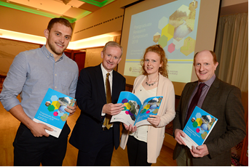

DAERA funded postgraduate student Samuel Hawe discussing his research with DAERAs Permanent Secretary, Dr. Denis McMahon.

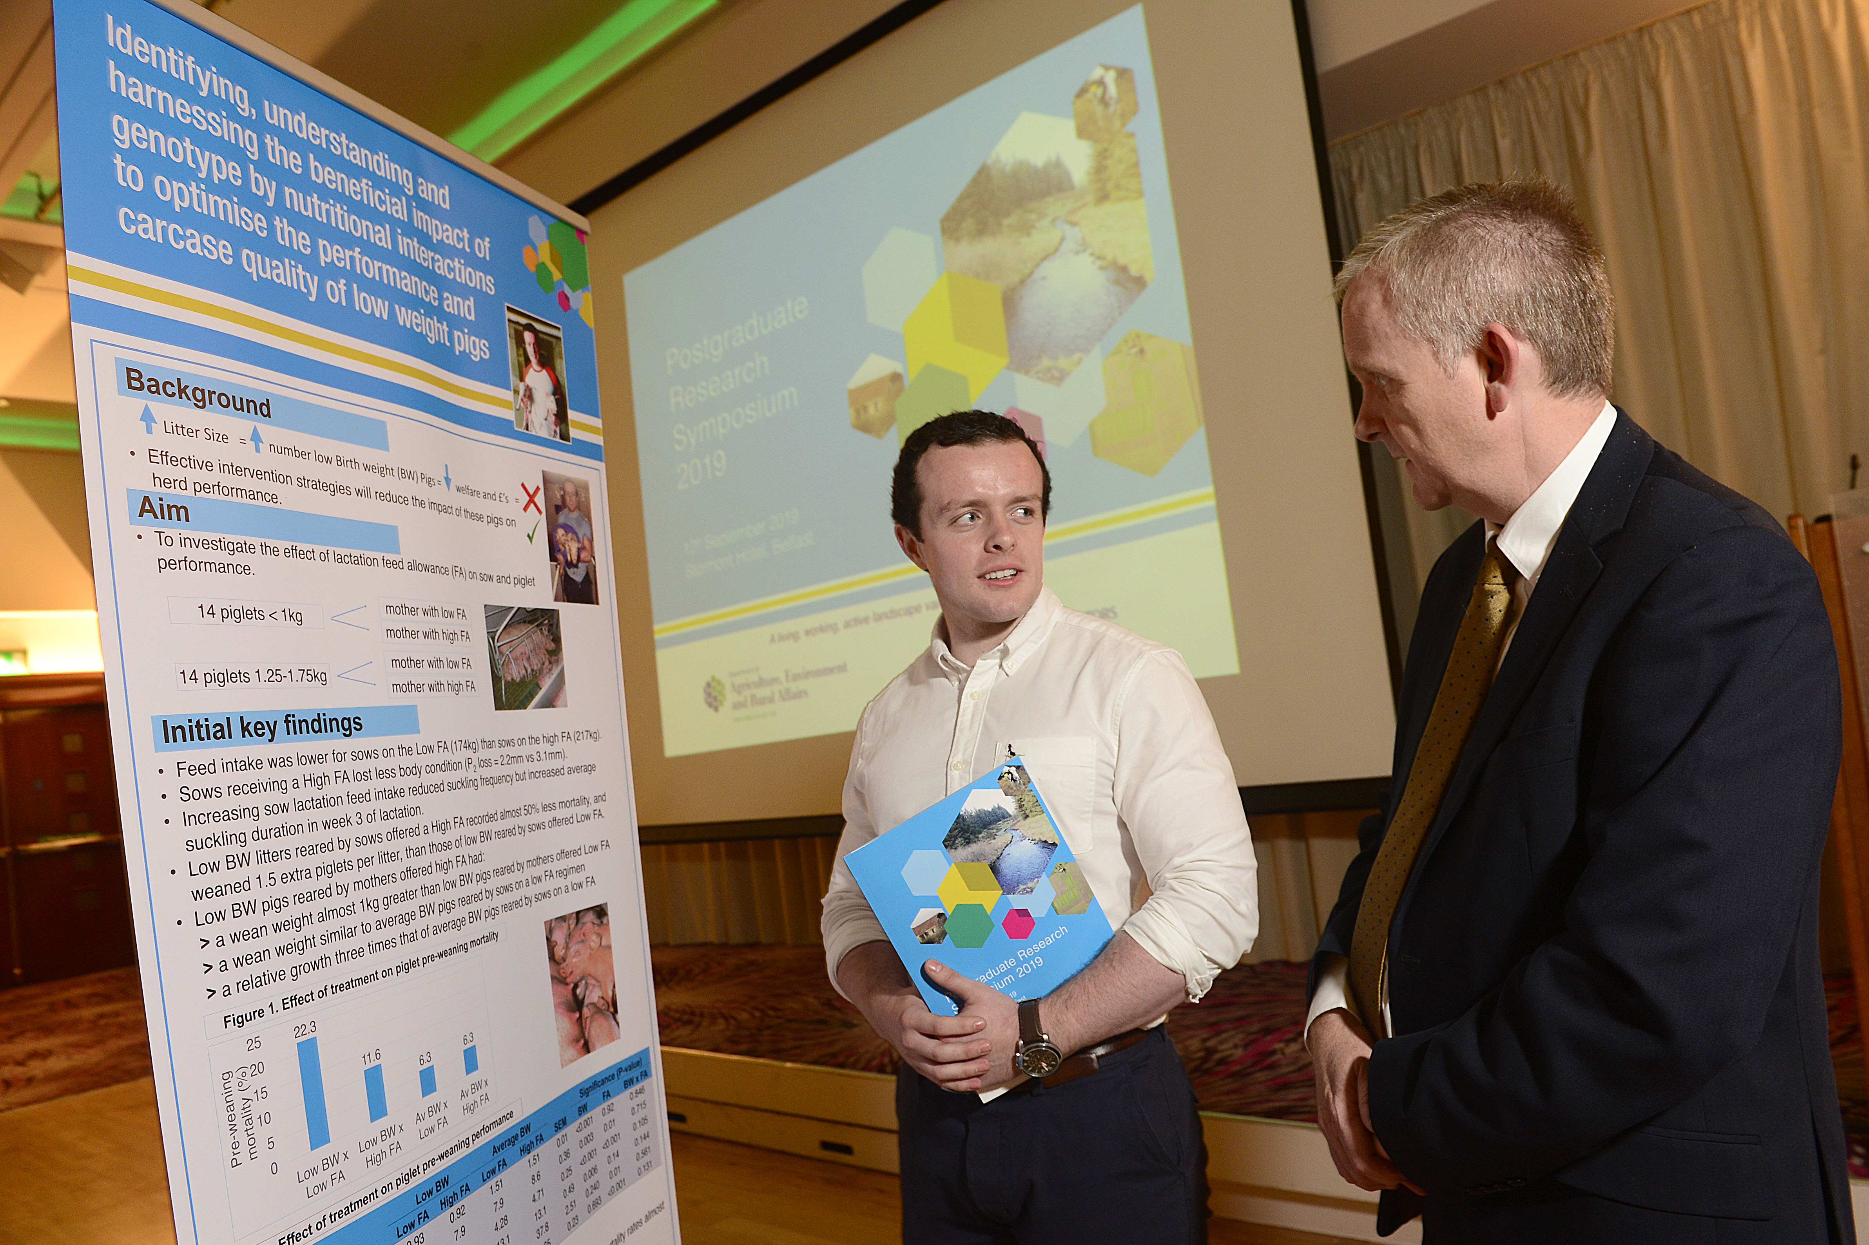

Some of the guests viewing the student posters.

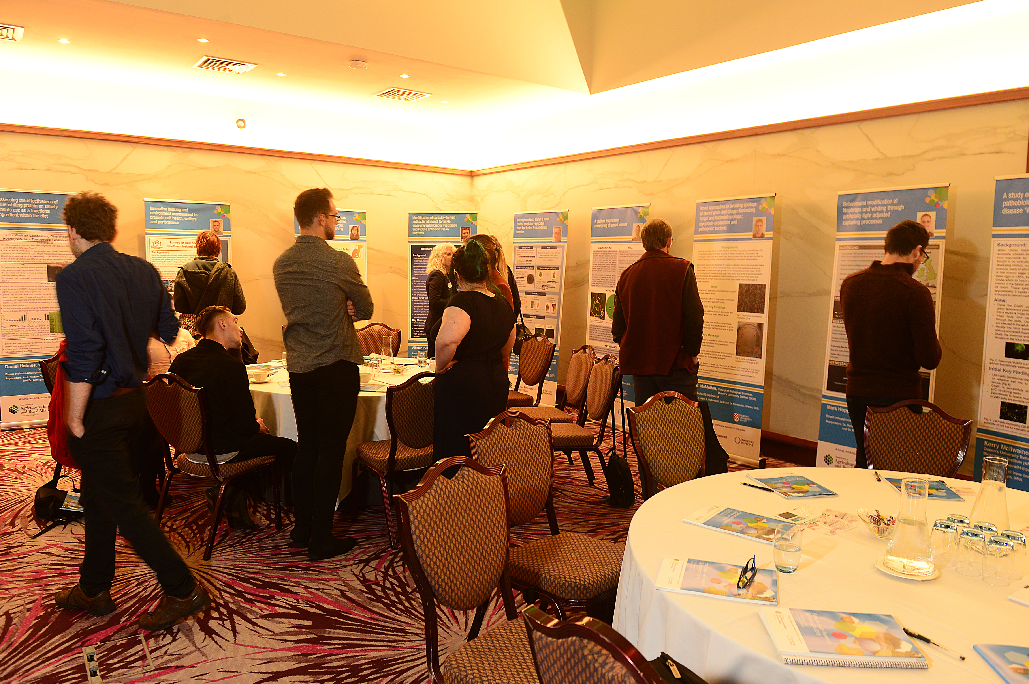

Slido was used by the audience to ask questions and vote for the best 1st and 2nd year poster.
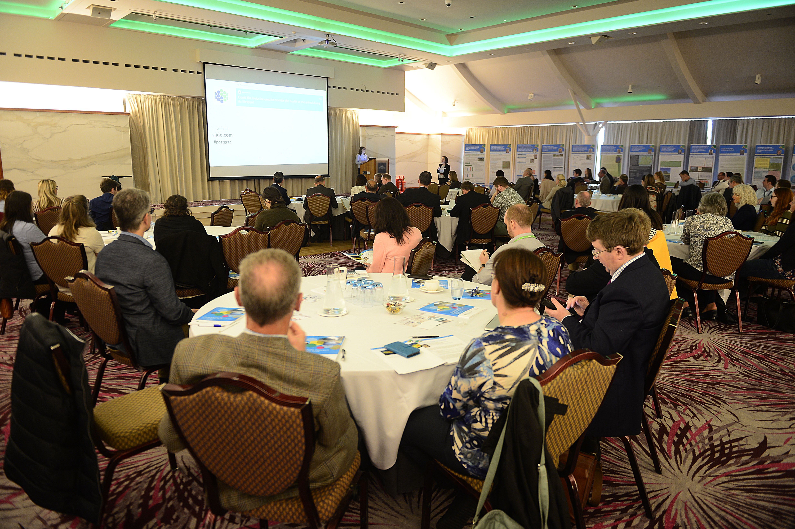

Great opportunity for networking.



Prizewinners

Prizewinners at the DAERA Postgraduate Symposium (Left to right: Katie Lawther (1st year poster), Paul Cottney (2nd year poster), Sophie Redpath (2nd year talk) and Naomi Rutherford (3rd year talk)) with Norman Fulton (deputy secretary), Mrs. Louise Millsopp (Chairperson) and Dr. Sam Strain (Chief Executive of Animal Health and Welfare NI).

