**Screening Report**

**Strategic Environmental Assessment Determination on the draft Ammonia Strategy Consultation 2022**

**1.0 Introduction**

This document constitutes DAERA’s Screening Report for a determination as to whether its draft Ammonia Strategy 2022 should be subject to Strategic Environmental Assessment (SEA) under the Environmental Assessment of Plans and Programmes (Northern Ireland) Regulations 2004.

* 1. **Programme Background**

Ammonia is a form of nitrogen which normally exists as a gas but it can also combine with airborne particles or rain. It is released largely through the management of slurries and manures and the spreading of fertiliser. Ninety-seven percent of ammonia emissions come from agriculture and these emissions are damaging many of our most valuable natural habitats. Ammonia impacts the environment in two ways; through direct ammonia concentrations in the air, and by reacting in the air to cause deposition of nitrogen on land. Ammonia is a particular issue for Northern Ireland due to the predominance of livestock farming.

Northern Ireland has almost 394 sites of high nature conservation value designated for their protection. Almost 250 of these are sensitive to the impacts of ammonia and nitrogen. The vast majority of designated sites are currently experiencing ammonia concentrations and nitrogen deposition above the critical levels and loads at which damage to plants may occur. There is significant evidence that important and protected plant species are being damaged by excess ammonia and nitrogen deposition. Urgent action is therefore required to reduce emissions.

* 1. **Programme Purpose and objectives**

DAERA propose to develop the Ammonia Strategy to address the impact of ammonia emissions on the environment in Northern Ireland. Ammonia reductions will support the restoration of biodiversity, ecosystems and the services they provide, while facilitating the sustainable development of a prosperous agri-food industry. The aim of the strategy is to achieve the sustained and tangible reductions in ammonia emissions are required to protect nature, to meet Northern Ireland’s legal obligations and to ensure a sustainable agri-food sector.

* 1. **Legislative Background**

The European Directive 2001/42/EC *'on the assessment of the effects of certain plans and programmes on the environment'*, known as the Strategic Environmental Assessment or SEA Directive, applies to certain types of plans and programmes, such as land use and spatial planning, to ensure that environmental effects of such plans and programmes are considered during their preparation.

The SEA Directive is transposed into law in Northern Ireland through The Environmental Assessment of Plans and Programmes Regulations (Northern Ireland) 2004.

The aim of the Directive as set out in Article 1 is *'to provide for a high level of protection of the environment and to contribute to the integration of environmental considerations into the preparation and adoption of plans and programmes with a view to promoting sustainable development'.*

There are a number of stages in the SEA process as set out in the legislation:

* Screening - determination of whether a particular plan, programme or modification is likely to have significant environmental effects. Consultation on said determination with consultation body.
* Scoping – determining the scope of the SEA with the relevant consultees on the level of detail of the SEA.
* Reporting – an assessment of the likely effects of the plan on the environment and the preparation of environmental report and publication.
* Consultation - Consultation with the general public and consultation body.
* Post-consultation - post adoption procedures. Publication of the Environmental Report taking into account feedback from consultation.
* Monitoring - Monitoring of the plan.

The draft Ammonia Strategy also highlights DAERA’s legal obligations. DAERA is responsible for:

* compliance with the Habitats Directive and implementing legislation in Northern Ireland, and ensuring that steps are taken to avoid deterioration of habitats and species of community importance.
* compliance with air quality legislation including the National Emissions Ceiling Regulations and the Air Quality Standards Regulations.

1. **Purpose of the Strategic Environmental Assessment Screening Report**

**1.3.1** The objective of Strategic Environmental Assessment is to provide for a high level of protection of the environment and to contribute to the integration of environmental considerations into the preparation and adoption of plans and programmes with a view to promoting sustainable development.

**1.3.2** The purpose of this document is to undertake a screening assessment that meets the requirements of the European Legislation, applied in NI through the Environmental Assessment of Plans and Programmes Regulations (Northern Ireland) 2004.

**1.3.3** Under the legislation, Responsible Authorities must carry out screening to determine whether plans or programmes are likely to have significant environmental effects. Annex II of the Directive sets out the criteria for determining if significant effects are likely.

1. **Assessment Methodology**

**2.1. Methodology**

Responsible Authorities must carry out screening to determine whether plans or programmes of the types covered by Article 3(3) and 3(4) of the Directive are likely to have significant environmental effects, and whether a SEA is required. The criteria for the screening process are set out in Annex II of the Directive and transposed through Schedule 1 of The Environmental Assessment of Plans and Programmes Regulations (Northern Ireland) 2004.

In accordance with Regulation 9 of the NI regulations 'the responsible authority shall apply the criteria specified in Schedule 1 to the plan, programme or modification under consideration, and shall prepare a report on whether the authority considers that the plan or programme, is likely to have significant environmental effects'.

The Screening report will provide a high-level overview of the Strategy to provide context for the screening process. The plan will then be screened against the criteria set out in Annex II of the Directive to determine the need for a SEA. The criteria are:

The characteristics of plans and programmes, having regard, in particular to:

* The degree to which the plan or programme sets a framework for projects and other activities, either with regard to the location, nature, size and operating conditions or by allocating resources;
* The degree to which the plan or programme influences other plans and programmes including those in a hierarchy;
* The relevance of the plan or programme for the integration of environmental considerations in particular with a view to promoting sustainable development;
* Environmental problems relevant to the plan or programme;
* The relevance of the plan or programme for the implementation of community legislation on the environment (e.g. plans and programmes linked to waste management or water protection).

Characteristics of the effects and of the area likely to be affected, having regard, in particular to:

* The probability, duration, frequency and reversibility of effects;
* The cumulative nature of the effects;
* The transboundary nature of the effects;
* The risks to human health or the environment;
* The magnitude and spatial extent of the effects (geographical area and size of the population likely to be affected);
* The value and vulnerability of the area likely to be affected due to: special natural characteristics or cultural heritage, exceeded environmental quality standards or limit values, intensive land use;
* The effects on areas or landscapes which have a recognised national, community or international protection status.

**2.2. Draft Ammonia Strategy**

The key components of the draft Ammonia Strategy are:

* Setting targets to guide action. The targets DAERA proposes for 2030 are to reduce agricultural ammonia emissions from Northern Ireland by at least 30% to ensure that Northern Ireland is achieving its fair share of the UK’s international target under the Gothenburg Protocol and reduce ammonia concentrations at every designated site by at least 40%. The longer term target to 2050 is to reduce ammonia emissions to a point where critical loads of nitrogen deposition and critical levels of ammonia are not being exceeded at designated sites.
* Identifying the pillars of a coherent approach to delivering these targets, namely;

An ambitious and verifiable ammonia reduction programme for implementation on farms, including an NI-wide element and additional measures to be targeted in areas around designated sites;

A strategic programme of conservation, restoration and management of our most valuable habitats;

* Highlighting the action DAERA will take to enable the strategy;
  + Support a science and innovation agenda that informs best practice on delivery of the targets;
  + Support farmers to deliver this change.

**3. Environmental Screening**

**3.1** **Screening Checklist**

The Office of the Deputy Prime Minister (ODPM) Practice Guide provides a checklist based on the SEA Regulations to help determine whether SEA is required. This guide has been used as the basis on which to assess the need for SEA as set out below.

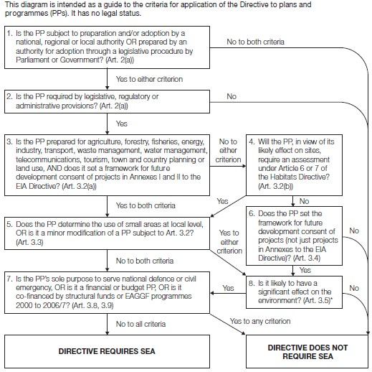

The table below sets out the questions identified in the diagram above and provides answers and reasons with regards to the draft Ammonia Strategy.

|  |  |  |  |  |
| --- | --- | --- | --- | --- |
| Establishing the need for SEA | | Answer | Reasons | Next Step |
| 1 | Is the PP subject to preparation and/or adoption by a national, regional or local authority OR prepared by an authority for adoption through a legislative procedure by Parliament or Government? (Art 2 (a)) | Yes | The draft Ammonia Strategy will be adopted by DAERA when finalised. | Proceed to Question 2 |
| 2 | Is the PP required by legislative, regulatory or administrative provisions? (Art 2 (a)) | Yes | Yes, there is a legal requirement to reduce ammonia emissions. | Proceed to Question 3 |
| 3 | Is the PP prepared for agricultural, forestry,  fisheries, energy, industry, transport, waste  management, water management,  telecommunications, tourism, town and county  planning or land use, AND does it set a framework  for future development consent of projects in  Annexes I and II to the EIA Directive? (Article  3.2(a)) | Yes | The draft Ammonia Strategy will impact primarily on the agricultural industry as 97% of ammonia emissions are from agriculture. | Proceed to Question 5 |
| 5 | Does the PP determine the use of small areas at  local level, OR is it a minor modification of a PP  subject to Article 3.2? (Article 3.3) | Yes | The draft ammonia strategy proposes spatial measures around designated sites, as well as an NI-wide component | Proceed to Question 8 |
| 8 | Is it likely to have a significant effect on the environment? (Article 3.5) | Yes | The aim of the ammonia strategy is to have a significant positive impact on the environment through the reduction of ammonia emissions and the protection of nature | Proceed to Question 7 |
| 7 | Is the PP’s sole purpose to serve national defence or  civil emergency, OR is it a financial or budget PP,  OR is it co-financed by structural funds or EAGGF  Programmes 2000 to 2006/7? (Article 3.8, 3.9) | No |  |  |

**3.2** The characteristics of plans and programmes, having regard, in particular, to:

**a)** *The degree to which the plan or programme sets a framework for projects and other activities, either with regard to the location, nature, size and operating conditions or by allocating resources.*

The draft ammonia strategy proposes a series of measures for ammonia reduction, including:

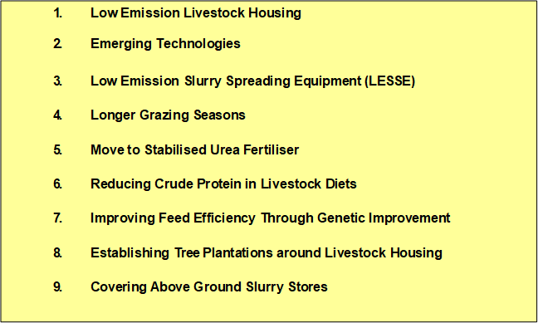

These activities will set an important framework for the future of agriculture in Northern Ireland and are likely to impact the majority of farming businesses in Northern Ireland.

1. *The degree to which the plan or programme influences other plans and programmes, including those in a hierarchy.*

The draft ammonia strategy will have an influence on all future agricultural plans and programmes as these will need to take into account the need for NI to reduce its ammonia emissions.

1. *The relevance of the plan or programme for the integration of environmental considerations in particular with a view to promoting sustainable development.*

Delivery of the ammonia strategy is integral to the sustainability of the NI agri-food sector. It highlights that farmers are dedicated to providing safe and healthy food products in a sustainable manner but current levels of ammonia emissions represent a threat to that sustainability. The draft strategy also pledges to support landowners and the necessary conservation actions to restore habitats and support sustainable development.

1. *Environmental problems relevant to the plan or programme.*

The draft Ammonia Strategy is dedicated to addressing the environmental problem of ammonia emissions and excess nitrogen deposition.

**e)** *The relevance of the plan or programme for the implementation of Community legislation on the environment (e.g. plans and programmes linked to waste management or water protection)*

DAERA is responsible for compliance with the Habitats Regulations, which is the relevant EU retained law with respect to habitats and species in Northern Ireland following EU Exit and ensuring that steps are taken to avoid deterioration of habitats and species of community importance. DAERA is also responsible for compliance with air quality legislation including the National Emissions Ceiling Regulations and the Air Quality Standards Regulations.

**3.3** Characteristics of the effects and of the area likely to be affected, having regard, in particular, to –

1. *The probability, duration, frequency and reversibility of the effects.*

Delivery of ammonia reduction through the draft ammonia strategy will have a long term positive impact on the Northern Ireland environment.

1. *The cumulative nature of the effects.*

The various measures highlighted in the draft strategy will combine to reduce ammonia emissions. The evidence base informing the draft strategy examined the cumulative impact of the ammonia reduction measures on emission levels.

1. *The transboundary nature of the effects.*

Delivering on the draft ammonia strategy will reduce the levels of transboundary Nitrogen Deposition emanating from Northern Ireland.

1. *The risks to human health or the environment (e.g. due to accidents).*

The draft ammonia strategy highlights that ammonia is a contributory factor to harmful particulate matter air pollution and that reducing ammonia emissions will have a positive impact on human health. As outlined above, sustained and tangible reductions in ammonia are required to protect nature, to meet Northern Ireland’s legal obligations and to ensure a sustainable agri-food sector.

1. *The magnitude and spatial extent of the effects (geographical area and size of the population likely to be affected).*

The draft ammonia strategy will have impacts across Northern Ireland given the potential for improved environmental and public health outcomes. The strategy will have a significant impact on farm businesses. There are approximately 25,000 active farm businesses in Northern Ireland and the area of agricultural holdings accounts for 1.02 million (m) ha (75 %) of Northern Ireland’s 1.36m ha.

**f)** *The value and vulnerability of the area likely to be affected due to:*

*i) special natural characteristics or cultural heritage;*

*ii) exceeded environmental quality standards or limit values; or*

*iii) intensive land-use.*

A key aim of the draft ammonia strategy is to protect priority habitats which are currently exceeding critical levels (the concentration of ammonia in the air) and critical loads (nitrogen deposition). ‘The Trends Report 2022: Trends in Critical Load and Critical Level exceedances in the UK13 provides key information on UK and DA ecosystems relating to air pollution targets and provides the means to develop targeted action for emission reduction policies. Key data from the Trends Report 2022 for designated sites in Northern Ireland:

• 98% of Special Areas of Conservation (SACs) and 83.3% of Special Protection Areas (SPA) had nitrogen deposition rates exceeding their Critical Load. These are NI’s most important habitats.

• 95.7% of Areas of Special Scientific Interest (ASSI) which are nationally important sites had nitrogen deposition rates exceeding their Critical Load for at least one feature.

• 100% of SACs, 100% of SPAs and 99.7% of ASSIs in NI had ammonia concentrations greater than 1 µg m3 (the long term annual average Critical Level for lichens and mosses and for ecosystems in which they are important).

• 27.8% of SACs, 21.4% of SPAs and 24.6% of ASSIs in NI had ammonia concentrations greater than 3 µg m3 (the long term annual average Critical Level for higher plants including heathland, semi-natural grassland, and forest ground flora). The draft ammonia strategy highlights that in practical terms, any exceedance of nitrogen deposition above the critical load or ammonia above the critical level can damage the habitat.

**g)** *The effects on areas or landscapes which have a recognised national, Community or international Protection status.*

Studies on the effects of excessive, locally deposited ammonia concentrations and nitrogen deposition to sensitive sites in Northern Ireland have shown evidence of direct damage to sensitive species and signs of nutrient enrichment affecting the species diversity and condition of the habitat. The draft ammonia strategy is required to address these ammonia levels.

**4.0 Conclusion**

The assessment in Section 3 concluded, based on the screening check and review against the environmental criteria as set out in in Annex II of the SEA Directive, that a Strategic Environmental Assessment will be required.

The next stage will to be to complete a SEA scoping to determine what significant effects may arise and what topics will be included within the SEA report.