|  |  |  |  |  |
| --- | --- | --- | --- | --- |
| **Agri-food Policy**  Sustainable Agri-food Development Division  Food and Farming Group | | | |  |
|  |  |  | Sustainable Agri-food Development Division  Clare House 303 Airport Road West  Sydenham Intake  Belfast  BT3 9ED Email: [marketing.standards@daera-ni.gov.uk](mailto:marketing.standards@daera-ni.gov.uk) | | |

13 August 2024

Dear Stakeholder,

**DISTRIBUTION OF THE RESIDUAL MILK MARKETING BOARD LEGACY ASSETS**

I am writing to seek your views on how to dispose of the assets of the Residual Milk Marketing Board (RMMB) which have been held by the Department since the dissolution of the Board on 1 August 2004.

**Background**

On 1 March 1995 the Milk Marketing Board for Northern Ireland ceased trading. The Residual Milk Marketing Board (RMMB) remained in place to deal with outstanding matters and was dissolved on 1 August 2004.

Since the date of dissolution, the Department has, under the Milk Marketing Board (Residuary Functions) Regulations (Northern Ireland) 1995 (the “Regulations”) as amended by the Milk Marketing Board (Residuary Functions)(Amendment) Regulations (Northern Ireland) 2002, held the assets transferred from the RMMB in order to discharge any remaining liabilities and to make payments to any milk producers entitled to them under distributions of monies carried out by the RMMB.

The Regulations required the Department to hold the transferred assets for at least a year before determining how they should be disposed of. In making that determination, the Department must consult on who the beneficiaries of that disposal should be if they are not relevant producers. The consultees must be relevant persons or organisations which appear to the Department to represent the interests of “relevant producers”.

Following action in pursuance of outstanding levy debt cases against former producers and the discharge of relevant liabilities, the Department holds a sum amounting to £76,882.60 for disposal.

The Department is satisfied that all outstanding business in relation to the RMMB has now been completed and that there is no reason to continue to hold these monies. The Department, therefore, proposes to make the required disposal of the monies as soon as possible after we have considered views as to the body(ies) to which the funds should go.

**Stakeholder views**

The Regulations define the possible beneficiaries as outlined below:

1. A corporate body or organisation connected with milk production in Northern Ireland;
2. A corporate body or organisation beneficial to relevant producers or to persons engaged in the production of milk in Northern Ireland; or
3. Relevant and eligible producers as would have been required of the Board

Given the opportunity directly to pay eligible producers has now gone, the options are a body corporate or other organisation which appears to the Department to have been established for purposes-

(i) connected with milk production in Northern Ireland; or

(ii) beneficial to relevant producers or to persons engaged in the production of milk in Northern Ireland.

Having considered the matter, it is suggested that the Department could distribute the monies to either:

• The Dairy Council for Northern Ireland – to be used for generic promotional activities, or

• Agri-Search NI – for research projects connected directly with the dairy industry.

**The Department would welcome any comments you have on this proposal to distribute residual assets from the Milk Marketing Board to one or both of the bodies suggested, including how the assets could be used for the betterment of the dairy sector in Northern Ireland.** Please feel free to suggest alternative bodies connected to milk production in Northern Ireland, or benefit producers in the production of milk in Northern Ireland.

**Equality and Rural Needs**

The policy has been considered for its impacts on equality and human rights, and has been screened out of the need for a full Equality Impact Assessment on the basis that it does not have any equality or human rights implications. The Department would welcome any comments or evidence on this conclusion. A Rural Needs Impact assessment has also been drafted and will be finalised when consultation responses are analysed.

**Privacy, confidentiality, and access to consultation responses**

The Department takes data protection and the security of your personal data seriously. It takes care to ensure that any personal information received from you is dealt with in a way which complies with the requirements of the UK General Data Protection Regulation and the Data Protection Act (2018).

Your response, and all other responses to the consultation, may be disclosed on request. The Department can only refuse to disclose information in exceptional circumstances. Before you submit your response, please read the paragraphs below on the confidentiality of consultations and they will give you guidance on the legal position about any information given by you in response to this consultation.

Section 8(e) of the Data Protection Act 2018 permits processing of personal data when necessary for an activity that supports or promotes democratic engagement. Information provided by respondents to this stakeholder engagement exercise will be held and used for the purposes of the administration of this current exercise and subsequently disposed of in accordance with the legislation. For more information and to view the DAERA Privacy Statement please go to: <https://www.daera-ni.gov.uk/publications/daera-privacy-statement-document>

The FOI Act gives the public a right of access to any information held by a public authority, namely, the Department in this case. This right of access to information includes information provided in response to a consultation. The Department cannot automatically consider as confidential, information supplied to it in response to a consultation. However, it does have the responsibility to decide whether any information provided by you in response to this consultation, including information about your identity should be made public or be treated as confidential. If you do not wish information about your identity to be made public please include an explanation in your response including any harm you believe such a disclosure might cause.

This means that information provided by you in response to the consultation is unlikely to be treated as confidential, except in very particular circumstances. The Lord Chancellor’s Code of Practice on the FOI Act provides that:

* The Department should only accept information from third parties in confidence if it is necessary to obtain that information in connection with the exercise of any of the Department’s functions and it would not otherwise be provided;
* The Department should not agree to hold information received from third parties “in confidence” which is not confidential in nature acceptance of which by the Department of confidentiality provisions must be for good reasons, capable of being justified to the Information Commissioner.

For further information about confidentiality of responses please contact the Information Commissioner’s Office or visit the [ICO Website](https://ico.org.uk/).

**Accessibility**

Copies of these documents can be made available, on request, in alternative formats e.g. in large print, Braille disc, audio cassette and other languages. Please contact us at [marketing.standards@daera-ni.gov.uk](mailto:marketing.standards@daera-ni.gov.uk), or 028 9037 8575, to arrange such copies. For those with hearing difficulties, please leave a message on the Department’s text phone (18001 028 9037 8575).

**Responding to the Department**

This letter is available on the Department’s website at:

[www.daera-ni.gov.uk/consultations](http://www.daera-ni.gov.uk/consultations)

Comments on this consultation, or on related issues as referred to above, can be sent to: [marketing.standards@daera-ni.gov.uk](mailto:marketing.standards@daera-ni.gov.uk)

**Please note that the closing date for comments is 5pm on 08 October 2024.**

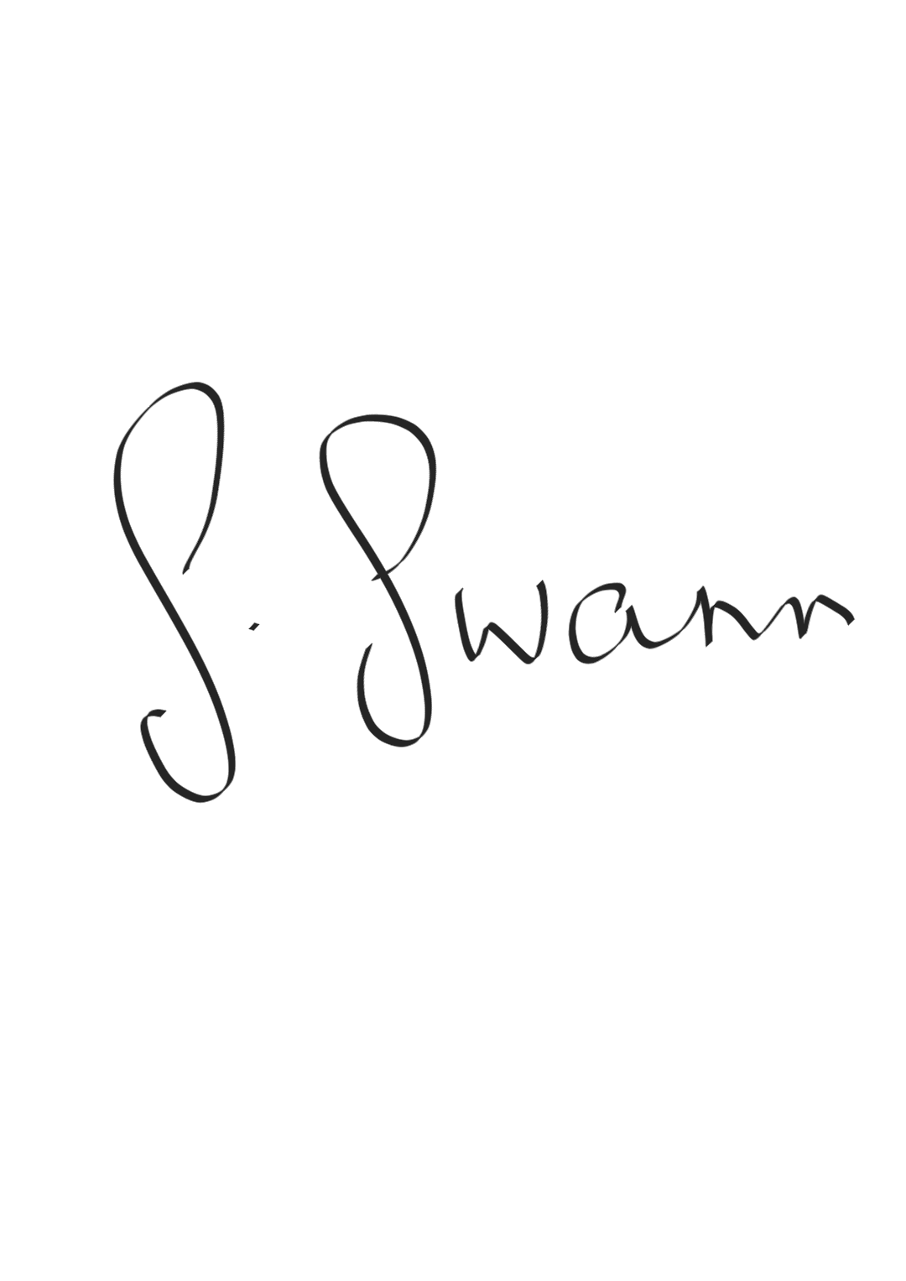

Yours sincerely,

**Samantha Swann**

**Agri-food policy**

**Sustainable Agri-food Development Division**